Teacher Key
- For the following pairs of elements, draw a diagram showing only the outer shell electrons. Draw arrows to show how electrons will be transferred.
  - Lithium, Bromine

Br
Li

  - Sodium, Sulfur
Na

Na
S

- For the following pairs of elements, A) identify the ions that will form, and B) write the formula of the compound.
  - Calcium, Oxygen
- Ca²⁺ O²⁻
- CaO

  - Magnesium, Iodine
- Mg²⁺ I⁻
- MgI₂

- For the following compounds, write the formula.
  - Potassium iodide
KI

  - Sodium oxide
Na₂O

[2]
(1 point for correct ions drawn; 1 point for correct arrows)
[2]

[2]
A) is 1 point
B) is 1 point

[2]
A) is 1 point
B) is 1 point

[1]

[1]

- For the following compounds, write the name.
  - Li₂O
Lithium oxide

  - CaI₂
Calcium iodide

- On the diagram of an electrolysis apparatus,
  - Mark the charge of each carbon electrode.

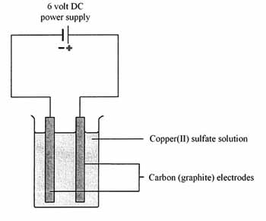
-
+
  - Predict which ions will travel to the positive (+) electrode and which will travel to the negative (-) electrode. (Assume the solution is Copper (II) sulfate dissolved in water.: CuSO₄ in H₂Op)
Cu²⁺ will travel to the negative electrode
SO₄²⁻ will travel to the positive electrode

[1]

[1]

[1]

[2]
(1 point for identifying the proper ions; another point for indicating correct direction)

