Name: Date:

Density
Density is the mass per unit volume. This means that the density of any solid, liquid or gas can be found by dividing its mass in kilograms by its volume in cubic metres.
Density can be found using the equation:
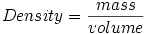
- The unit for density is kg m⁻³
- The density of water is approximately 1000 kg m⁻³ and air is approximately 1.3 kg m⁻³

Densities of solids, liquids and gases
When most substances change from a solid state to a liquid state their volume does not change much. This is because the particles stay approximately the same distance apart. This means that the density of a substance, say iron, does not change by much when it melts.
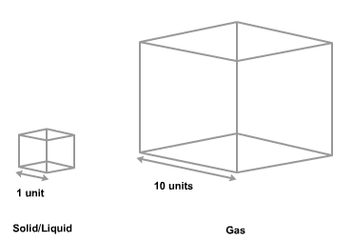
When a liquid changes into a gas, the spacing between the particles increases by a factor of about ten. As such, because the volume of a substance is length × breadth × height, the volume will increase by a factor of 1000.
As a result, the density of a substance decreases by a factor of approximately 1000 when it changes from a liquid to a gas.

Pressure
Pressure (of a solid) is the force per unit area.
This means that the pressure a solid object exerts on another solid surface is its weight in newtons divided by its area in square meters.
Pressure can be found using the equation:
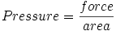
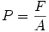
- The unit for pressure is the pascal (Pa).
- One pascal is equivalent to one newton per square meter.
- Atmospheric pressure is approximately 1 × 10⁵ Pa.

States of matter
The kinetic particle theory explains the properties of the different states of matter. The particles in solids, liquids and gases have different amounts of energy. They are arranged differently and move in different ways.
The table below summarizes the arrangement and movement of the particles in solids, liquids and gases, and shows simple diagrams for the arrangement of the particles.

Diagram of particle arrangement and movement
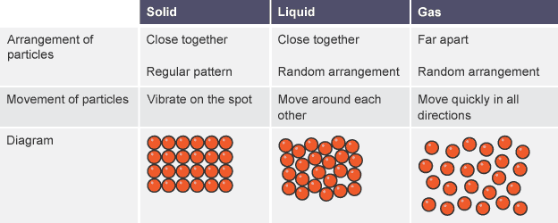

Solids
The table shows some of the properties of solids and why they are like this.
Property | Why
Solids have a fixed shape and cannot flow | The particles cannot move from place to place
Solids cannot be compressed or squashed | The particles are close together and have no space to move into

Liquids
The table shows some of the properties of liquids and why they are like this.
Property | Why
Liquids flow and take the shape of their container | The particles can move around each other
Liquids cannot be compressed or squashed | The particles are close together and have no space to move into

Gases
The table shows some of the properties of gases and why they are like this.
Property | Why
Gases flow and completely fill their container | The particles can move quickly in all directions
Gases can be compressed or squashed | The particles are far apart and have space to move into

State changes
Substances can exist as a solid, liquid or gas. Converting from one state to another usually involves heating or cooling.
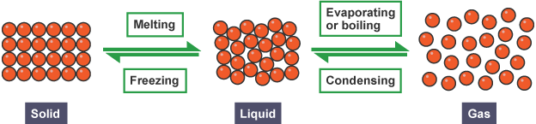
- Heat must be supplied to a substance for it to melt, evaporate or boil. For example, you need to heat ice to melt it, and you need to heat water to make steam.
- Heat must be removed from a substance to condense or freeze it. In other words, the substance must be cooled down.
Under certain conditions, some solids turn straight into a gas when heated. This process is called sublimation. A good example is solid carbon dioxide, also called ‘dry ice’. At atmospheric pressure, it turns straight into gaseous carbon dioxide.
Liquid carbon dioxide can only exist under high pressure, such as in fire extinguishers. Iodine also sublimes - it turns directly from shiny purple-black crystals to a purple vapor when warmed up.

Changing the pressure
A gas will also liquefy (turn into a liquid) if its pressure is increased enough. This is because the particles are moved close enough for bonds to form between the particles.
Gas cylinders used for camping stoves and barbecues contain liquefied petroleum gas (LPG) under high pressure. As soon as the pressure is released, the liquid turns back to a gas.

Evaporation and condensation
Evaporation and condensation are changes of state:
- evaporation involves a liquid changing to a gas
- condensation involves a gas changing to a liquid.
Evaporation is the reason why damp clothes dry on a washing line. Condensation is the reason why windows become foggy on a cold day.

Evaporation
The particles in a liquid have different energies. Some will have enough energy to escape from the liquid and become a gas. The remaining particles in the liquid have a lower average kinetic energy than before, so the liquid cools down as evaporation happens. This is why sweating cools you down. The sweat absorbs energy from your skin so that it can continue to evaporate.

Condensation
The particles in a gas have different energies. Some may not have enough energy to remain as separate particles, particularly if the gas is cooled down. They come close together and bonds form between them. Energy is released when this happens. This is why steam touching your skin can cause scalds: not only is the steam hot, but energy is released into your skin as the steam condenses.

Factors affecting the rate of condensation and evaporation
The rate of condensation increases if the temperature of the gas is decreased. On the other hand, the rate of evaporation increases if the temperature of the liquid is increased. It is also increased if:
- the surface area of the liquid is increased
- air is moving over the surface of the liquid.

Energy and Temperature when Changing state
A substance must absorb heat energy so that it can melt or boil. The temperature of the substance does not change during melting, boiling or freezing, even though energy is still being transferred.
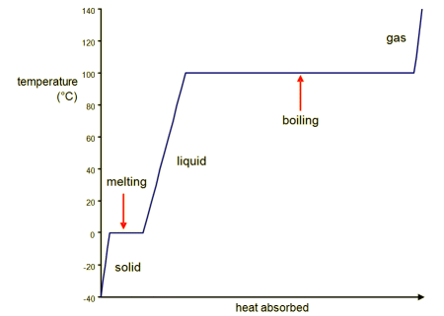
A heating curve for ice

The specific latent heat of a substance is a measure of how much heat energy is needed to melt or boil it. It is the energy needed to melt or boil 1 kg of the substance.
Different substances have different specific latent heats. The specific latent heat of a given substance is different for boiling than it is for melting. The table shows some examples.

Latent heats of substances
substance | specific latent heat of melting kJ/kg | specific latent heat of boiling kJ/kg
water | 334 | 2260
lead | 22.4 | 855
oxygen | 13.9 | 213

- Which theory describes the arrangement and movement of particles in solids, liquids and gases?
  - Theory of relativity
  - Kinetic theory
  - Atomic theory
- In which state of matter are the particles mostly touching but arranged in a random way?
  - Solid
  - Liquid
  - Gas
- In which state of matter do the particles have the most energy?
  - Solid
  - Liquid
  - Gas
- Why can liquids not be compressed easily?
  - The particles are in a random arrangement
  - The particles are closely packed
  - The particles are free to move over each other
- Why do solids have a fixed shape?
  - The particles are fixed in place
  - The particles are closely packed
  - The particles vibrate
- What is the name of the change when a liquid becomes a solid?
  - Melting
  - Boiling
  - Freezing
- What is sublimation?
  - When a solid turns into a gas
  - When a gas turns into a solid
  - When a gas turns into a liquid
- What eventually happens if energy is continually removed from a liquid?
  - It boils
  - It evaporates
  - It freezes
- What eventually happens to a gas if its pressure is increased?
  - It condenses
  - It evaporates
  - It melts
- Which of the following will sublime at room temperature and pressure?
  - Ice
  - Graphite
  - Solid carbon dioxide (dry ice)
- As a solid melts:
  - Its temperature increases
  - Its temperature stays the same.
  - Its temperature decreases.

- A certain material has a mass of 0.134 kg and a volume of 0.000015 m³. What is the density of this substance? Show your work.

- A block of copper has a volume of 0.005 m³. The density of copper is 8.96 X 10³ kg.m⁻³. Calculate the mass of the copper block.

- What is the volume of 0.10 kg of titanium? (The density of titanium is 4.54 X 10³ kg.m⁻³.)

- A cube with sides of 0.200 m weighs 25 N. Determine the pressure that the cube applies to the ground. Give your answer in N/m²

- If the cube (with sides of 0.200 m) had a mass of 10 kg, what pressure would it apply to the ground?

- A cube-shaped box of mass 10 kg is sitting on a level table. If the length of each edge of the box is 0.1 m, calculate the pressure the box exerts on the table.

- Water evaporates at room temperature (25ºC), but the boiling point of water is 100ºC.
  - Use your understanding of changes of state to describe this concept.

- Explain why a change in pressure can cause a gas to condense.

- Consider the three points (A, B, C) on the temperature versus time graph.

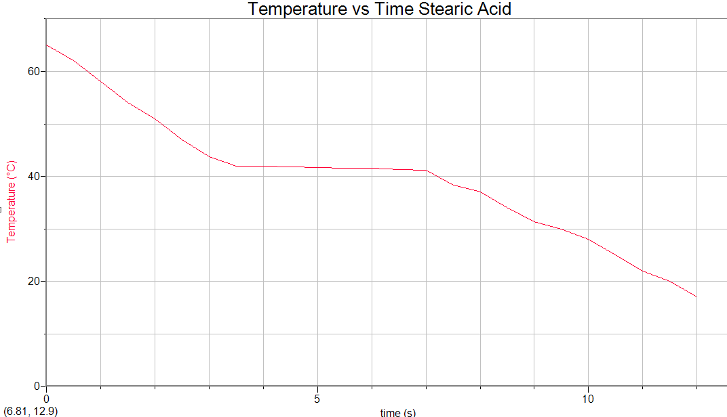
C
B
A

  - What about the particles in the system was changing at each of these times?

 | Change in Temperature? | Change in State? | Justify your answer
A
B
C

  - Draw particle diagrams for each marked point.
C
B
A

  - What is the freezing point of stearic acid? How do you know?

http://www.bbc.co.uk/bitesize/higher/physics/mech_matt/pressure/revision/1/
http://www.bbc.co.uk/education/guides/zccmn39/revision

