Name: ____________________________________________________________________________________________________ Class: Maroon 2

Motion and energy changes
Work done and energy transferred are measured in joules (J). The work done on an object can be calculated if the force and distance moved are known.
- Objects raised against the force of gravity increase gravitational potential energy.
- The more mass an object has and the faster it moves, the more kinetic energy it has.

Weight
Weight is the force of gravity, and is based on the relationship between mass and gravitational field strength. Gravitational field strength is measured in newtons per kilogram, (N/kg), and it is often simply referred to by its symbol: g.
Weight (newton, N) = mass (kilogram, kg) x gravitational field strength (N/kg)
$$F_{g}=m ∙g$$
The gravitational field strength on the Earth's surface is about 10 N/kg. This is quite handy because all you need to do to convert between weight and mass is to multiply the mass by 10.
For example, a 1kg bag of sugar weighs 1 × 10 = 10 N.

Gravitational potential energy (GPE)
If you lift a book up onto a shelf you have to do work against the force of gravity. The book has gained gravitational potential energy. Any object that is raised against the force of gravity has an increase in its gravitational potential energy.
The important relationship in this case is between change in gravitational potential energy, weight and change in height.
This equation shows the relationship between gravitational potential energy (joule, J), weight (Newton, N) and change in height (meter, m):
Change in GPE = weight x change in height
$$E_{g}=F_{g}∙h$$
or
$$E_{g}=m∙g∙h$$
For example, if a 1 N weight is raised by 5 m it gains 1 × 5 = 5 J of gravitational potential energy.

Kinetic energy (KE)
Every moving object has kinetic energy (KE). The more mass an object has and the faster it is moving, the more kinetic energy it has. So the bigger the object, the faster it will move.
This equation shows the relationship between kinetic energy (J), mass (kg) and speed (m/s):
Kinetic energy = 1/2 × mass × speed²
$$E_{k}= \frac{1}{2}m∙v^{2}$$
(Notice that the speed is squared)

Conservation of energy
Energy is always conserved – the total amount of energy present stays the same before and after any changes.

The pendulum
The pendulum shows the principal of conservation of energy in action. Gravitational potential energy is converted to kinetic energy and back, over and over again, as the pendulum swings.
The diagram (next page) shows a pendulum in three positions - the two ends of its swing and as it passes through the middle point.
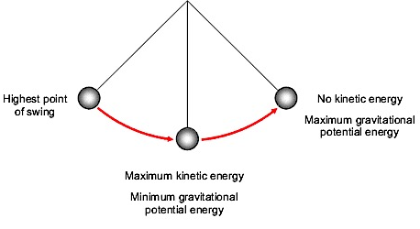
When the pendulum bob is at the start of its swing it has no kinetic energy because it is not moving, but its gravitational potential energy (GPE) is at a maximum, because it is at the highest point.
As the bob swings downwards it loses height. So its gravitational potential energy (GPE) decreases. The work done on the bob by the gravitational force (weight) pulling it downwards increases its kinetic energy. The loss of GPE = the gain in KE.
At the bottom of its swing, the bob's kinetic energy is at a maximum and its gravitational potential energy is at a minimum - because it is at its lowest point.
As the bob swings upwards it slows down. Its kinetic energy decreases as work is done against its weight. As it gains height the gravitational potential energy increases again.
At the very top of its swing it stops for a moment. It once again has no kinetic energy, but its gravitational potential energy is at a maximum.
At all points during the swing, the total (GPE + KE) is constant.
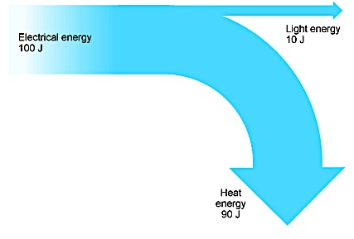
Note that in a real pendulum the bob's swing will become slightly lower with each swing, because some energy is lost (dissipated, 'wasted') through heating, due to air resistance.

Efficiency

'Wasted' energy
Energy cannot be created or destroyed. It can only be transferred from one form to another or moved. Energy that is 'wasted', like the heat energy from an electric lamp, does not disappear. Instead, it is transferred into the surroundings and spreads out so much that it becomes very difficult to do anything useful with it.

Electric lamps
Ordinary electric lamps contain a thin metal filament that glows when electricity passes through it. However, most of the electrical energy is transferred as heat energy instead of light energy. At the right is the Sankey diagram for a typical filament lamp.

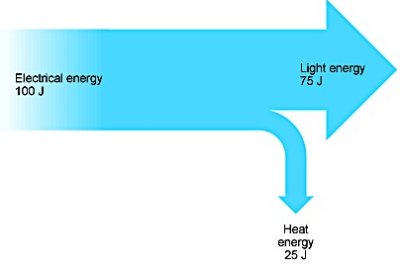
Modern energy-saving lamps work in a different way. They transfer a greater proportion of electrical energy as light energy. At the left is the Sankey diagram for a typical energy-saving lamp.

From the diagram, you can see that much less electrical energy is transferred, or 'wasted', as heat energy.

Calculating efficiency [E]
The efficiency of a device such as a lamp can be calculated using this equation:

$$efficiency \frac{useful energy transferred}{energy supplied} *100$$

The efficiency of the filament lamp is (10 ÷ 100) × 100 = 10%.
This means that 10% of the electrical energy supplied is transferred as light energy (90% is transferred as heat energy).

The efficiency of the energy-saving lamp is (75 ÷ 100) × 100 = 75%. This means that 75% of the electrical energy supplied is transferred as light energy (25% is transferred as heat energy).

Note that the efficiency of a device will always be less than 100%.

Work and Power

Work
Work and energy are measured in the same unit, the joule (J).
Amount of energy transferred (joule, J) = work done (joule, J)

Work is done whenever a force moves something.
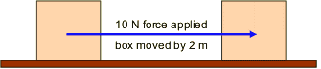
Everyday examples of work include walking up stairs, lifting heavy objects, pulling a sledge and pushing a shopping trolley. Whenever work is done energy is transferred from one place to another. Both energy and work are measured in joules, J.

Calculating work done
This equation shows the relationship between work done, force applied and distance moved:

Work done = force × distance

$$W=F ∙d$$

- Work done is measured in joules, J
- Force is measured in newtons, N
- Distance is measured in metres, m

In the example above, 10 N is applied to move the box 2 m.
Work done = 10 × 2 = 20 J

Power
Power is a measure of how quickly work is being done and so how quickly energy is being transferred.

Calculating power
The equation that relates power, work done and time is:

$$Power= \frac{Work done}{time}$$

$$P= \frac{W}{t}$$

- Power is measured in watts, W
- Work done is measured in joules, J
- Time is measured in seconds, s

For example, an electric drill transfers 3000 J in 15 s. What is its power?
Power = 3000 ÷ 15 = 200 W

Resources:
http://www.bbc.co.uk/schools/gcsebitesize/science/add_ocr_21c/explaining_motion/energychangesrev1.shtml
http://www.bbc.co.uk/schools/gcsebitesize/science/add_ocr_gateway/forces/workpowerrev1.shtml

Multiple-Choice Questions
- What is the unit for work?

  - Effort (E)
  - Joule (J)
  - Newton (N)

- What is the energy change when a 10 N force moves an object a distance of 2 m?

  - 5 J
  - 10 J
  - 20 J

- What is the weight of a 1 kg bag of sugar?

  - 1 kg
  - About 2 pounds
  - 10 N

- An 800 N man climbs 5 m up a ladder. How much gravitational potential energy does he gain?

  - 4000 J
  - 160 J
  - 80 kg

- What is the kinetic energy of a 2 kg dog running at 6 m/s?

  - 12 J
  - 36 J
  - 72 J

- A flowerpot weighing 5 N falls off a windowsill 10 m above the ground. What is its kinetic energy just before it hits the ground?

  - 2J
  - 50 J
  - 250 J

- How much work is done lifting a 250 N box by 2 m?

  - 125 J
  - 5 kJ
  - 500 J

- What force is needed to do 500 J of work over a distance of 5 m?

  - 100 N
  - 2.5 kN
  - 250 N

- What is the power of a machine that does 2000 J of work in 5 s?

  - 0.0025 W
  - 400 W
  - 10 kW

- How much work can a 500 W machine do in 1 minute?

  - 500 J
  - 30 000 J
  - 3 kJ

- An electric lamp is 25% efficient. If it receives 100 J per second of electrical energy, how much of this is transferred as light energy?

  - 25 J/s
  - 75 J/s
  - 75 W

Short-Response Questions
- An elephant of mass 4000 kg is moving at 0.5 m / s.
  - Calculate the kinetic energy of the elephant. State the formula that you use and show your working.

- An elephant lifts a mass of 300 kg through a vertical distance of 2 m.
  - State the weight that the elephant lifts.

  - Calculate the work done by the elephant. State the formula that you use and show your working.

- An elephant weighing 40 000 N stands with all four feet in contact with the ground. Each foot of the elephant has an area of 0.4 m².
  - Use the formula
$$P= \frac{F}{A}$$
to calculate the pressure exerted by the elephant on the ground.

- A passenger weighs 900 N.
  - Calculate the work done lifting the passenger a vertical distance of 6 m up the escalator. State the formula that you use and show your working.

  - State the potential energy the passenger has gained when he reaches the top of the escalator.

  - If the escalator travels at a constant speed of 5 m/s, what is the kinetic energy of the passenger?

