Name: ______________________________________

Forms of energy
You should be able to recognize the main types of energy:
- magnetic
  - energy in magnets and electromagnets
- kinetic (movement energy)
  - the energy in moving objects
- heat
  - also called thermal energy
- light
  - also called radiant energy
- gravitational potential
  - stored energy in raised objects
- chemical
  - stored energy in fuel, foods and batteries
- sound
  - energy released by vibrating objects
- electrical
  - energy in moving charges or static electric charges
- elastic potential
  - stored energy in stretched or squashed objects
- nuclear
  - stored in the nuclei of atoms

Energy transfer diagrams
Different types of energy can be transferred from one type to another. Energy transfer diagrams show each type of energy, whether it is stored or not, and the processes taking place as energy is transferred.
This energy transfer diagram shows the useful energy transfer in a car engine. You can see that a car engine transfers chemical energy, which is stored in the fuel, into kinetic energy in the engine and wheels.
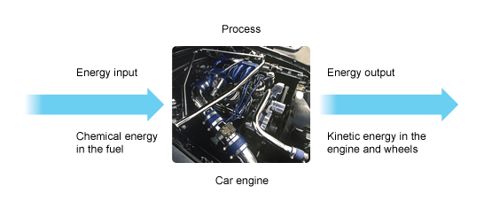
This diagram shows the energy transfer diagram for the useful energy transfer in an electric lamp. You can see that the electric lamp transfers or converts electrical energy into light energy.
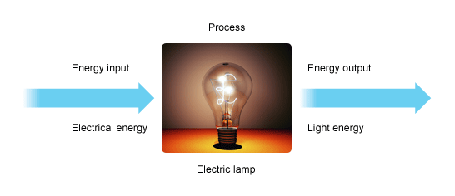
Notice that these energy transfer diagrams only show the useful energy transfers. However, car engines are also noisy and hot, and electric lamps also give out heat energy.
Energy transfer by heating
Heat can be transferred from place to place by conduction, convection and radiation. Dark matt surfaces are better at absorbing heat energy than light shiny surfaces. Heat energy can be lost from homes in many different ways and there are ways of reducing these heat losses.

Infrared radiation
All objects emit (give out) and absorb (take in) thermal radiation, which is also called infrared radiation. The hotter an object is, the more infrared radiation it emits.
Infrared radiation is a type of electromagnetic radiation, which involves waves rather than particles. This means that, unlike conduction and convection, radiation can even pass through the vacuum of space. This is why we can still feel the heat of the Sun, although it is 150 million km away from the Earth.
Some surfaces are better than others at emitting and absorbing infrared radiation. This table summarizes the differences.

Comparison of surfaces abilities to reflect and absorb radiation
Type of surface | Ability to emit infrared radiation | Ability to absorb infrared radiation
dark, matt (dull) | good | good
light, shiny | poor | poor
Light, shiny surfaces are also good reflectors of infrared radiation.

Kinetic theory
The kinetic particle theory explains the properties of the different states of matter. The particles in solids, liquids and gases have different amounts of energy. They are arranged differently and move in different ways.
 | Solid | Liquid | Gas
Arrangement of particles | close together  regular pattern | close together random | far apart  random
movement of particles | vibrate about a fixed position | move around each other | move quickly in any direction
diagram

Solids

The table shows some of the properties of solids and why they are like this.
Property of solids | Why they are like this
They have a fixed shape and cannot flow | The particles cannot move from place to place
They cannot be compressed or squashed | The particles are close together and have no space to move into

Liquids

Some of the properties of liquids and why they are like this
Property of liquids | Why they are like this
They flow and take the shape of their container | The particles can move around each other
They cannot be compressed or squashed | The particles are close together and have no space to move into

Gases

Some of the properties of gases and why they are like this
Property of gases | Why they are like this
They flow and completely fill their container | The particles can move quickly in all directions
They can be compressed or squashed | The particles are far apart and have space to move into

Conduction
Heat energy can move through a substance by conduction. Metals are good conductors of heat but non-metals and gases are usually poor conductors of heat. Poor conductors of heat are called insulators. Heat energy is conducted from the hot end of an object to the cold end.
Heat transfer by conduction
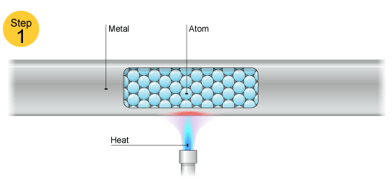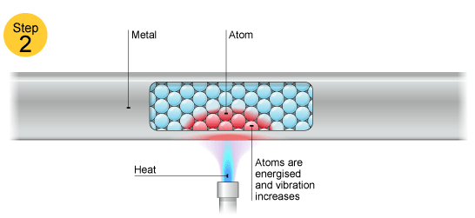
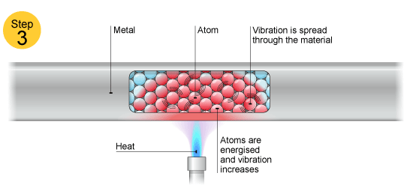

Heat conduction in metals
The electrons in piece of metal can leave their atoms and move about in the metal as free electrons. The parts of the metal atoms left behind are now charged metal ions. The ions are packed closely together and they vibrate continually. The hotter the metal, the more kinetic energy these vibrations have. This kinetic energy is transferred from hot parts of the metal to cooler parts by the free electrons. These move through the structure of the metal, colliding with ions as they go.

Convection
Liquids and gases are fluids. The particles in these fluids can move from place to place. Convection occurs when particles with a lot of heat energy in a liquid or gas move and take the place of particles with less heat energy. Heat energy is transferred from hot places to cooler places by convection.
Liquids and gases expand when they are heated. This is because the particles in liquids and gases move faster when they are heated than they do when they are cold. As a result, the particles take up more volume. This is because the gap between particles widens, while the particles themselves stay the same size.

The liquid or gas in hot areas is less dense than the liquid or gas in cold areas, so it rises into the cold areas. The denser cold liquid or gas falls into the warm areas. In this way, convection currents that transfer heat to place from place are set up.

Evaporation and Condensation
Evaporation and condensation are changes of state:
- evaporation involves a liquid changing to a gas
- condensation involves a gas changing to a liquid.
Evaporation is the reason why damp clothes dry on a washing line. Condensation is the reason why windows become foggy on a cold day.

Evaporation
The particles in a liquid have different energies. Some will have enough energy to escape from the liquid and become a gas. The remaining particles in the liquid have a lower average kinetic energy than before, so the liquid cools down as evaporation happens. This is why sweating cools you down. The sweat absorbs energy from your skin so that it can continue to evaporate.

Condensation
The particles in a gas have different energies. Some may not have enough energy to remain as separate particles, particularly if the gas is cooled down. They come close together and bonds form between them. Energy is released when this happens. This is why steam touching your skin can cause scalds: not only is the steam hot, but energy is released into your skin as the steam condenses.

Factors affecting the rate of condensation and evaporation
The rate of condensation increases if the temperature of the gas is decreased. On the other hand, the rate of evaporation increases if the temperature of the liquid is increased. It is also increased if:
- the surface area of the liquid is increased
- air is moving over the surface of the liquid.
Resources:
http://www.bbc.co.uk/schools/gcsebitesize/science/aqa/energyefficiency/energytransfersrev1.shtml
http://www.bbc.co.uk/schools/gcsebitesize/science/aqa/heatingandcooling/heatingrev1.shtml
Review Questions:

- The useful energy transfer that happens in an electric lamp is:

  - electricity → light
  - electricity → sound
  - electricity → heat

- 'Wasted energy' becomes less useful because:

  - it is destroyed after use
  - it becomes increasingly spread out
  - it makes the surroundings become cooler

- What substances can convection happen in?

  - In solids and gases
  - In solids and liquids
  - In liquids and gases

- What type of radiation do all hot objects emit?

  - Infra-red radiation
  - Microwave radiation
  - Gamma radiation

- What are the best absorbers of thermal radiation?

  - Light, dull surfaces
  - Black, shiny surfaces
  - Black, dull surfaces

- What are the worst emitters of thermal radiation?

  - Light, shiny surfaces
  - Light, dull surfaces
  - Black, dull surfaces

- How does heat pass through a single pane of window glass?

  - By conduction and convection
  - By conduction and radiation
  - By convection and radiation

- Which statement about liquids is correct?
  - They can be compressed because their particles are free to move
  - They expand to fill their container because their particles are free to move
  - They cannot be compressed because their particles are close together

- Explain, in terms of heat transfer, why saucepans used on the stove
  - are made of aluminum

  - have wooden handles

- A dish of hot food is placed on a wooden table.
  - Describe three processes by which the dish and its contents could lose heat to the surroundings.

  - Describe one way of reducing the heat loss to the surroundings.

  - Which form of heat loss would this reduce?

- Complete the statements about energy using words from the following list

chemical, electrical, geothermal, heat, hydroelectric, light, kinetic, potential, strain, tidal, wave

  - A coal fire converts ________________ energy into _______________ energy and _________________ energy.
  - When a ball falls from rest, its _____________ energy increases and its ______________ energy decreases.
  - The source of energy in which hot rocks under the Earth’s surface heat water to produce steam is referred to as ______________________ energy.
- Describe the solid, liquid and gas states using particle diagrams. Make three diagrams that include particles in motion, where appropriate, and indicate a reasonable magnitude of velocity.

- The figure below shows an electric kettle.
Explain why the heating element is placed near the bottom of the kettle.

