*Name: ____________________________________________________________________________*

*Revision Packet Instructions: 1) Read the included material. Additional resources are available at the indicated websites. 2) Answer the questions at the end of the reading. 3) Readings and Questions with the notation [E] refer to items that will be on the Extended Exam. They are not required for students taking the Core Exam.*

Displacement, velocity, acceleration and force are all vector quantities. The speed of an object can be calculated from the slope on a distance-time graph.

The velocity of an object is its speed in a particular direction. The slope on a velocity-time graph represents the acceleration of an object. The distance travelled is equal to the area under a velocity-time graph.

**Forces and motion**

Let’s take this knowledge of speed and velocity further to look at **vector** quantities. A vector quantity has a **size** and a **direction**. The following are all vector quantities:

* Displacement
* Velocity
* Acceleration
* Force

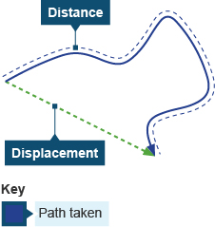

**Displacement** is the **distance** travelled in a **straight** line. It has both a direction and a size.

The **velocity** of an object is its **speed** in one particular **direction**.

The **acceleration** of an object is calculated from its change in **velocity** and the **time** taken.

The **force** of an object is also a vector as it has a size (measured in Newtons) and a direction.

# Speed

When an object moves in a straight line at a steady speed, you can calculate its speed if you know how far it travels and how long it takes. This equation shows the relationship between speed, distance travelled and time taken:

$$speed= \frac{distance travelled}{time taken}$$

* The units for speed are meters per second ($\frac{m}{s})$
* The units for distance are meters (m) and the units for time are (s)
* For example, a car travels 300 meters in 20 seconds.
  + Its speed is 300 ÷ 20 = 15 $\frac{m}{s}$.

# Distance-time graphs

You should be able to draw and explain distance-time graphs for objects moving at steady speeds or standing still.

## Background information

The vertical axis of a distance-time graph is the distance travelled from the start. The horizontal axis is the time from the start.

## Features of the graphs

When an object is stationary, the line on the graph is horizontal. When an object is moving at a steady speed, the line on the graph is straight, but sloped. The diagram shows some typical lines on a distance-time graph.

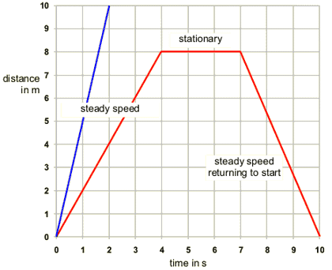

* Note that the steeper the line, the greater the speed of the object. The blue line is steeper than the red because it represents an object moving faster than the one represented by the red line.
* The red lines on the graph represent a typical journey where an object returns to the start again. Notice that the line representing the return journey slopes downwards.

# Velocity-time graphs [E]

You should be able to explain velocity-time graphs for objects moving with a constant velocity or constant acceleration.

## Background information

The velocity of an object is its speed in a particular direction. This means that two cars travelling at the same speed, but in opposite directions, have different velocities.

The vertical axis of a velocity-time graph is the velocity of the object. The horizontal axis is the time from the start.

## Features of the graphs

When an object is moving with a constant velocity, the line on the graph is horizontal. When an object is moving with a constant acceleration, the line on the graph is straight, but sloped. The diagram shows some typical lines on a velocity-time graph.

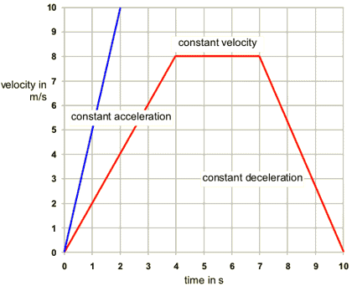

* The steeper the line, the greater the acceleration of the object. The blue line is steeper than the red line because it represents an object with a greater acceleration.
* Notice that a line sloping downwards - with a negative gradient - represents an object with a constant deceleration - slowing down.

## Calculating distance [E]

The distance travelled can be calculated from the graph, too. The area under the graph is equal to the distance travelled. Study this velocity-time graph.

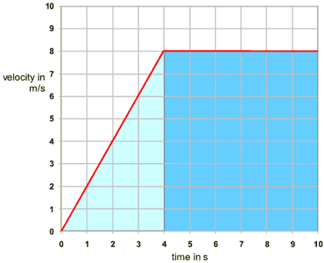

## The area [E]

The area under the line in a velocity-time graph represents the distance travelled. To find the distance travelled in the graph above, you need to find the area of the light-blue triangle and the dark-blue rectangle.

1. **Area of light-blue triangle**
   * The width of the triangle is 4 seconds and the height is 8 metres per second. To find the area, you use the equation:
   * area of triangle = 1⁄2 × base × height
   * so the area of the light-blue triangle is 1⁄2 × 8 × 4 = 16 m
2. **Area of dark-blue rectangle**
   * The width of the rectangle is 6 seconds and the height is 8 metres per second. So the area is 8 × 6 = 48 m.
3. **Area under the whole graph**
   * The area of the light-blue triangle plus the area of the dark-blue rectangle is:
   * 16 + 48 = 64 m.
   * This is the total area under the distance-time graph. This area represents the distance covered.

# Acceleration [E]

You should be able to calculate the acceleration of an object from its change in velocity and the time taken.

## The equation

When an object moves in a straight line with a constant acceleration, you can calculate its acceleration if you know how much its velocity changes and how long this takes. This equation shows the relationship between acceleration, change in velocity and time taken:

$$acceleration= \frac{change in velocity}{time taken}$$

* Acceleration is measured in $\frac{m}{s^{2}}$ or $\frac{m}{\frac{s}{s}}$
* Change in velocity is measured in meters per second ($\frac{m}{s}$) and time is measured in seconds (s)
* For example, a car accelerates in 5s from 25 m/s to 35 m/s.
* Its velocity changes by 35 - 25 = 10 m/s.
* So its acceleration is 10 ÷ 5 = 2 m/s2.

A stationary object remains stationary if the sum of the forces acting upon it - resultant force - is zero. A moving object with a zero resultant force keeps moving at the same speed and in the same direction.

Acceleration depends on the force applied to an object and the object's mass. Gravity is a force that attracts objects with mass towards each other. The weight of an object is the force acting on it due to gravity.

# Resultant force (both exams)

You should be able to use the idea of the resultant force on an object to determine its movement.

An object may have several different forces acting on it, which can have different strengths and directions. They can be added together to give the **resultant force**. This is a single force that has the same effect on the object as all the individual forces acting together.

## When the resultant force is zero

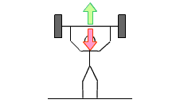

When all the forces are balanced, the resultant force is zero. In this case:

* A stationary object remains stationary
* A moving object keeps on moving at the same speed in the same direction

For example, in the diagram of the weightlifter, the resultant force on the bar is zero, so the bar does not move. Its weight acting downwards is balanced by the upward force provided by the weightlifter.

The longer the arrow, the bigger the force. In this diagram, the arrows are the same length, so we know they are the same size.When the resultant force is not zero

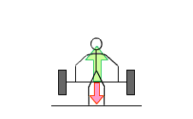

When all the forces are not balanced, the resultant force is not zero. In this case:

* A stationary object begins to move in the direction of the resultant force
* A moving object speeds up, slows down or changes direction depending on the direction of the resultant force

In this diagram of the weightlifter, the resultant force on the bar is not zero. The upwards force is bigger than the downwards force. The resultant force acts in the upwards direction, so the bar moves upwards.

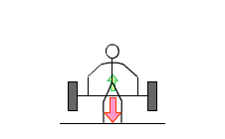

In this next diagram of the weightlifter, the resultant force on the bar is also not zero. This time, the upwards force is smaller than the downwards force. The resultant force acts in the downwards direction, so the bar moves downwards.

This can be shown with numbers in a calculation. If the upwards force was 3 N and the downward force 7 N then the resultant force would be 4 N (the difference between the two forces). It would act in a downwards direction.

# Resultant forces and motion

You should know that objects accelerate when the resultant force is not zero, and understand the factors that affect the size of the acceleration.

## Size of the force

An object will accelerate in the direction of the resultant force. The bigger the force, the greater the acceleration. Doubling the size of the (resultant) force **doubles** the acceleration.

## The mass

An object will accelerate in the direction of the resultant force. A force on a large mass will accelerate it less than the same force on a smaller mass.

Doubling the mass **halves** the acceleration.

# Forces and acceleration calculations

You should know the equation that shows the relationship between resultant force, mass and acceleration, and be able to use it.

## The equation [E]

**Resultant force (newton, N) = mass (kg) × acceleration (m/s2).**

**or,**

You can see from this equation that 1 N is the force needed to give 1 kg an acceleration of 1 m/s2.

* For example, the force needed to accelerate a 10 kg mass by 5 m/s2 is:
* 10 x 5 = 50 N
* The same force could accelerate a 1 kg mass by 50 m/s2 or a 100 kg mass by 0.5 m/s2.
* Putting it simply, we can say that it takes more force to accelerate a larger mass.

# Calculating weight

Weight is **not** the same as mass. Mass is a measure of how much stuff is in an object. Weight is a force acting on that stuff. You have to be careful. In physics, the term weight has a specific meaning, and is measured in newtons. Mass is measured in kilograms. The mass of a given object is the same everywhere, but its weight can change.

## Gravitational field strength

Weight is the result of gravity. The gravitational field strength of the Earth is **10 N/kg** (ten newtons per kilogram). This means an object with a mass of 1kg would be attracted towards the center of the Earth by a force of 10 N. We feel forces like this as weight.

You would weigh less on the Moon because the gravitational field strength of the Moon is one-sixth of that of the Earth **(1.6 N/kg)**. But note that your mass would stay the same.

## Weight

On Earth, if you drop an object it accelerates towards the centre of the planet. You can calculate the weight of an object using this equation:

**weight (N) = mass (kg) × gravitational field strength (N/kg)**

or, $F_{g}=m∙g$

# Hooke's Law

When an elastic object - such as a spring - is stretched, the increased length is called its extension. The extension of an elastic object is directly proportional to the force applied to it:

F = k × x

* **F** is the force in newtons, N (sometimes referred to as the *load*)
* **k** is the 'spring constant' in newtons per meter, N/m
* **x** is the extension in meters, m

This equation works as long as the elastic limit (the limit of proportionality) is not exceeded. If a spring is stretched too much, for example, it will not return to its original length when the load is removed.

## The spring constant

The spring constant k is different for different objects and materials. It is found by carrying out an experiment. For example, the unloaded length of a spring is measured. Different numbers of slotted masses are added to the spring and its new length measured each time. The extension is the new length minus the unloaded length.

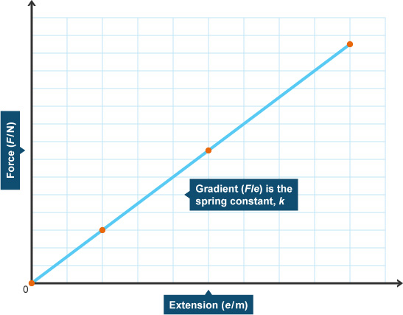

Assuming the limit of proportionality (elastic limit) is not exceeded, a graph of force against extension produces a straight line that passes through the origin. The gradient of the line is the spring constant, k. The greater the value of k, the stiffer the spring.

1. The figure below shows the speed/time graph for a motorcycle.

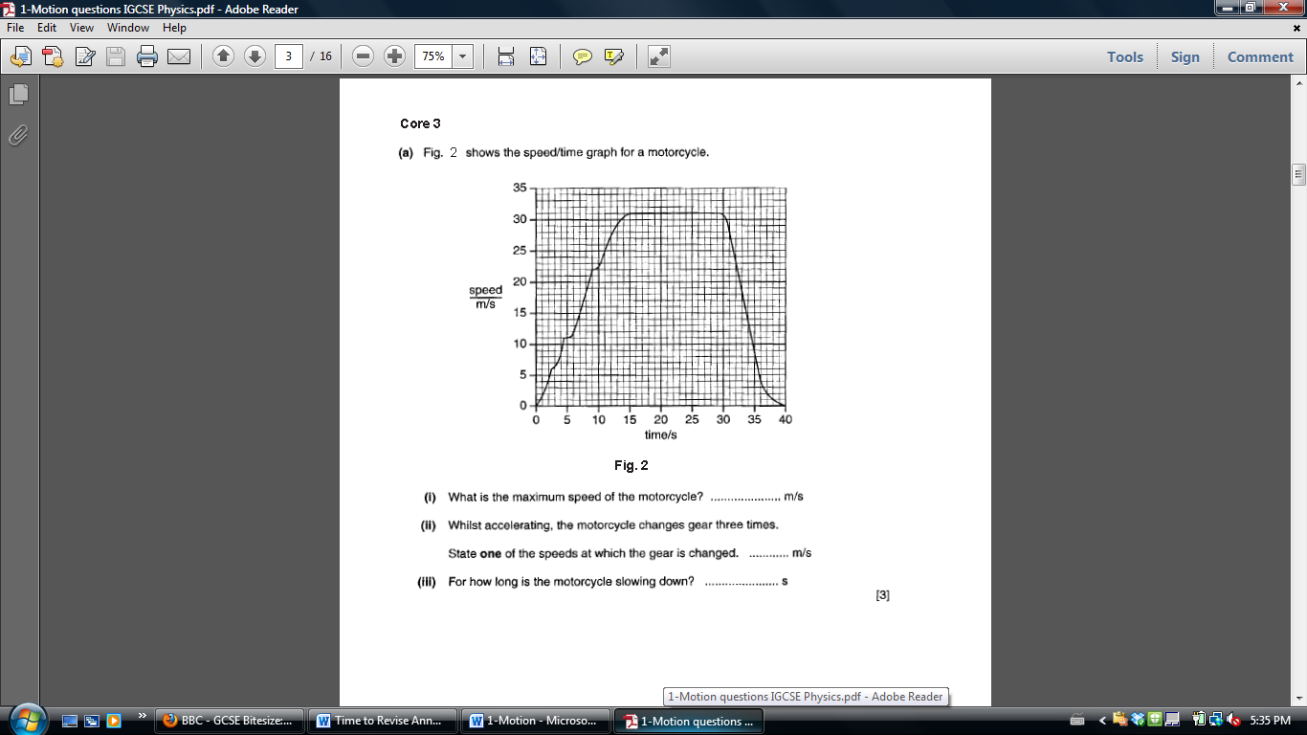

* 1. What is the maximum speed of the motorcycle?
  2. Describe what is happening from 15 seconds to 30 seconds.
  3. While accelerating, the motorcycle changes gear three times. State **one** of the speeds at which the gear is changed.
  4. For how long is the motorcycle slowing down?
  5. Find the distance the motorcycle travels from 15 seconds to 30 seconds. [E]
  6. The motorcycle has a mass of 240 kg. Find its weight. Show the formula used and your working.

1. A car accelerates its speed at a constant rate for 10 s, as shown in the figure below. [E]

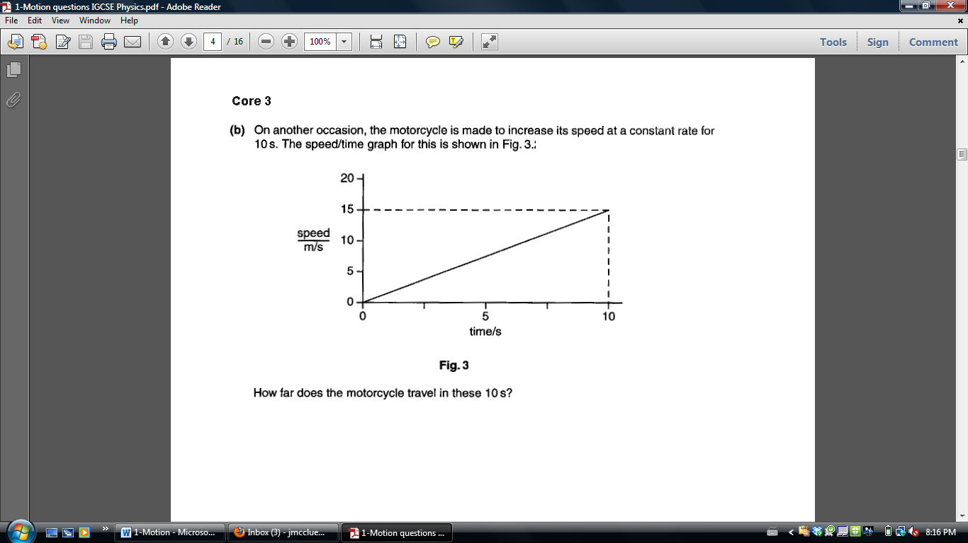

How far does the car travel in these 10s?

1. Moving cars always experience friction. A driver goes on a short journey in a car. The figure below shows the car at four places during the journey. The arrows represent the size and direction of the horizontal forces on the car.

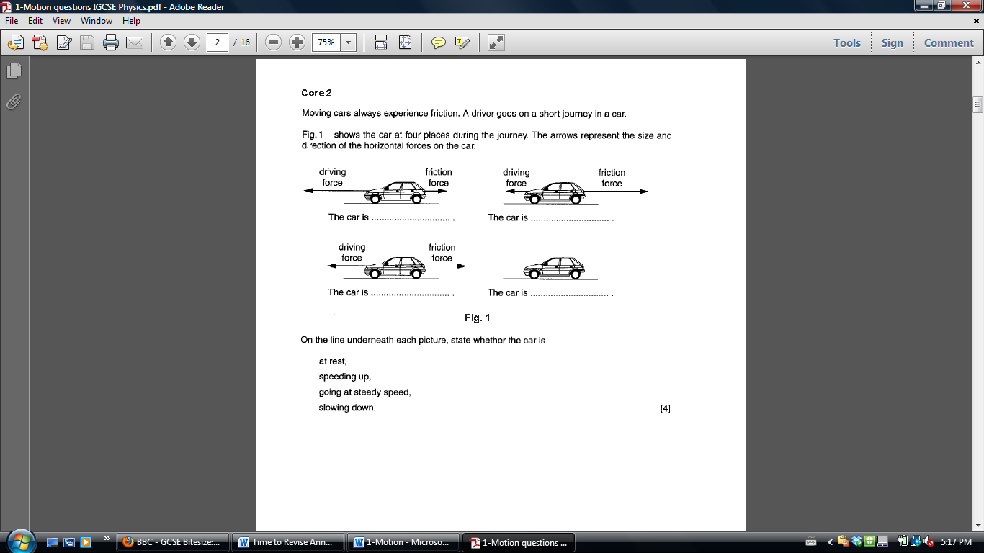

On the line underneath each picture, state whether the car is

At rest

Speeding up

Going at steady speed

Slowing down

* 1. At one point during the journey, the car travels 100 m in 2.5 seconds. Calculate the speed of the car. State the formula that you use and show your working.

At another point during the journey, the car is traveling at a speed of 25 m/s. It decelerates for 10 s until it comes to a complete stop. Calculate the deceleration of the car. State the formula that you use and show your working



1. The car pictured above has a driving force of 800 N and a friction force of 1100 N. Determine the net force.
2. A tennis player hits a ball with a large force. What force will be required to return the 0.1kg ball with an acceleration of 500 m/s2? State the formula that you use and show your working.
3. A force of 1500N is applied to a 1200 kg car. What will its acceleration be? State the formula that you use and show your working.
4. The table below shows the results of an experiment in which a piece of plastic foam was stretched by hanging weights from one end.

|  |  |  |
| --- | --- | --- |
| Load (N) | Length (cm) | Extension (cm) |
| 0.0 | 83.0 | 0.0 |
| 5.0 | 87.0 | 4.0 |
| 10.0 | 91.0 |  |
| 15.0 | 95.0 |  |
| 20.0 | 99.0 |  |

Complete the third column to show the value of the extension produced by each load.

Graph the extension vs load on the graph on the next page.



* 1. Determine the stiffness of the spring (k) by finding the slope of the graph in #6.
  2. Predict the extension for a load of 45 N, assuming the limit of proportionality is not passed.

1. An unstretched spring is 12 cm long. A load (force) of 5N stretches it to 15 cm. How long will it be under a load of 15 N? [E]

References

http://www.bbc.co.uk/schools/gcsebitesize/science/add_edexcel/motion_forces/motionrev1.shtml

http://www.bbc.co.uk/schools/gcsebitesize/science/add_edexcel/motion_forces/forcesrev1.shtml

http://www.bbc.co.uk/schools/gcsebitesize/science/add_aqa/forces/forceselasticityrev2.shtml