Cells
Specification
- State the resolution and magnification that can be achieved by a light microscope, a transmission electron microscope and a scanning electron microscope
- Explain the difference between magnification and resolution
- Explain the need for staining samples for use in light microscopy and electron microscopy
- Calculate the linear magnification of an image
- Describe and interpret drawings and photographs of eukaryotic cells as seen under an electron microscope and be able to recognise the following structures: nucleus, nucleolus, nuclear envelope, rough and smooth endoplasmic reticulum (ER), Golgi apparatus, ribosomes, chloroplasts, plasma (cell membrane), centrioles, flagella and cilia
- Outline the functions of the structures listed
- Outline the interrelationship between the organelles involved in the production and secretion of proteins (no detail of protein synthesis is required)
- Explain the importance of the cytoskeleton in providing mechanical strength to cells, aiding transport within cells and enabling cell movement
- Compare and contrast, with the aid of diagrams and electron micrographs, the structure of prokaryotic cells and eukaryotic cells
- Compare and contrast with the aid of diagrams and electron micrographs the structure and ultrastructure of plant cells and animal cells

Introduction – Discovery of the cell
In 1665 Robert Hooke, using a microscope, discovered that cork was composed of numerous small units. He called them cells. By 1838 the amount of plant material shown to be composed of cells persuaded Matthias Schleiden, a German botanist that all plants were made up of cells. The following year Theodor Schwann reached the same conclusion about the organisation of animals. Their joint findings became known as cell theory. Originally cells were thought to be hollow but with the development of better light microscopes, the nucleus and some of the larger organelles became visible e.g. chloroplasts. With the invention of the electron microscope, which can magnify 500 times more than a light microscope other organelles became visible.
Cytology – is the study of cell ultrastructure. Organisms vary considerably, and cells also vary in size and shape, but there is a remarkable similarity in their basic structure and organisation. Modern theory states:
- All living organisms are composed of cells
- All new cells are derived from other cells
- Cells contain the hereditary material of an organism which is passed from parent to daughter cells
- All metabolic processes take place in cells
Aggregation of cells
Unicellular – one cell
Multicelluar – many cells
- Colony – simple group of unicells, each carrying out all life processes and able to survive on their own
- Organisms – more complex groups where cells show differentiation and rely on each other. Specialisation, interdependence and integration → multicelluar organism
Tissue – a group of cells with the same shape and job
Organ – a structure in a plant or animal made up of several different types of tissues
Examples of organs
Liver – comprises liver tissue and other tissues e.g. blood
Leaf
- Palisade mesophyll – packed with chloroplasts
- Spongy mesophyll – air spaces for diffusion of gases
- Epidermal tissue – on upper and lower surfaces. Includes guard cells.
- Vascular tissue – veins. Phloem (food), xylem (water and mineral ions)
- Collenchyma – living cells with extra cellulose thickening e.g. midrib and petiole (leaf stalk)
- Sclerenchyma – made of lignified fibres providing rigidity. Mature cells are dead. Found in stems and in vascular bundles. (N.B. Parenchyma, collenchyma and sclerenchyma have increasing amounts of structural support/degrees of lignification.)

Simple differences between animal and plant cell – revision

Animal | Plant
Nucleus containing chromosomes | Nucleus containing chromosomes
Cytoplasm (containing a solution of ions and organic compounds) | Cytoplasm
Cell membrane (selective barrier between cell and its external environment) | Cell membrane
 | Cell wall
 | Chloroplasts
 | Large vacuole

Magnification and Resolution
Magnification
Magnification is the number of times bigger an image is than the specimen/original
Resolution
Resolution is the ability to distinguish 2 points as separate points. It refers to the degree of detail visible.

Microscopes
Light microscope
- Relatively cheap
- Can magnify up to about x1500
- Requires the specimen to be thin as the light has to shine through from below
- May have its own light source or may use mirrors to reflect light
- Specimen requires staining with dyes to improve contrast

Electron microscopes
- Very expensive
- 2 types:
Transmission electron microscope (TEM)
- Electrons are fired through extremely thin sections of specimen
- The electrons are scattered
- Magnetic lenses focus the image onto a fluorescent screen or photographic plate
Scanning electron microscope (SEM)
- Electrons reflect off the surface of the specimen
- Give 3-d image of the surface

Table of comparisons

 | Light microscope | TEM | SEM
Radiation source | Light | Electrons | Electrons
Wavelength | 400-700nm | 0.005nm | 0.005nm
Lenses | Glass | Electromagnetic | Electromagnetic
Specimen | Living or non-living supported on glass slide | Non-living supported on a small copper grid in a vacuum | Non-living supported on a metal disc in a vacuum
Maximum resolution | 200nm | 1nm | 10nm
Maximum magnification | X1500 | X250,000 | X100,000
Stains | Coloured dyes | Impregnated with heavy metals | Coated with carbon or gold
Type of image | Coloured | Monochrome (black and white) | Monochrome (black and white)

Cells and their organelles

Eukaryotic vs prokaryotic

Karyon (greek) = kernel or nucleus
Pro = before
Eu = true

Prokaryotes are bacteria – the cells are simple in structure and lack complex organelles and internal membranes. Cells that are typical of animals and plants have a complex set of internal membranes and organelles. The nucleus is surrounded by a nuclear envelope, which separate the genetic material for the rest of the cytoplasm. These cells are termed eukaryotic.

Common features of EUKARYOTIC cells
Cell surface membrane (plasma membrane)
- Selective barrier between the cell contents and the surrounding environment
- Controls the passage of substances in and out of cell
- Regulates internal environment
- Ensures suitable conditions for the chemical reactions that go on inside the cell
- First theories about structure came in 1935 with the invention of the electron microscope – Davson & Danielli proposed a bilayer of lipids coated with protein
- 1972 Singer & Nicolson proposed the ‘fluid–mosaic’ model – a bilayer of lipid with proteins embedded or spanning the structure. The proteins and lipids can move around, hence fluid. Carbohydrates also found but always associated with lipids or proteins as glycolipids or glycoproteins.
- Lipids – phospholipids, glycolipids and cholesterol. All have polar and non-polar areas to the molecule. Phosphate point outwards, fatty acid chains point into the bilayer. The carbohydrate on the glycoprotein always points out of the cell.
- Proteins - intrinsic completely span membrane, extrinsic sit part way into membrane. Hydrophillic and hydrophobic area of the molecule help maintain stability.

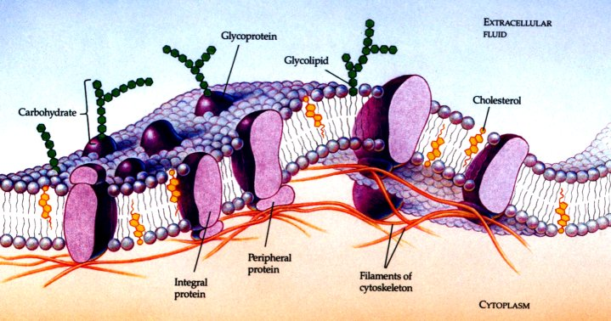

Membranous organelles
Nucleus, chloroplast, mitochondrion, endoplasmic reticulum, Golgi apparatus, vacuoles

Nucleus
Functions:
- To contain the genetic material of a cell in the form of chromosomes
- To act as a control centre for the activities of the cell (by regulating the synthesis of proteins and enzymes)
- To carry the instructions for the synthesis of proteins in the nuclear DNA
- To be involved in the production of ribosomes and RNA
- In cell division
Structure:
- Bounded by a double membrane, the nuclear envelope.
- The outer membrane is continuous with the endoplasmic reticulum and often has ribosomes on its surface.
- The inner and outer membranes fuse at intervals giving nuclear pores (c. 3,000) which allow passage of large molecules e.g. RNA between nucleoplasm and cytoplasm.
- The space between the membranes is continuous with the cisternae of the ER.
- Nucleoplasm contains chromosomes, made up of coils of DNA bound to proteins called histones.
- In a nucleus that is not dividing the chromosomes form a diffuse network called chromatin – so called because it is easy to stain and can be readily observed under the microscope.
- Nucleoplasm also contains one or more nucleoli (s. nucleolus) – function is to make rRNA and tRNA.
- Made of DNA from sections of one or several chromosomes which come together to code for the RNA.
- Area stains easily due to the concentration of DNA and RNA in the area and hence appears as a dark area in the nucleus. Disappears during cell division as the chromosomes separate and shorten.

Endoplasmic reticulum
Structure:
- Complex system of membrane-bound flattened sacs or tubules throughout the cytoplasm, called cisternae.
- It is an extension of the outer nuclear membrane
- 2 types:
  - Smooth ER involved in synthesis of lipids.
  - Rough ER the cisternae have ribosomes which are involved in the synthesis of proteins. Found most abundantly in cells which are growing or which secrete enzymes.
Functions:
- Providing a large surface area for chemical reactions
- Providing a pathway for the transport of materials through the cell
- Producing proteins, especially enzymes (rough ER)
- Producing lipids and steroids (smooth ER)
- Collecting and storing synthesised materials
- Providing a structural skeleton to maintain cellular shape

Mitochondria
- Found in cytoplasm of most eukaryotic cells (absent in some highly specialised cells like mature red blood cells).
- Range in shape from round to elongated typically 5µm x 0.2µm.
- Bounded by double membrane. Inner membrane is folded inwards to form shelf like projections called cristae (s. crista).
- Site of TCA metabolic pathway – also known as Krebs cycle.
- Elementary particles are stalked structures on the cristae which are the site of respiration – probably contain enzymes.
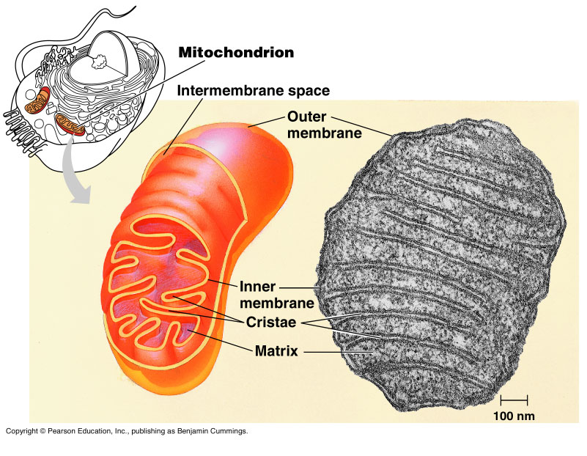
Golgi apparatus
- Involved in the modification of proteins.
- Consists of a stack of flattened cisternae with associated vesicles
- Small membrane bound vesicles pinch off from the ER and fuse with the cisternae of the Golgi apparatus
- The vesicles contain protein which then have carbohydrate attached (proved by the radioactive labelling of amino acids)
- Sorts the proteins and lipids and directs them to their destinations e.g. into lysosomes
- Vesicles containing the modified protein pinch off and can be secreted

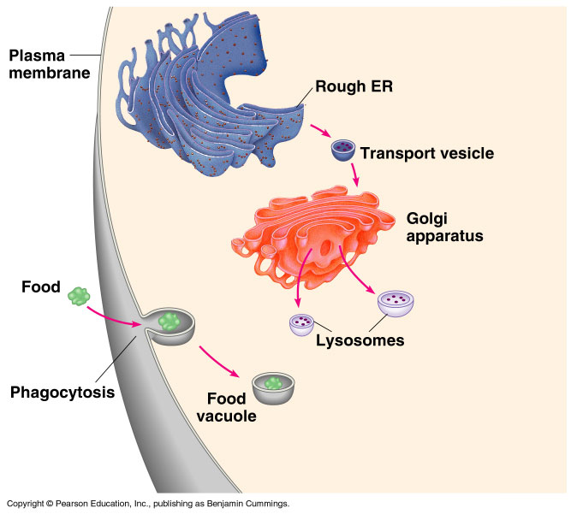

Chloroplasts
- Large plastid (organelle in a plant cells) containing chlorophyll and carrying out photosynthesis
- Surrounded by an envelope of 2 membranes (the chloroplast envelope)
- The outer membrane is similar in structure to the plasma membrane
- The inner membrane is folded into a series of lamella (paired folds of membranes) and is highly selective in what is allowed in and out of the chloroplast
- Contains gel-like matrix called stroma through which runs a system of membranes that are stacked in places to form grana (s. granum)
- Grana consist of stacks of flattened sacs called thylakoids, which contain the chlorophyll
- Some thylakoids have tubular extensions with interconnect adjacent grana
- Stroma also have starch grains

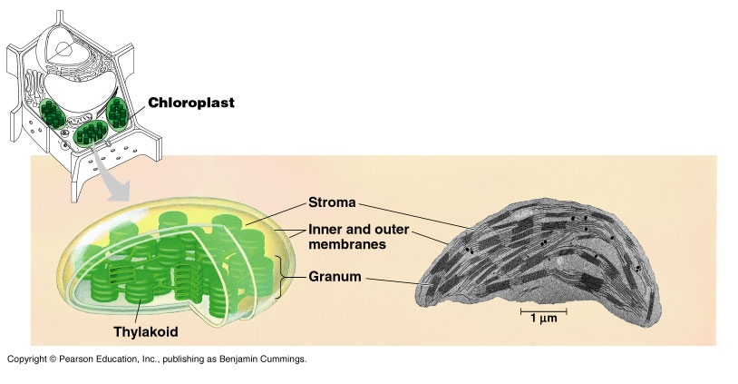

Non-membranous structures

Microtubules, centrioles, ribosomes and cell walls

Ribosomes
- Small cytoplasmic granules found in all cells
- May occur in groups called polysomes
- May be associated with the endoplasmic reticulum or occur freely within the cytoplasm
- Enormous numbers mean that they can account for up to 20% of the mass of the cell
- Made up of one large and one small sub-unit and comprise ribosomal RNA and protein
- Important in the synthesis of proteins where they move along mRNA in succession
- Made of roughly equal amounts of protein and RNA
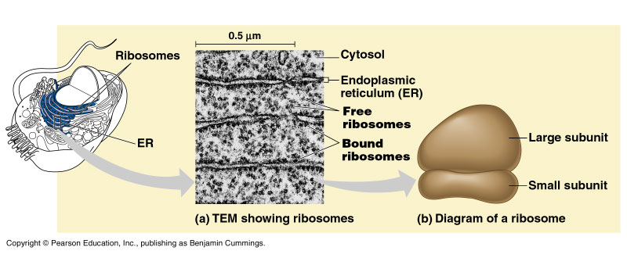
Microtubules
- Found in eukaryotic cells but not prokaryotic cells
- Slender, hollow, unbranched tubes 20-25 nm in diameter and up to several microns long
- Made of protein tubulin
- Provide an internal skeleton (cytoskeleton) for cells and help to determine their shape
- To aid transport within cells by providing routes along which materials move
- To form a framework along which the cellulose cell wall of plants is laid down
- As major components of cilia and flagella where they are grouped in a very precise way and contribute to their movement
- Make up the spindle during cell division and within the centrioles from which the spindle is formed. Here they help to draw the chromosomes or chromatids to opposite poles
- They can increase in length by the addition of more subunits at one end or shorten by their removal so they may be constantly built up or broken down within cells

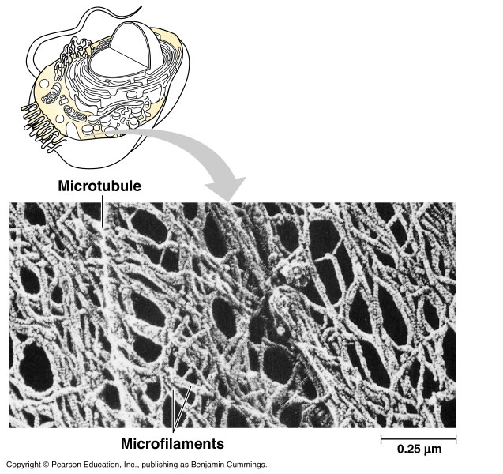

Centrioles
- Found in most animal cells and some fungi and algae
- Hollow cylinders about 0.2µm in diameter
- Wall of centrioles is made up of nine triplets of microtubules
- Occur in pairs arranged at right angle to each other, forming the centrosome
- At cell division they migrate to opposite poles of the cell and synthesise the microtubules of the spindle
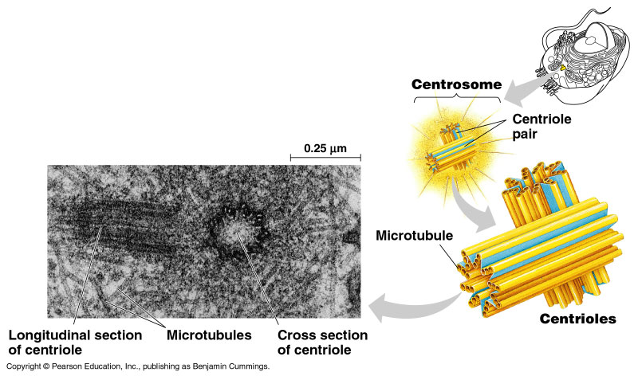

Cell wall
- Surround the living contents of cells, but themselves ore not living so not classed as organelles
- Relatively rigid structures secreted by living material and provide support and protection for the cell and its contents
- In plants they are made of cellulose, in other organisms e.g. bacteria, algae and protozoa, they are made of other materials

The cellulose cell wall
- A characteristic feature of plant cells
- Consists of cellulose microfibrils embedded in an amorphous polysaccharide matrix e.g. pectin, hemicelluloses or lignin
- Microfibrils may be regular or irregular in arrangement and have high tensile strength
- Provides support in herbaceous plants. As water enters the cell osmotically the cell wall resists expansion and an internal pressure is created which provides turgidity for the plant
- Provides direct support for the cell and the plant – strength may be increased by the presence of lignin in the matrix of the cellulose fibres
- Permits the movement of water through and along it
- In some cells the presence of cutin, suberin or lignin in the matrix makes the cell less permeable to substances
- The cell walls of neighbouring cells are held together by the middle lamella, a sticky jelly like substance containing a mixture of magnesium and calcium pectates.
- Cell walls have narrow pores through which very fine strands of cytoplasm, called plasmodesmata, pass. These provide a connection between the living contents of adjacent cells and a pathway for the movement for material from cell to cell.
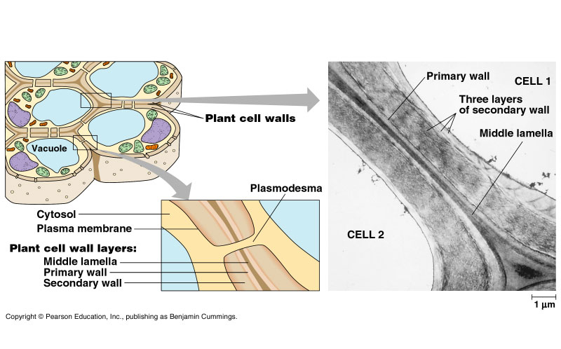

The first wall to be laid down after cell division is called the primary cell wall. Microfibrils run in all directions allowing for growth. When maximum size is reached the secondary wall is laid down in layers each at slightly different angles to each other.

PROKARYOTIC cells
- Kingdom Prokaryotae includes all bacteria
- Simple in structure and lack complex organelles and internal membranes
- Thought to have first evolved about 3,500m years ago
- Eukaryotes are thought to have evolved from prokaryotes about 1,500m years ago
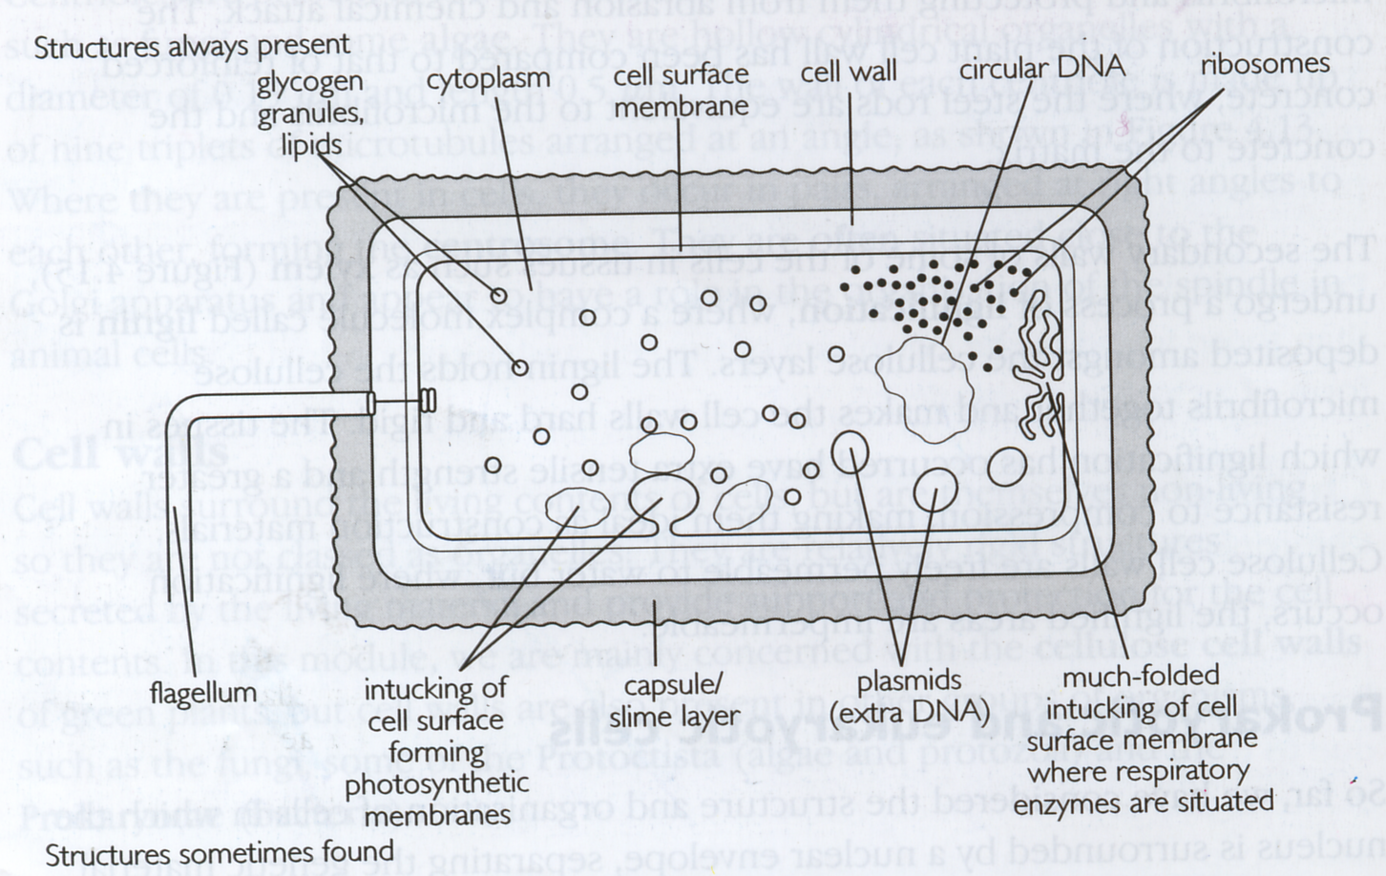

Structures always present:

Cell wall | rigid, made of a peptidoglycan called murein
Glycogen granules | Glycogen is main energy storage form
DNA | arranged as a closed loop, not associated with proteins (naked)
Ribosomes | Concerned with protein synthesis
Cell membrane | Controls what passes into and out of the cell
Cytoplasm | Site of chemical reactions

Structures sometimes present
Slime | Outside the cell wall
Plasmids | Small loops of DNA which can replicate independently of the main ‘chromosome’ (useful in genetic engineering)
Flagella | Consist of a single fibril rather than the 9 + 2 arrangement of eukaryotes. Concerned with movement.
Pili/fimbriae | Tiny filaments attached to the cell wall or capsule
Invaginations | Tucking of the cell membrane where respiratory enzymes and chlorophyll (in photosynthetic bacteria) are found

