Name: ____________________________________________________________

**DUE DATE: Thursday, May 1 **Some problems will count towards academic grade**

**Part 1: Membranes**

1. The figure represents the appearance of a plant cell in salt solutions of three different concentrations.
2. State which of the diagrams, **J** to **L**, represents a fully plasmolysed cell. [1]
3. Suggest why the vacuole in **K** is smaller than that in **L**. [1]
4. Region **S** contains salt solution. State what this indicates about the permeability of the cell wall. [1]
5. Describe how proteins are arranged in a plasma membrane and the part they play in transporting substances into and out of cells. [6]
6. An experiment was carried out in which an artificial membrane was used to form the boundary of a model of a cell. A solution of different sugars was placed inside this ‘cell’, which was then placed in a beaker containing a solution of sucrose and glucose.

The artificial membrane is:

•permeable to monosaccharides (e.g. glucose and fructose) and water; •not permeable to disaccharides (e.g. maltose and sucrose); •flexible.

The diagram at the right shows the ‘cell’, together with the concentrations of the sugars inside the ‘cell’ and in the surrounding solution. The figures represent the concentration in mol dm-3.

1. State which sugar or sugars will show a net movement **out of** the ‘cell’. [1]
2. State which sugar or sugars will show a net movement **into** the ‘cell’. [1]
3. Name the method by which these sugars cross the membrane.[1]
4. Explain why the volume of the ‘cell’ would change during the experiment. [4]
5. The artificial membrane used in this experiment does not resemble a plasma  
   (cell surface) membrane in all respects. State **one** method by which substances would be **unable** to cross the artificial membrane. [1]
6. Red blood cells of mammals respond to changes in the concentration of salts in the fluid that surrounds them. If they are placed in a solution that has a lower concentration of salts than blood plasma, they swell and may burst. This bursting is known as haemolysis.
7. Explain why red blood cells may burst when they are placed in a solution that has a lower concentration of salts than blood plasma. [3]

An experiment was carried out in which red blood cells were placed in salt solutions of different concentrations. The percentage of cells which were destroyed by haemolysis was recorded. The results are shown in the graph below.

The graph shows that the red blood cells do not all haemolyse at the same salt concentration.

1. Using the graph, state the salt concentration at which the percentage of haemolysed red blood cells is equal to those that are not haemolysed. [1]

..................................... g dm–3

1. Suggest why different red blood cells haemolyse at different salt concentrations. [1]
2. The diagram below represents the structure of the plasma (cell surface) membrane.
3. State the name given to the model of membrane structure shown in the diagram. [1]
4. State the approximate width of the membrane in a typical animal cell. [1]
5. Name the parts labelled **A** to **C**. [3]
6. Describe the structure of the molecule labelled **A**. [1]
7. Molecule **D** is a glycoprotein. This molecule consists of a protein embedded in the membrane with a branched carbohydrate chain projecting out from the surface of the cell. Outline **three** roles of glycoproteins in membranes. [3]

**Part 2: Enzymes**

1. The flow chart shows the way in which fructose is produced from starch in the food industry.

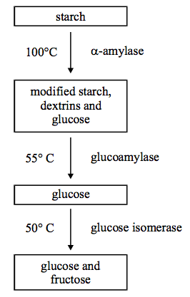

1. Describe in detail a biochemical test which could be used to show that reducing sugars were produced in the first stage of this process.[4]
2. In the laboratory, the optimal conditions for bacterial -amylase are a pH of 7 and a temperature of 80°C. In terms of your knowledge of the way in which enzymes work, explain why the rate of reaction would change if:
3. the temperature fell by 10°C; [2]
4. the pH changed substantially. [3]
5. Lactose is a disaccharide found in milk. Many adults are unable to digest lactose and suffer intestinal problems if they drink milk. Milk can be treated with the enzyme lactase and this reduces the amount of lactose present. The graph shows the change in lactose concentration during the course of the reaction.

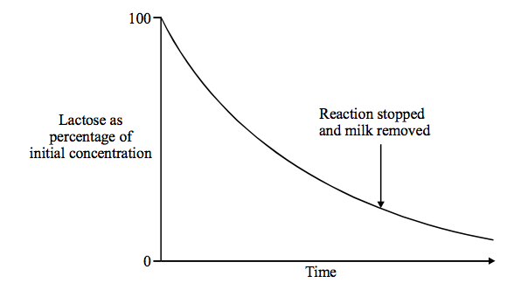

1. Explain the change in the rate of reaction with time. [2]
2. Suggest why the reaction is stopped at the time shown on the graph. [1]
3. Draw a line on the graph to show how the reaction would be affected if a competitive inhibitor were added. [2]
4. Describe how **nonncompetitive** inhibitors affect the mode of action of enzymes. [4]