MCj02788480000[1]**Name: __________________________________________________________________________________**

**Strawberry DNA Extraction Lab**

**Purpose**: To extract DNA from a strawberry plant

**Overview**: In this investigation you will break open strawberry cells, prepare a filtered extract containing strawberry DNA, and separate out molecules of DNA in a test tube.

**Background**: Strawberries are octoploid, meaning that every cell in a strawberry contains eight copies of each of its chromosomes. A strawberry has 7 chromosomes in each set for a grand total of 56 chromosomes. As a result, strawberries contain large amounts of DNA. After this lab, you will never eat a strawberry again without thinking about how much DNA is in it! Strawberry DNA is easy to extract because strawberries are easy to mash, and ripe strawberries produce enzymes that contribute to the breakdown of cell walls. These enzymes are known as cellulase and pectinase. To extract the DNA, you will first break strawberry cells apart mechanically, by crushing them. Next, you will add detergents to dissolve the cell’s plasma membranes. A filtering step then removes the cell debris. The result will be a red colored solution containing DNA and other small dissolved molecules such as sugars and proteins. When cold ethanol is layered on top of this solution, molecules of ethanol repel the DNA molecules, and the DNA clumps together. A ropelike clump of many DNA molecules forms that is large enough to see with the unaided eye.

**Pre-lab Activity, Part 1**: **Answer the following pre-lab questions in your lab notebook prior to coming to lab.**

**1.** To isolate strawberry DNA, you must separate it from other cell materials. Some of the lab steps you will use are listed in the left column below. Match the letter of each lab step with its effects on strawberry cells and enter your answers in the spaces provided.

|  |  |
| --- | --- |
| **Lab Steps** | **Effects on Strawberry Cells** |
| 1. Mash the fruit 2. Filter the strawberry extract 3. Add detergent solution 4. Layer cold ethanol over filtered extract | _______ breaks open the cells  _______ dissolves plasma membrane  _______clumps DNA  _______separates organelles and cell debris, such as fragements of cell walls and membranes, from DNA and small dissolved molecules such as proteins and sugars |

1. If a molecule of DNA is invisible even under a microscope, how will you be able to see the strawberry DNA you extract?
2. Why do you think the clump of DNA molecule has a ropelike shape?

**Pre-lab Activity, Part 2**: **Write out a short introduction/purpose in your lab notebook before coming to lab.**

**Materials:**

1 zip-lock bag, 1 strawberry, wooden coffee stirrer, graduated cylinder, ice cold ethanol, test tube rack, test tube, wooden coffee stirrer, 100 ml beaker

filtration apparatus: cheesecloth, funnel,

ice cold ethanol, 10 ml detergent solution

**Procedures:**

1. Place one strawberry in a ziplock bag. Press the air out of the bag, seal it carefully. Mash the bagged strawberry with your fist for 2 minutes. *DO NOT POUND ON THE TABLE!*
2. While one partner is mashing the strawberry, the other should obtain 10 ml of the buffer solution from one of the 4 flasks located around the room.
3. 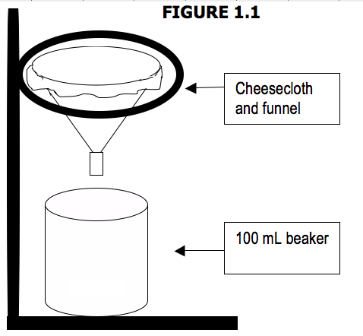Add 10 mL of the buffer solution to the bag. Press the air out carefully and seal the bag
4. Mash the strawberry for 1 minute. (*DO THIS SLOWLY TO AVOID CREATING FOAM*).
5. Make sure your filtration apparatus is set up properly (see **FIGURE 1.1**). Place test tube securely in the rack.
6. Obtain two pieces of cheese cloth and layer them on top of one another over the funnel. Press the cheese cloth into the funnel to avoid spilling when draining your strawberry/buffer mash. **CAUTION**: Handle glassware carefully to avoid breakage.
7. Pour the strawberry/buffer mash into the filtration apparatus, and let it drop directly into the 100 ml beaker (see **FIGURE 1.1**)
8. When most of the liquid has drained from the strawberry/buffer mash into the beaker, remove the funnel from the filtration apparatus and discard the cheesecloth containing strawberry pulp.
9. Pour the strawberry liquid extract into your test tube so it is approximately ¼ full.
10. 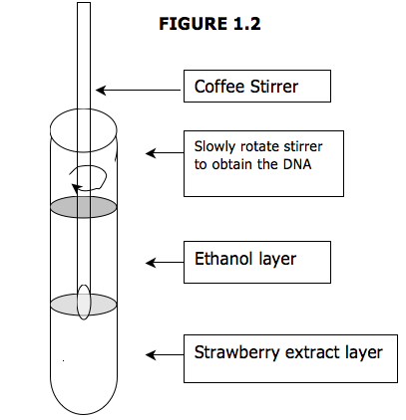Obtain 40 ml of ice cold ethanol from the ice bin using your pipette and 50 ml beaker.
11. Slowly drizzle the cold ethanol along the side of the test tube, until the test tube is about half full of liquid. The ethanol should form a separate layer on top of the filtered extract.
12. Dip the wooden coffee stirrer into the tube to where the ethanol and extract layers meet, as shown in **FIGURE 1.2**. Gently twirl the wooden coffee stirrer. Keep the tube at eye level so that you can see what is happening. Observe the characteristics of the DNA as it precipitates (clumps together).