Name: Class: Table Letter:

Background:
Mammals are vertebrates having hair on their body and mammary glands to nourish their young. The majority are placental mammals in which the developing young, or fetus, grows inside the female's uterus while attached to a membrane called the placenta. The placenta is the source of food and oxygen for the fetus, and it also serves to get rid of fetal wastes. The dissection of the fetal pig in the laboratory is important because pigs and humans have the same level of metabolism and have similar organs and systems. Also, fetal pigs are a byproduct of the pork food industry so they aren't raised for dissection purposes, and they are relatively inexpensive.

Directions Terms:
Ventral | Toward the belly | Lateral | Away from midline
Dorsal | Toward the back or spine | Anterior | Relative to forward movement
Superficial | At the surface | Posterior | Opposite of anterior
Deep | Toward the interior | Proximal | Toward center or attachment point
Medial | Toward midline or midsagittal plane | Distal | Away from center or attachment

Objectives:
- Identify important external structures of the fetal pig.
- Identify major structures associated with a fetal pig's digestive, respiratory, circulatory, urogenital, & nervous systems.
- Compare the functions of certain organs in a fetal mammal with those of an adult mammal.

Materials:
preserved fetal pig, dissecting pan, dissecting kit, dissecting pins, string, plastic bag, metric ruler, paper towels, goggles, apron, 1 pair of nitrile gloves per day,

Format:
This lab will be divided into the following lab components: A- External Anatomy, B-Incision/Oral Cavity, C- Digestive System, D- Circulatory System, E- Respiratory System, F-Urogenital System, G-Nervous System

Pre-lab:
Before observing internal or external structures of the fetal pig, use your dissection manual, textbook, and dissection notebook to answer the pre-lab questions on the fetal pig. You may have to refer to more than one dissection manual to answer all the questions so trade and share with other dissection groups.

***Wear your lab apron and eye cover at all times. Watch your time and be sure to clean up all equipment and working area each day before leaving.

DAILY CLEAN-UP INSTRUCTIONS: Clean up your materials and work area. Wrap the pig in damp paper towels and put it in a zip-lock plastic bag. Return your lab equipment and pig to the back table and then thoroughly wash your hands with soap. Wipe off your table, throw away your gloves, and clean off the surrounding area. Do not throw away any biowaste (fetal pig material).

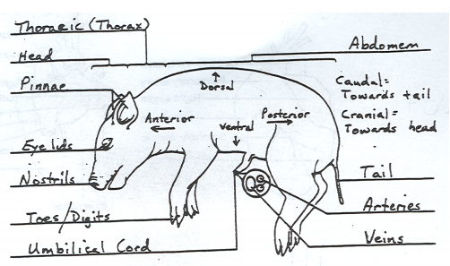
Day 1 –
PART A: External Anatomy
- Obtain a fetal pig and rinse off the excess preservative by holding it under running water. Lay the pig on its side in the dissecting pan and locate dorsal, ventral,& lateral surfaces. Also locate the anterior and posterior ends.
- A fetal pig has not been born yet, but its approximate age since conception can be estimated by measuring its length. Measure your pig's length from the tip of its snout to the base of its tail and record this on your hand-in. Use the length/age chart to determine the age of your fetal pig & record this. Refer to APPENDIX 1 on the last page of this document for help.
- Examine the pig's head. Locate the eyelids and the external ears or pinnae. Find the external nostrils.
- Study the pig's appendages and examine the pig's toes. Count and record the number of toes and the type of hoof the pig has.
- Locate the umbilical cord. With scissors, cut across the cord about 1 cm from the body. Examine the 3 openings in the umbilical cord. The largest is the umbilical vein, which carries blood from the placenta to the fetus. The two smaller openings are the umbilical arteries which carry blood from the fetus to the placenta.
- Lift the pig's tail to find the anus. Study the ventral surface of the pig and note the tiny bumps called mammary papillary. These are present in both sexes. In the female these structures connect to the mammary glands.
- Determine the sex of your pig by locating the urogenital opening through which liquid wastes and reproductive cells pass. In the male, the opening is on the ventral surface of the pig just posterior to the umbilical cord. In the female, the opening is ventral to the anus. Record the sex of your pig. Refer to APPENDIX 2 on the last page of this document for help.
- Carefully lay the pig on one side in your dissecting pan and cut away the skin from the side of the face and upper neck to expose the masseter muscle that works the jaw, lymph nodes, and salivary glands. Label these on your hand-in.
- With scissors, make a 3-cm incision in each corner of the pig's mouth. Your incision should extend posteriorly through the jaw.
- Spread the jaws open and examine the tongue.
- Observe the palate on the roof of the mouth. The anterior part of the palate is the hard palate, while the posterior part is the soft palate.
- Locate the epiglottis, a cone-shaped structure at the back of the mouth. Above the epiglottis, find the round opening of the nasopharynx. This cavity carries air from the nostrils to the trachea, a large tube in the thoracic which supplies air to the lungs.
- Dorsal to the glottis, find the opening to the esophagus. Examine the tongue and note tiny projections called sensory papillae.
- Examine the teeth of the pig. Canine teeth are longer for tearing food, while incisor are shorter and used for biting. Pigs are omnivores, eating plants and animals.
- Label the drawing of the inside of the pig's mouth on your handout.

Get Ms. Campbell’s stamp before continuing to the next part. You may do this before you’ve answered all of the questions, as long as you have recorded all essential info.
STOP:
Ms. Campbell’s Stamp Goes Here Before Continuing

PART B: The Incision
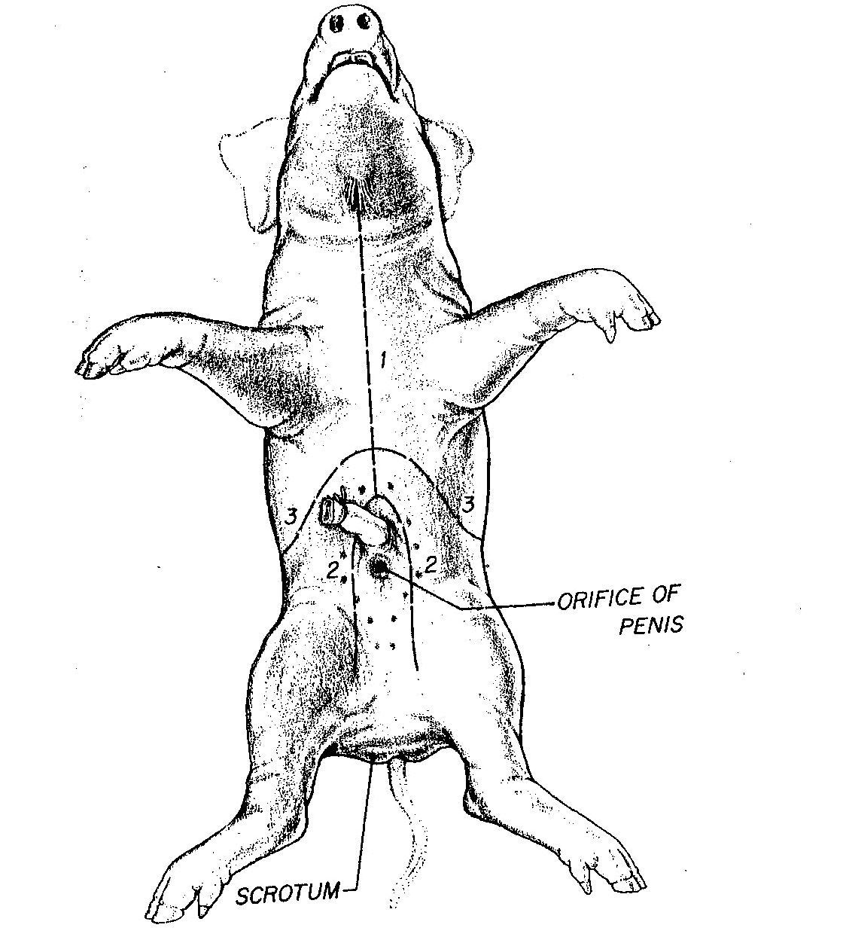
- Place the fetal pig ventral side up in the dissecting tray.
- Tie a string securely around a front limb. Run the string under the tray, pull it tight, and tie it to the other front limb. Repeat this procedure with the hind limbs to hold the legs apart so you can examine internal structures.
- Study the diagram at the right. The dashed lines numbered 1-5 show the first set of incisions that you will make. To find the exact location for the incision marked 2, press along the thorax with your fingers to find the lower edge of the ribs. This is where you will make incision 2.
- With scissors, make the incisions in order, beginning with 1. Be sure to keep the tips of your scissors pointed upward because a deep cut will destroy the organs below. Also, remember to cut away from yourself.
- After you have made your incisions through the body wall, you will see the peritoneum, a thin layer of tissue that lines the body cavity. Cut through the peritoneum along the incision lines.
- Spread the flaps of the body wall apart. Cut the umbilical vein which extends through the liver.
- Once the vein is cut, carefully pull the flap of skin, including the end of the umbilical cord between the hind legs. You are now able to see the organs of the abdominal cavity.
If time remains continue with part C, the digestive tract. Otherwise, clean up and return your materials and pig as instructed at the end of Part C.

Get Ms. Campbell’s stamp before continuing to the next part. You may do this before you’ve answered all of the questions, as long as you have recorded all essential info.
STOP:
Ms. Campbell’s Stamp Goes Here Before Continuing

Part C: Digestive System
- Locate the diaphragm, a sheet of muscle that separates the abdominal cavity from the thoracic cavity. Find the most obvious structure in the abdominal cavity, the brownish-colored liver. Count the number of lobes.
- Find the tube-like esophagus which joins the mouth and the stomach. Food moves down the esophagus by muscular contractions after being softened by saliva in the mouth. Follow the esophagus and locate the soft, sac-like stomach beneath the liver.
- With scissors, cut along the outer curve of the stomach. Open the stomach and note the texture of its inner walls. These ridges inside the stomach are called rugae and increase the area for the release of digestive enzymes. The stomach may not be empty because fetal pigs swallow amniotic fluid.
- The pig has a digestive system which is classified as monogastric or nonruminant. Humans also have this type of digestive system. They have one stomach (mono=one, gastric=stomach). Locate the entrance to the stomach or esophageal area, the cardiac region which is largest, and the pyloric region where the stomach narrows to join to the small intestine.
- At the end of the stomach, there is a sphincter, or ring-shaped muscle to control food leaving the stomach and entering the duodenum. Locate the cardiac sphincter at the junction of the stomach and esophagus, and the pyloric sphincter at the junction of the stomach and small intestine. Fetal pigs receive their nourishment from their mother through the umbilical cord.
- Identify the first part of the small intestine, the U-shaped duodenum, which connects to the lower end of the stomach. Pancreatic juice, made by the pancreas, and bile, made by the liver and stored in the gall bladder, are add to food here to continue digestion.
- Study the rest of the small intestine. Notice that it is a coiled, narrow tube, held together by tissue called mesentery. The soupy, partly digested food that enters the small intestine from the stomach is called chyme.
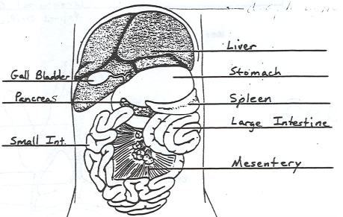
- Carefully cut through the mesentery and uncoil the small intestine. Note and record its length in centimeters. The mid-section is called the jejunum, while the last section is called the ileum.
- With scissors, remove a 3-cm piece of the lower small intestine. Cut it open and rinse it out.
- Observe the inner surface of the small intestine. Run your finger along it and note its texture. Using a magnifying glass, examine the villi, the tiny projections that line the small intestine and increase the surface area for absorption.
- Follow the small intestine until it reaches the wider, looped large intestine. Cut the mesentery and unwind the large intestine or colon. Measure and record its length.
- At the junction of the large and small intestine, locate a blind pouch called the caecum. The caecum has no known function in the pig.
- Notice that the large intestine leads into the rectum, a tube that runs posteriorly along the dorsal body wall. The rectum carries wastes to the opening called the anus where they are eliminated.
- Locate the thin, white pancreas beneath the stomach and duodenum. Pancreatic juice flows through pancreatic ducts to the duodenum.
- Between the lobes of the liver, find the small, greenish-brown gall bladder. Locate the hepatic duct which carries bile from the liver to the gall bladder.
- Find the spleen, a long, reddish-brown organ wrapped around the stomach. The spleen filters out old red blood cells and produces new ones for the fetus.
- On the diagram on the Part C hand-in, label the pig's body organs.

Refer to the clean-up directions on the first page. Your entire table must be completely cleaned up before leaving, and you must help Ms. Campbell clean-up the other areas in the classroom. Before you leave, you must get Ms. Campbell’s stamp to receive points for cleanup.
CLEAN-UP:
Ms. Campbell’s Stamp Goes Here Before Leaving the Class

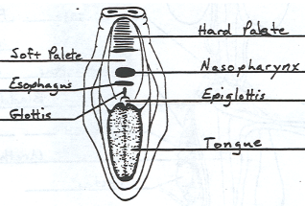
Day 2–
PART D: Respiratory System
- Be sure to wear your lab apron and eye cover.
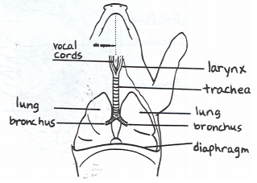
- Examine the diaphragm, a sheet of muscle that stretches across the abdominal cavity and separates it from the thoracic cavity where the lungs are located. The diaphragm isn't used by the fetal pig because gas exchange occurs through the umbilical cord. The diaphragm in adult pigs moves up and down changing air pressure in the chest cavity causing air to move into and out of the lungs.
- In order to see the upper part of the respiratory system, you will need to extend cut #1 up under the pig's throat and make to more lateral incisions in order to fold back the flaps of shin covering the throat.
- In the thoracic cavity, carefully separate the pericardium or sac surrounding the heart and the diaphragm from the body wall.
- Locate the two, spongy lungs that surround the heart. The tissue that covers and protects the lungs is called pleura. The lungs haven't been used by the fetus so they have never contained air.
- Find the trachea, a large air tube that lies anterior to the lungs. The trachea is easy to identify because of the cartilaginous rings that help keep it form collapsing as the animal inhales and exhales.
- Notice that the trachea branches into each lung. These two tubes are called bronchial tubes. Inside the lungs these branch into smaller bronchioles that end with a grape-like cluster of air sacs or alveoli where oxygen and carbon dioxide are exchanged with capillaries.
- Lying ventral to the trachea or windpipe, locate the pinkish-brown, V-shaped structure called the thyroid gland. This gland secretes hormones that control metabolism.
- At the top, anterior end of the trachea, find the hard, light-colored larynx or voice box. This organ contains the vocal cords that enable the animal to produce sound.
- Locate the epiglottis at the top of the trachea. This flap of skin closes over the trachea whenever you swallow. Find the area called the pharynx at the back of the nasal cavity. Air enters an adult pig through the mouth or nose before passing through the pharynx and down the trachea to the lungs.
- Label the diagram of the respiratory system on your part D hand-in.

Get Ms. Campbell’s stamp before continuing to the next part. You may do this before you’ve answered all of the questions, as long as you have recorded all essential info.
STOP:
Ms. Campbell’s Stamp Goes Here Before Continuing

PART E: Circulatory System
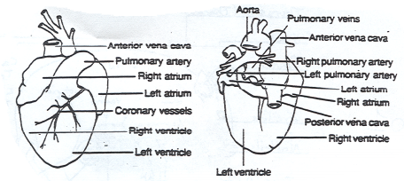
- Be sure to wear your lab apron and eye cover.
- Locate the heart. It is covered by a thin tissue called the pericardium. Remove this membrane to study the heart.
- Pigs, like all mammals, have four-chambered hearts. The right side of the heart pumps blood to the lungs, while the left side of the heart pumps blood to all other parts of the body. Locate the right and left sides of the heart.
- Each side of the heart has an upper and a lower chamber. Upper chambers are called atria and receive blood, while lower chambers are called ventricles and pump blood out of the heart. Locate the right and left atria and ventricle.
- Notice that the surface of the heart is covered with blood vessels. These are part of the coronary circulation, a set of arteries and veins whose only job is to nourish the heart tissue. Blockage in these vessels causes heart attacks.
- Anterior to the heart, locate another large vein that enters the right atrium. This vein, the anterior vena cava, brings blood to the right atrium from the anterior part of the body.
- Now lift the heart to view its dorsal surface. Observe the posterior vena cava that carries blood from the posterior part of the body and empties it into the right atrium.
- Find the pulmonary artery which leaves the right ventricle. After birth, this vessel carries blood to the lungs. However, in a fetus, a shunt called the ductus arteriosus allows fetal blood to bypass the lungs and go directly to the aorta, the largest artery of the body.
- Locate the pulmonary veins that enter the left atrium. After birth, these vessels carry oxygenated blood from the lungs to the heart.
- Identify the aorta, a large artery that transports blood from the left ventricle. Many arteries that carry blood throughout the body branch off of the
- Remove the heart by severing the blood vessels attached to it.
- Hold the dorsal and ventral surfaces of the heart with your thumb and forefinger and rest the ventricles on your dissecting tray. With a scalpel, cut the heart into dorsal and ventral halves. Caution: The scalpel is very sharp. Use it carefully and always cut away from yourself.
- Remove any material inside the heart and expose the walls of the atria and the ventricles.
- Study the internal features of these chambers and note where vessels leave or enter each chamber. Locate the valves between each atrium and ventricle. These structures prevent blood from flowing backward in the heart.
- Label the fetal pig heart diagram on your PART E hand-in.

Get Ms. Campbell’s stamp before continuing to the next part. You may do this before you’ve answered all of the questions, as long as you have recorded all essential info.
STOP:
Ms. Campbell’s Stamp Goes Here Before Continuing

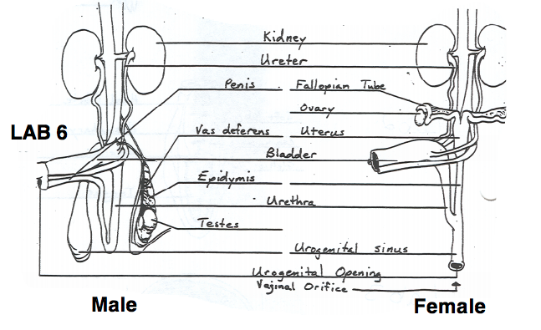
PART F: Urogenital System
- Be sure to wear your lab apron and eye cover.
- Remove the digestive organs to study the excretory and reproductive organs that make up the urogenital system.
- Locate the large, bean-shaped kidneys lying against the dorsal body wall. Notice that they are covered by the peritoneum. Kidneys filter wastes from blood.
- Find the ureters, tubes which extend from the kidneys to the bag-like urinary bladder. The urinary bladder lies between the umbilical arteries and temporarily stores liquid wastes filtered from the blood.
- Lift the urinary bladder to find the urethra, the tube which carries urine out of the body. Follow the urethra to the urogenital opening on the outside of the pig's body.
- Make sure that incision #6 extends all the way to the anus but be careful to not cut too deep and damage the internal organs.
- Follow the directions below for locating the excretory and reproductive organs in either a male or female pig. When you finish observing the organs in a pig of one sex, exchange specimens with another classmate to view the organs in a pig of the opposite sex.
Male System
- In the male pig, locate the two scrotal sacs at the posterior end of the pig. If the pig is in the later stages of development, you will find a testis in each sac. If the pig is in an early stage of development, the oval-shaped testes will be in the abdominal cavity. These testes have not yet descended into the scrotal sacs.
- On each testis, find the coiled epididymis. Sperm cells produced in the testis pass through the epididymis and into a tube called the vas deferens. This tube crosses over a ureter and enters the urethra.
- Follow the urethra to the penis, a muscular tube lying just below the skin posterior to the umbilical cord. In mammals, the penis is the organ that transfers sperm.
- Label the diagram of the male urogenital system on your day 5 hand-in.
Female System
- In the female pig, find the two bean-shaped ovaries at the posterior end of the abdominal cavity. Observe the coiled Fallopian tube attached to each ovary, which carries eggs from the ovary.
- Follow the Fallopian tube to the uterus. The uterus is dorsal to the urinary bladder and the urethra.
- Trace the uterus to a muscular tube called the vagina. The vagina will appear as a continuation of the uterus. Sperm from the male are deposited into this organ during mating. The vagina and the urethra open into a common area called the urogenital sinus. This cavity opens to the outside at the urogenital opening.
- Label the diagram of the female urogenital system on your Part F hand-in.

Refer to the clean-up directions on the first page. Your entire table must be completely cleaned up before leaving, and you must help Ms. Campbell clean-up the other areas in the classroom. Before you leave, you must get Ms. Campbell’s stamp to receive points for cleanup.
CLEAN-UP:
Ms. Campbell’s Stamp Goes Here Before Leaving the Class

Day 3–
PART G: Nervous System
- Be sure to wear your lab apron and eye cover.
- With the pig dorsal side down, open both thoracic and abdominal flaps and locate the spinal column.
- Select a site along the spine and remove any organs blocking your view of the spine. Using a scalpel, expose the spine and locate any emerging nerves. Trace one as far as you can into the body.
- Place the pig dorsal side up in your dissecting tray. In the thoracic region, remove the skin and muscle to expose 10mm of the vertebral column.
- Using forceps to grip the spine and scissors to cut, open the vertebral canal by cutting off the vertebral arch. Note the dura mater or outermost covering of the brain & spinal cord.
- Make a second cut on the other side of this vertebrae, and fold the spine section upward so you can view the cross-section. Locate the white and gray matter, dorsal and ventral root, central canal, and a dorsal root ganglion.
- With the dorsal side of the pig up, remove the skin from the entire skull.
- Cut through the skull near the center being careful not to break the meninges or membranes covering and protecting the brain.
- After the skull is open, chip away the pieces but do not use the scalpel blade for chipping.
- When the brain is completely exposed, locate the 2 large hemispheres called the cerebrum. Fissures indenting the surface of the cerebrum are called sulci (sulcus, singular). Gyri (gyrus, singular) are ridges projecting outward from the surface.
- Locate the longitudinal fissure or indention that runs laterally between the right and left cerebral hemispheres. The olfactory lobes that control smell are at the front of the cerebrum. The cerebrum controls thinking, senses, etc.
- Posterior to the cerebrum is the cerebellum. Locate the cerebellum and the transverse fissure that separates it from the cerebrum. The cerebellum consists of 2 lateral hemispheres and is involved with the control of muscles and coordination.
- Find the fissure between the right and left cerebellum hemispheres called the vermis.
- Carefully remove the brain from the skull in order to locate the hind section of the brain known as the medulla oblongata. The medulla connects the brain to the spinal cord and controls all vital functions of the body such as heart beat and breathing.
- Label the diagrams of the brain and spinal cord on your Part G hand-in.
Refer to the clean-up directions on the first page. Your entire table must be completely cleaned up before leaving, and you must help Ms. Campbell clean-up the other areas in the classroom. Before you leave, you must get Ms. Campbell’s stamp to receive points for cleanup.
CLEAN-UP:
Ms. Campbell’s Stamp Goes Here Before Leaving the Class

APPENDIX 1: DETERMINING THE SEX OF YOUR SPECIMEN
Males are identified by the presence of a urogenital opening or preputial orifice just posterior to the umbilical cord as shown in the left panel below. Depending on the age of the pig it may be possible to see or feel the penis as it passes towards this opening. Males also possess a pair of scrotal swellings at the posterior end that can help in identification.
In contrast to males, the urogenital opening in females is immediately ventral to or below the tail and anus. This opening is also marked by a fleshy tubercle called the genital papilla as shown in the right panel below. The presence (or absence) of a genital papilla is probably the most straight-forward way for you to determine the sex of your specimen.
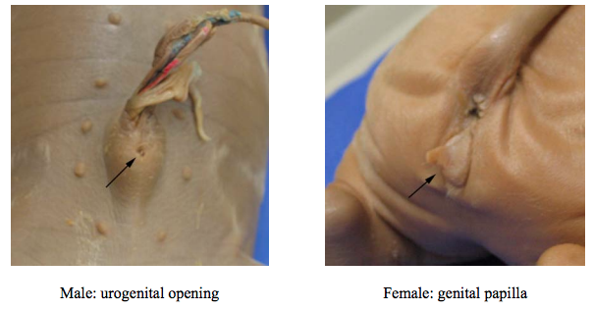

APPENDIX 2: AGE OF FETUS
The period of gestation for the pig is 112-115 days. The age of the fetus can be estimated by measuring the body length from the tip of the snout to the attachment of the tail on the pig’s dorsal side. Compare this length to the data given on relative sizes of a fetal pig at different times during gestation or the time of development inside the uterus. (mm = millimeters)
21 days : 11 mm
35 days : 17 mm
49 days : 28 mm
56 days : 40 mm
100 days: 220 mm
115 days: 300 mm

