Element | Reaction with water
Potassium | Violently
Sodium | Very quickly
Lithium | Quickly
Calcium | More slowly
Name: __________________________________________________________
This revision covers: 1) Reactivity series, 2) Oxidation/reduction reactions, 3) Electrolysis, 4) Acid-Base reactions
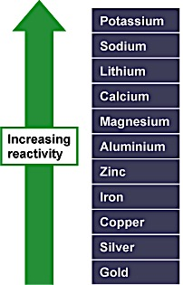
Reactivity series
The reactivity series allows us to predict how metals will react. A more reactive metal will displace a less reactive metal from a compound. Rusting is an oxidation reaction.
The reactivity series
In a reactivity series, the most reactive element is placed at the top and the least reactive element at the bottom. More reactive metals have a greater tendency to lose electrons and form positive ions.
Element | Reaction with dilute acids
Calcium | Very quickly
Magnesium | Quickly
Zinc | More slowly
Iron | More slowly than zinc
Copper | Very slowly
Silver | Barely reacts
Gold | Does not react
A reactivity series of metals could include any elements. See the example at right. Observations of the way that these elements react with water, acids and steam enable us to put them into this series.
The tables at right show how the elements react with water and dilute acids

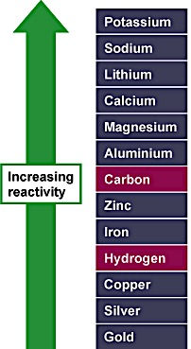
Non-metals in the reactivity series
It is useful to place carbon and hydrogen into the reactivity series because these elements can be used to extract metals. At left is the reactivity series including carbon and hydrogen.
Note that zinc and iron can be displaced from their oxides using carbon but not using hydrogen. However, copper can be extracted using carbon or hydrogen.

Displacement reactions of metal oxides
A more reactive metal will displace a less reactive metal from a compound. The thermite reaction is a good example of this. It is used to produce white hot molten (liquid) iron in remote locations for welding. A lot of heat is needed to start the reaction, but then it releases an incredible amount of heat, enough to melt the iron.
Aluminum + iron(III) oxide → iron + aluminum oxide
2Al + Fe₂O₃ → 2Fe + Al₂O₃
Because aluminum is more reactive than iron, it displaces iron from iron(III) oxide. The aluminum removes oxygen from the iron(III) oxide:
- iron is reduced
- aluminum is oxidized
In general, the greater the difference in reactivity between two metals in a displacement reaction, the greater the amount of energy released.
Aluminum is much higher than iron in the reactivity series, so the thermite reaction releases a lot of energy. Magnesium is very high in the reactivity series, and copper is very low - so the reaction between magnesium and copper oxide is more violent.

EXAMPLE 1: Reactions between metals and metal oxides allow us to put a selection of metals into a reactivity series. Using metals A, B and C:
 | Metal A | Metal B | Metal C
A oxide | X | Displaces A | Displaces A
B oxide | No reaction | X | No reaction
C oxide | No reaction | Displaces C | X
Metal A cannot displace either B or C - so it must be the least reactive and be at the bottom of this reactivity series.
Metal B displaces both A and C - so it must be the most reactive and be at the top of this reactivity series.
Metal C displaces A but cannot displace B - so it must be more reactive than A but less reactive than B, and be in between them in this reactivity series. Therefore, the order is as shown at right.

Displacement reactions of solutions
A more reactive metal will displace a less reactive metal from a solution of one of its salts. For example:
magnesium + copper(II) sulfate → copper + magnesium sulfate
Mg(s) + CuSO₄(aq) → Cu(s) + MgSO₄(aq)
In this reaction, the blue color of the copper(II) sulfate fades as it is used up (magnesium sulfate solution is colorless). We would also see copper metal forming.
EXAMPLE 2: Reactions between metals and solutions of metal salts allow us to put a selection of metals into a reactivity series. Using metals J, K and L, view the table below (left).
Metal J displaces both K and L - so it must be the most reactive and be at the top of this reactivity series.
 | Metal J | Metal K | Metal L
J sulfate | X | No reaction | No reaction
K sulfate | Displaces K | X | Displaces K
L sulfate | Displaces L | No reaction | X
Metal K cannot displace either J or L - so it must be the least reactive and be at the bottom of this reactivity series.
Metal L displaces K but cannot displace J - so it must be more reactive than K but less reactive than J, and be in between them in this reactivity series. Therefore, the order is:
Oxidation and reduction
Oxidation is the loss of electrons from a substance. It is also the gain of oxygen by a substance. For example, magnesium is oxidized when it reacts with oxygen to form magnesium oxide:
magnesium + oxygen → magnesium oxide
2Mg + O₂ → 2MgO
Reduction is the gain of electrons by a substance. It is also the loss of oxygen from a substance. For example, copper(II) oxide can be reduced to form copper when it reacts with hydrogen:
copper(II) oxide + hydrogen → copper + water
CuO + H₂ → Cu + H₂O
Usually, oxidation and reduction take place at the same time in a reaction. We call this type of reaction a redox reaction.
Note that:
- the oxidizing agent is the chemical that causes oxidation
- the reducing agent causes the other chemical to be reduced
Take a look at the following thermite reaction: Aluminum + iron(III) oxide → iron + aluminum oxide
It is easy to see that the aluminum has been oxidized. This means that the iron oxide is the oxidizing agent. We can also see that the iron oxide has been reduced. This means that the aluminum is the reducing agent.
Rusting
Rusting is an oxidation reaction. The iron reacts with water and oxygen to form hydrated iron(III) oxide, which we see as rust. Here is the word equation for the reaction:
iron + water + oxygen → hydrated iron(III) oxide
Iron and steel rust when they come into contact with water and oxygen. Both water and oxygen are needed for rusting to occur. In the experiment below, the nail does not rust when air (containing oxygen) or water is not present:
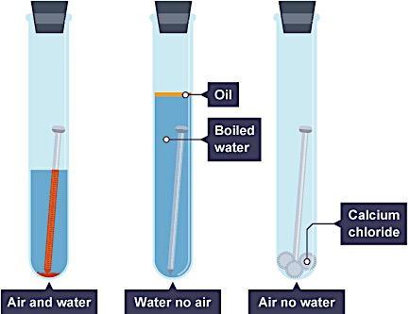
Calcium chloride absorbs water in the right-hand test tube
Salt dissolved in water does not cause rusting - but it does speed it up, as does acid rain.
Aluminum does not rust (corrode) because its surface is protected by a natural layer of aluminum oxide. This prevents the metal below from coming into contact with air (containing oxygen).
Unlike rust, which can flake off the surface of iron and steel objects, the layer of aluminum oxide does not flake off.

Metal and non-metal oxides
Many metals and non-metals react with oxygen in the air when they are heated to produce metal oxides and non-metal oxides.
The table shows three of these reactions in detail.
Element | Type | Reaction type | Oxide | Nature
Magnesium | Metal | Highly exothermic - magnesium burns with bright white flame | Magnesium oxide, MgO - solid white powder | Basic
Carbon | Non-metal | Exothermic - carbon glows orange when heated strongly | Carbon dioxide, CO₂ - colorless gas with no odor | Acidic
Sulfur | Non-metal | Burns slowly with a blue flame | Sulfur dioxide, SO₂ - colorless gas with choking smell | Acidic

Electrolysis
Passing an electric current through ionic compounds when they are molten or in aqueous solution causes them to break down into simpler substances. During this process – which is called electrolysis - negative ions are discharged at the positive electrode (anode) and positive ions are discharged at the negative electrode (cathode). The amount of product is directly proportional to the current flowing and the time taken.

Electrolysis
Electrolysis is the decomposition (breaking down) of a liquid by passing an electric current through it.
Electrolysis needs:
- an electrolyte – the liquid that the electric current flows through
- a negative electrode (the cathode)
- a positive electrode (the anode)
- a dc (direct current) power supply
During electrolysis, ions in the electrolyte move to the electrodes and are discharged there.

Name | Formula
Hydrogen | H⁺
Ammonium | NH₄⁺
Sodium | Na⁺
Copper(II) | Cu²⁺

Cations Anions
Anions are negatively charged ions. They are attracted to the anode (positive electrode). You should be able to recognize anions from their chemical formulae, which all have a – sign.
The table shows some examples.
Cations are positively charged ions. They are attracted to the cathode (negative electrode). You should be able to recognize cations from their chemical formulae, which all have a + sign.
The table shows some examples.

Name | Formula
Chloride | Cl⁻
Oxide | O²⁻
Hydroxide | OH⁻
Sulfate | SO₄²⁻

Electrolysis of sodium hydroxide and sulfuric acid
Electrolysis of aqueous solutions (where an ionic substance is dissolved in water) can easily be carried out in a school laboratory. You will need:
- a beaker or similar container for the electrolyte [electrolyte: A substance which in solution will conduct an electric current.]
- two graphite rods or copper strips for the electrodes [electrode: A conductor used to establish electrical contact with a circuit. The electrode attached to the negative terminal of a battery is called a negative electrode, or cathode. The electrode attached to the positive terminal of a battery is the positive electrode, or anode.]
- a power pack or battery, with leads to connect the terminals to the electrodes
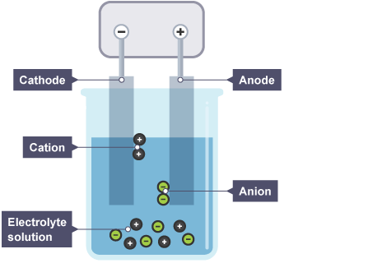
Apparatus needed for electrolysis of aqueous solutions

Sodium hydroxide and sulfuric acid
When sodium hydroxide solution or sulfuric acid is electrolyzed, two gases are produced:
- hydrogen at the cathode
- oxygen at the anode
- These gases can be collected in test tubes placed over the electrodes. Simple chemical tests show which is which:
- hydrogen burns with a ‘pop’ when lit using a splint
- oxygen makes a glowing splint relight

Half-equations [E]
Sodium hydroxide solution and sulfuric acid both contain hydrogen ions, H⁺, and hydroxide ions, OH–. The following half equations describe what happens at the two electrodes.
At the cathode: 2H⁺ + 2e⁻ → H₂
At the anode: 4OH⁻ - 4e⁻ → O₂ + 2H₂O
You might have expected sodium to be produced at the cathode during the electrolysis of sodium hydroxide solution. However, sodium is more reactive than hydrogen, so hydrogen is given off instead.

Electrolysis of copper(II) sulfate
Copper(II) sulfate solution can be electrolyzed [ using carbon electrodes. During electrolysis:
- the cathode gets coated with copper
- bubbles of oxygen are given off at the anode
Copper(II) sulfate solution is blue because of the copper(II) ions it contains. As these ions are discharged as copper atoms at the cathode, the blue color of the solution gradually fades.

Half equations [E]
The following half equations describe what happens at the two electrodes.
At the cathode: Cu²⁺ + 2e⁻ → Cu
At the anode: 4OH⁻ - 4e⁻ → O₂ + 2H₂O

Electrolysis of molten compounds
The ions in the electrolyte must be free to move to theelectrodes for electrolysis to work. They are free to move in aqueous solutions and in molten liquids. However, the ions are in fixed positions in solid ionic compounds - they cannot move around, so electrolysis does not work in solids.
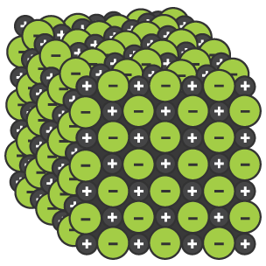
Ions in ionic solids are arranged in a giant lattice and cannot move around
When a molten (melted) ionic compound is electrolyzed:
- the positive ions are discharged at the cathode
- the negative ions are discharged at the anode
- For example, during the electrolysis of molten lead bromide:
- lead ions, Pb²⁺, move to the cathode and are discharged as lead
- bromide ions, Br–, move to the anode and are discharged as bromine

Half equations [E]
Molten mead bromide contains Pb²⁺ ions and Br– ions. The half equations for the electrode processes:
At the cathode: Pb²⁺ + 2e⁻ → Pb
At the anode: 2Br⁻ - 2e⁻ → Br₂
Acids and bases
Bases are substances that can react with acids and neutralize them. Alkalis are bases that are soluble in water. The pH scale measures how acidic or alkaline a substance is. Substances with a pH lower than 7 are acidic, those with a pH of 7 are neutral and those with a pH greater than 7 are alkaline.
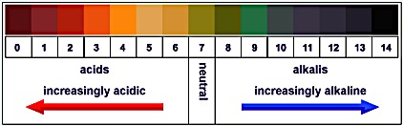
The pH scale
The chemical properties of many solutions enable them to be divided into three categories - acids, alkalis and neutral solutions. The strength of the acidity or alkalinity is expressed by the pH scale.
- solutions with a pH less than 7 are acidic
- solutions with a pH of 7 are neutral
- solutions with a pH greater than 7 are alkaline.
If universal indicator is added to a solution it changes to a color that shows the pH of the solution.

Bases and acids
Bases are substances that can react with acids and neutralize them. Bases such as metal oxides and metal hydroxides react with acids to form neutral products.
Examples of bases include: copper(II) oxide, and zinc hydroxide.
An alkali is a soluble base, a base that can dissolve in water. For example, copper(II) oxide is a base because it can neutralize acids but, because it does not dissolve in water, it is not an alkali.
Examples of alkalis include: sodium hydroxide, and potassium hydroxide.
All alkalis are bases.
Neutralization
When an alkali is added to an acid the pH of the mixture rises. This is because the alkali reacts with the acid to form neutral products. The reverse situation also happens too: when an acid is added to an alkali the pH of the mixture falls. This is because the acid reacts with the alkali to form neutral products.
A reaction in which acidity or alkalinity is removed is called neutralization. A neutralization involving an acid and a base (or alkali) always produces salt and water.
acid + base → salt + water
Hydrogen ions and pH
In all solution, all acids contain hydrogen ions, H⁺. The greater the concentration of these hydrogen ions, the lower the pH.
Naming salts
The name of the salt produced in a neutralization reaction can be predicted. The first part of the name is ‘ammonium’ if the base used is ammonia. Otherwise, it is the name of the metal in the base. The second part of the name comes from the acid used:
- chloride, if hydrochloric acid is used
- nitrate, if nitric acid is used
- sulfate, if sulfuric acid is used
- phosphate, if phosphoric acid is used.
The table shows some examples.
acid | + | base | → | salt + water
hydrochloric acid | + | copper oxide | → | copper chloride + water
sulfuric acid | + | sodium hydroxide | → | sodium sulfate + water
nitric acid | + | calcium hydroxide | → | calcium nitrate + water
phosphoric acid | + | iron(III) oxide | → | iron(III) phosphate + water
Carbonates and acids
Carbonates also neutralize acids. As well as a salt and water, carbon dioxide is also produced. The name of the salt can be predicted in just the same way.
For example: hydrochloric acid + potassium carbonate → potassium chloride + water + carbon dioxide

References:
http://www.bbc.co.uk/schools/gcsebitesize/science/aqa/limestone/calciumcarbonaterev1.shtml
http://www.bbc.co.uk/schools/gcsebitesize/science/aqa/fundamentals/chemicalreactionsrev1.shtml
http://www.bbc.co.uk/schools/gcsebitesize/science/ocr_gateway/chemical_resources/acids_basesrev_print.shtml
http://www.bbc.co.uk/education/guides/zjwnb9q/revision/6
http://www.bbc.co.uk/education/guides/z8ktyrd/revision/3
http://www.bbc.co.uk/education/guides/zqjsgk7/revision/6

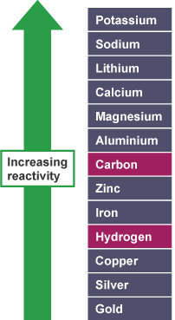
Review Questions: Multiple-Choice
Use the reactivity series, shown at right, to answer questions 1-3
- Which is the most reactive of these three metals?

- Lithium
- Copper
- Zinc

- Which metal can be displaced from its ores by heating with carbon? [E]

- Calcium
- Iron
- Platinum

- Which of these displacement reactions will produce the most energy? [E]

- Iron oxide and aluminum
- Magnesium and copper oxide
- Magnesium and silver nitrate

- What has been reduced in this reaction: iron oxide + carbon → iron + carbon monoxide?

- Iron oxide
- Carbon
- Carbon monoxide

- What is oxidized in this reaction: lead oxide + carbon → lead + carbon monoxide?

- Lead oxide
- Carbon
- Lead

- Which three substances are essential for rusting to take place?

- Iron, salt and water
- Iron, oxygen, water
- Steel, oxygen, acid

- Why does aluminum not corrode as quickly as steel and iron?

- It is not very reactive
- It is always painted
- It has a protective layer of aluminum oxide

- What is produced from the electrolysis of sea water? [E]

- Hydrogen and oxygen
- Chlorine and hydrogen
- Chlorine, hydrogen and sodium hydroxide

- What type of substances undergo electrolysis?

- Ionic
- Covalent
- Metallic

- Which electrode do the negative ions move to?

- Positive
- Negative
- They stay in solution

- What name is given to a positive charged particle?

- Anion
- Cation
- Atom

- Why does solid lead bromide not conduct electricity? [E]

- It has no ions in it
- There are no covalent electrons that are able to move
- The ions are fixed in place and cannot move

- If electricity is passed through molten lead bromide, what happens?

- It splits into lead and bromine
- It catches on fire
- Nothing

- Which of the following describes the products formed at the negative electrode (cathode)?

- Metals or hydrogen
- Metals or oxygen
- Halogens or oxygen

- Which of the following describes the products formed at the negative electrode (cathode)?

- Metals or hydrogen
- Metals or oxygen
- Halogens or oxygen

- If electricity is passed through molten zinc chloride, what happens? [E]
- Zinc is formed at the cathode and chlorine at the anode
- Zinc is formed at the anode and chlorine at the cathode
- Hydrogen is formed at the cathode and oxygen is formed at the anode

- In the electrolysis of zinc chloride, which is the correct half equation for the negative electrode (cathode)? [E]

- 2Br⁻ → Br₂ + 2e⁻
- Zn²⁺ + 2e⁻ → Zn
- Zn → Zn²⁺ + 2e⁻

- What is produced when aqueous copper chloride is electrolyzed?

- Copper at the cathode and chlorine at the anode
- Hydrogen at the cathode and chlorine at the anode
- Copper at the cathode and oxygen at the anode

- Which of the options could be used as an electrolyte when purifying copper?

- Copper sulfate
- Lead nitrate
- Distilled water
- Which half equation shows what happens at the negative electrode when purifying copper by electrolysis? [E]

- Cu²⁺ + 2e⁻ →Cu
- Cu²⁺ → Cu + 2e⁻
- Cu → Cu²⁺ + 2e⁻

- Which pH would show a strong acid?

- 1
- 14
- 5

- What are the products from a metal carbonate + acid reaction?

- Salt and water
- Salt, water and carbon dioxide
- Salt and carbon dioxide

- Zinc oxide + sulfuric acid ?

- zinc sulfate + water
- zinc sulfide + water
- zinc sulfuric acid

- What color does litmus solution turn in an alkali?

- Red
- Green
- Blue

- Which of these might have a pH of 9?

- Ethanoic acid
- Sulfuric acid
- Calcium hydroxide

- Universal indicator is added to a colorless solution and turns dark blue. What does this tell you?

- It is an acid
- It is neutral
- It is an alkali

- Which ion is present in all acid solutions?

- Hydrogen ion, H⁺
- Hydroxide ion, OH⁻
- Hydride ion, H⁻

- What name is given to a base that dissolves in water?

- Amphoteric
- An alkali
- A salt

- Which ionic equation takes place in an acid-alkali neutralization reaction? [E]

- H⁺ + OH⁻ → H₂O
- HCl → H⁺ + Cl⁻
- NH₃ + H₂O → NH₄⁺ + OH⁻

- When an alkali neutralizes an acid, what is made?

- water
- salt and water
- salt only

- Which of these is the most likely pH of a weak alkali?

- 8
- 14
- 6

- All of the following produce water and a salt when reacted with acid. Which of the following also produces another substance?

- A base
- A carbonate
- An alkali

- What is the name of the salt produced when nitric acid is neutralized by copper carbonate? [E]

- Nitrogen carbonate
- Copper chloride
- Copper nitrate

- A sample of acid rain in a beaker has a pH of 4. Alkali is dripped in. What happens to the pH of the liquid in the beaker?

- It goes down
- It stays the same
- It goes up

- The balanced symbol equation for the reaction between sulfuric acid and potassium hydroxide solution is: [E]

- H₂SO₄ + KOH → KSO₄ + H₂O
- H₂SO₄ + 2KOH → K₂SO₄ + H₂O
- H₂SO₄ + 2KOH → K₂SO₄ + 2H₂O

- Which of these combinations of reactants would produce potassium nitrate? [E]
- Sodium hydroxide and sulfuric acid
- Potassium carbonate and hydrochloric acid
- Potassium hydroxide + nitric acid

- Which of the following is a correctly balanced equation for the oxidation of copper? [E]
- Cu + O₂ → CuO
- Cu + O₂ → 2CuO
- 2Cu + O₂ → 2CuO

Review Questions: Short-Response
- A student had access to the following substances. Which of these substances would be a good choice for the student as an electrolyte? Why?
Substance | Type of Bonding | Solubility in Water
Silver chloride (AgCl) | Ionic | Insoluble
Dextrose (C₆H₁₂O₆) | Covalent | Soluble
Potassium carbonate (K₂CO₃) | Ionic | Soluble
Lauric acid [CH₃(CH₂)₁₀COOH] | Covalent | Insoluble

- The figure below shows a process in which a copper chloride is split into elements.
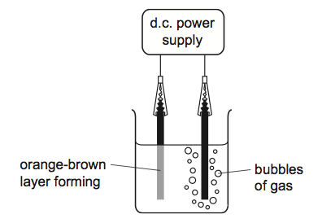
  - Name the process shown in the figure.

  - Label the cathode and the anode.

  - Describe and explain, in terms of ions, electrons and atoms, what happens to cause an orange-brown layer to build up on the surface of electrode on the left.

  - Name a gas that is contained in the bubbles rising from the surface of electrode on the right.

  - Write the half-equations for the reaction at each electrode. [E]
Substance | Product at negative  electrode | Product at positive  electrode
Molten lead  bromide | lead | A
Molten B | magnesium | chlorine
Aqueous sodium  sulfate solution | C | oxygen
Aqueous copper  sulfate solution | D | E

- The table shows the results of passing electricity through some substances. Carbon electrodes were used.
- Name A, B, C, D and E.

- What is the name used for substances that conduct electricity and are decomposed by it?

- Why must the substances be molten or in solution?

(d) Explain why reduction takes place at the negative electrode. [E]

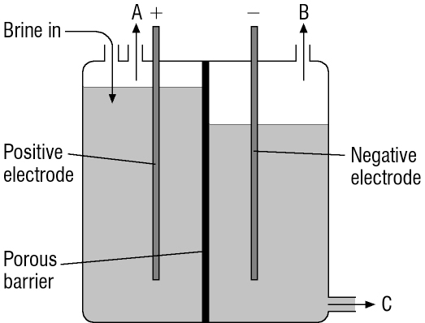
- The diagram shows a cell used for the electrolysis of brine. Brine is a solution of sodium chloride in water. [E]
(a) Name and give the formulae of the positive ions in brine.

(b) Name and give the formulae of the negative ions in brine.

(c) Name gases A and B. [E]

(d) Explain as fully as you can how gas B is produced. [E]

(e) Name the product in solution C. [E]

- Review the following, choosing the correct word from each pair in brackets by circling it.
Acids are compounds that dissolve in water giving hydrogen ions. Sulfuric acid is an example. It can be neutralized by (acids/bases) to form salts called (nitrates / sulfates). Many (metals/non-metals) react with acids to give (hydrogen/carbon dioxide). Acids react with (chlorides/carbonates) to give (hydrogen/carbon dioxide). Since they contain ions, solutions of acids are (good/poor) conductors of electricity. They also affect indicators. Litmus turns (red/blue) in acids while universal indicator turns (red/green/blue). The level of acidity of an acid is shown by its (concentration/pH number). The (higher/lower) the number, the more acidic the solution.

- A and B are white powders. A is insoluble in water, but B dissolves. Its solution has a pH of 3. A mixture of A and B bubbles or effervesces in water, giving off a gas. A clear solution forms.
a Which of the two powders is an acid?

b The other powder is a carbonate. Which gas bubbles off in the reaction?

c Although A is insoluble in water, a clear solution forms when the mixture of A and B is added to water. Suggest why. [E]

- Oxygen reacts with other elements to form oxides. Three examples are: calcium oxide, phosphorus pentoxide, and copper(II) oxide.
a Which of these is:

- i an insoluble base?
- ii a soluble base?
- iii an acidic oxide?

b When the soluble base is dissolved in water, the solution changes the color of litmus paper. What color change will you see?

c i Write a word equation for the reaction between the insoluble base and sulfuric acid.

ii What is this type of reaction called?

d Name another acidic oxide.

- Complete the following equations to show what happens when metals are heated with oxides of other metals.
a) magnesium + copper oxide
b) lead + tin oxide
c) [Extended] Fe₂O₃(s) + 3Zn(s)
- State which element is oxidized and which is reduced in the reactions that were shown above.
a) magnesium + copper oxide Oxidized: Reduced: .
b) lead + tin oxide Oxidized: Reduced: .
c) [Extended] Fe₂O₃(s) + 3Zn(s) Oxidized: Reduced: .

- When iron oxide is heated with aluminum powder, the following reaction takes place:
Aluminum + iron oxide → iron + aluminum oxide
When aluminum oxide is heated with iron no reaction takes place.
- Which of the two metals is more reactive? [E]

- The formula for iron oxide is Fe₂O₃. The formula for aluminum oxide is Al₂O₃. Write a balanced symbol equation to show the reaction between aluminum and iron oxide. [E]

c) Window frames made from aluminum do not corrode as quickly as windows made form iron. Explain this statement using the information above.

- The table below is about the preparation of salts. [E]
Method of preparation | Reactants | Salt formed | Other products
a acid + alkali | calcium hydroxide and nitric acid | calcium nitrate | water
b acid + metal | zinc and hydrochloric acid | .................................. | .................................
c acid + alkali | ................. and potassium hydroxide | potassium sulfate | water only
d acid + carbonate | .............................. and ......................... | sodium chloride | water and ..............
e acid + metal | .............................. and ......................... | iron(II) sulfate | .................................
f acid + ................... | nitric acid and sodium hydroxide | ................................... | .................................
g acid + insoluble base | .............................. and copper(II) oxide | copper(II) sulfate | .................................
h acid + .................. | .............................. and ............................. | copper(II) sulfate | carbon dioxide and ...............
- Fill in the missing details for rows a-d. Here is a word bank:
Zinc chloride, hydrogen, sulfuric acid, hydrochloric acid, sodium carbonate, carbon dioxide
- Fill in the missing details for rows e-h. [E]
- Write a word equation for the reaction between calcium hydroxide and nitric acid (row a)

- Write balanced equations for THREE of the eight reactions. [E]

