Name: __________________________________________________________

Writing Formulae and Equations
When elements react, their atoms join with other atoms to form compounds. Chemical bonds form when this happens, which involves atoms transferring or sharing electrons.
During a chemical reaction, reactants are changed into products. Chemical symbols and formulae are used to represent substances in symbol equations. Molecular formulas show the number of each type of atom in a molecule, while displayed formulas show the atoms and bonds in a molecule.

Reactions and compounds
New substances are formed by chemical reactions. When elements react together to form compounds their atoms join to other atoms using chemical bonds. For example, iron and sulfur react together to form a compound called iron sulfide. Compounds usually have different properties from the elements they contain.

Chemical formulas
The chemical formula of a compound shows how many of each type of atom join together to make the units which make up the compound. For example, in iron sulfide every iron atom is joined to one sulfur atom, so we show its formula as FeS.
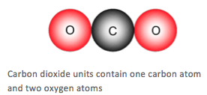
In sodium oxide, there are two sodium atoms for every oxygen atom, so we show its formula as Na₂O. The small 2 after an element tells you there are two atoms of that particular element in each molecule. For example, the water molecule H₂O has two hydrogen atoms. Notice that the 2 is written as a sub script, so Na2O or H2Owould be wrong. Notice that you do not write a number 1 if there is only one atom of an element in a molecule.
This diagram at right shows that one carbon atom and two oxygen atoms combine to make up the units of carbon dioxide. Its chemical formula is written as CO₂.
Brackets
Some formulas have brackets in them. For example, sodium hydroxide is NaOH, but magnesium hydroxide is Mg(OH)₂. The 2 outside the brackets tells you that you have two of each atom inside the bracket. So in Mg(OH)₂ you have one magnesium atom, two oxygen atoms and two hydrogen atoms.

For example, consider more complex formulae such as Na₂SO₄ and Fe(OH)₃:
- a unit of Na₂SO₄ contains two sodium atoms, one sulfur atom and four oxygen atoms joined together
- a unit of Fe(OH)₃ contains one iron atom, three oxygen atoms and three hydrogen atoms - the brackets show that the 3 applies to O and H

Writing equations
You should be able to write word equations for the reactions you study. If you are taking the Extended exam, you should also be able to write and balance symbol equations.
Chemical equations show what happens in a reaction. In general, we write:
reactants → products
The reactants are the substances that react together. The products are the substances produced in the reaction. Individual substances are separated by a plus sign.

Word equations
A word equation gives the names of the substances involved in a reaction. For example:
copper + oxygen → copper(II) oxide
Copper and oxygen are the reactants because they are on the left of the arrow. Copper oxide is the product because it is on the right of the arrow.

Balanced equations (see below for more steps on how to balance equations)
Balanced equations give the symbols and formulas of the substances involved in a reaction. If we just replace the words shown above by the correct chemical formulas, we will get an unbalanced equation, as shown here:
Cu + O₂ → CuO
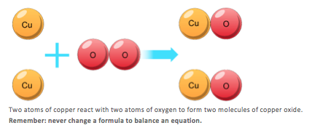
Notice that there are unequal numbers of each type of atom on the left-hand side compared with the right-hand side. To make things equal, you need to adjust the number of units of some of the substances until you get equal numbers of each type of atom on both sides.
To make things equal, we need to adjust the number of units of some of the substances until we get equal numbers of each type of atom on both sides of the arrow.
Here is the balanced symbol equation:
2Cu + O₂ → 2CuO
You can see that we now have two copper atoms and two oxygen atoms on each side. This matches what happens in the reaction.

Here are some other examples of balanced equations. Check that you understand why they are balanced.
- Mg + Cl₂ → MgCl₂
- 2Na + Cl₂ → 2NaCl
- 4Fe + 3O₂ → 2Fe₂O₃
- 4Na + O₂ → 2Na₂O
- 2Na + 2H₂O → 2NaOH + H_{2.}

Formulas and equations
You should recall certain chemical formulas. You should also be able to write balanced symbol equations if you are given the formulas of the reactants and products.

Specified formulas

Formulas of substances
name | formula | name | formula
oxygen | O₂ | calcium carbonate | CaCO₃
carbon monoxide | CO | hydrochloric acid | HCl
carbon dioxide | CO₂ | sodium chloride | NaCl
water | H₂O | potassium chloride | KCl
calcium oxide | CaO | nitrogen | N₂
ammonia | NH₃

Balancing equations [E]
Example 1: write the balanced equation for the reaction between hydrogen and oxygen to produce water.

Step 1
Write the formulae for each substance:
H₂ + O₂ → H₂O

Step 2
Check for an unbalanced element, for example, O. Adjust the number of each atom or molecule needed, but never change a formula. We need two O atoms on each side:
H₂ + O₂ → 2H₂O

Step 3
Check for another unbalanced element. In this example, there are 2 H atoms on the left and 2 × 2 = 4 atoms on the right. So we need to double the number of hydrogen molecules:
2H₂ + O₂ → 2H₂O
Example 2: Write the balanced equation for the reaction between calcium and water to produce calcium hydroxide and hydrogen.
Step 1
Write the formulae for each substance:
Ca + H₂O → Ca(OH)₂ + H₂
Step 2
Check for one unbalanced element, for example, O. Adjust the number of each atom or molecule needed, but never change a formula. We need two Os on each side:
Ca + 2H₂O → Ca(OH)₂ + H₂
Step 3
Check for another unbalanced element. In this example, the equation is now balanced.

State symbols [E]
Sometimes it is useful to know whether the reactants and products in a chemical reaction are solids, gases, liquids or dissolved in water. We can add state symbols to a symbol equation to show this.
State symbol and meaning
Symbol | Meaning
(s) | Solid
(l) | Liquid
(g) | Gas
(aq) | Aqueous (dissolved in water)
For example, for the reaction between sodium and water, this is the symbol equation with state symbols:
2Na(s) + 2H₂O(l) → 2NaOH(aq) + H₂(g)

Conservation of mass [E]
No atoms are lost or made during a chemical reaction. This means that the mass is always conserved. In other words, the total mass of products after the reaction is the same as the total mass of the reactants at the start.
This fact allows you to work out the mass of one substance in a reaction if the masses of the other substances are known. For example:
Carbon reacts with oxygen to form carbon dioxide: C + O₂ → CO₂
12 g of carbon will react to form 44 g of carbon dioxide. It must react with 44 – 12 = 32 g of oxygen to do this.

Chemical calculations [E]
In chemistry, it is important to know how much of a chemical is used and produced in a reaction. The amount of reactants used and products. made can be calculated using relative atomic masses and relative formula masses. The total mass of the reactants is equal to the total mass of the products made.

Relative atomic mass
Different atoms have different masses. Atoms have such a small mass. Mass is measured in 'kg'. it is more convenient to know their masses compared to each other. Carbon is taken as the standard atom and has a relative atomic mass (A_{r}) of 12.
Atoms with an A_{r} of less than this have a smaller mass than a carbon atom. Atoms with an A_{r} which is more than this have a larger mass than a carbon atom.
The table below shows some A_{r} values (you do not need to remember them: you will be given them in the exam if you need them to answer a question)
Element | A_{r}
H | 1
C | 12
O | 16
Mg | 24
Cl | 35.5

A_{r} values of elements
These values tell you that magnesium atoms are twice as heavy as carbon atoms, and 24 times heavier than hydrogen atoms; while hydrogen atoms are 12 times lighter than carbon atoms. They also allow you to work out that three oxygen atoms weigh the same as two magnesium atoms.
Chlorine's A_{r} of 35.5 is an average of the masses of the different isotopes of chlorine.

Relative formula mass [E]
For your exam, you will need to know what relative formula mass is - and be able to work out the relative formula mass of a compound when given its formula.
To find the relative formula mass (M_{r}) of a compound, you just add together the A_{r} values for all the atoms in its formula.

Examples
- Example 1: Find the M_{r} of carbon monoxide (CO).
- The A_{r} of carbon is 12 and the A_{r} of oxygen is 16.
- So the M_{r} of carbon monoxide is 12 + 16 = 28.
- Example 2: Find the M_{r} of sodium oxide (Na₂O).
- The A_{r} of sodium is 23 and the A_{r} of oxygen is 16.
- So the M_{r} of sodium oxide is (23 x 2) + 16 = 62.
The relative formula mass of a substance, shown in grams, is called one mole of that substance. So one mole of carbon monoxide has a mass of 28 g, and one mole of sodium oxide has a mass of 62 g.
The table shows some more examples of relative formula mass calculations, using the relative atomic mass values given at the bottom of the page.

Relative formula mass calculations
Compound | Formula | Calculation | M_{r}
Water | H₂O | 1 + 1 + 16 = | 18
Sodium hydroxide | NaOH | 23 + 16 + 1 = | 40
Magnesium hydroxide | Mg(OH)₂ | 24 + 16 + 16 + 1 + 1 = (remember that there are two of each atom inside the brackets) | 58
A_{r} of H = 1 A_{r} of O = 16 A_{r} of Na = 23 A_{r} of Mg = 24

Reacting masses [E]
In all chemical reactions, the total mass of reactants used is equal to the total mass of the products made:
reactants → products
The arrow shows that the reactants become the products. The greater the amount of reactants used, the greater the amount of products produced. For any one reaction, the ratio of reactant to product does not change. So if the ratio of mass of reactants to mass of products is known, the mass produced by any mass of reactant can be calculated:

How to calculate reactant mass [E]
We can use masses in a reaction to help us calculate the amount of reactant and product.
Moles = Mass/ Molar Mass
- Write out the equation for the reaction. Make sure it is balanced.
- Work out the relative masses of the substances needed in the calculation. Remember to multiply by the number of molecules that are present.
- Convert the relative masses into the units in the question.
- Find the ratio by dividing both numbers by the smallest relative mass.
- Find the mass of the unknown by multiplying the mass of the known by the ratio of the unknown.
Question: For example: What mass of carbon dioxide is formed when 12 g of carbon is burned in air?
Answer
- Write out the equation for the reaction. Make sure it is balanced.
C + O₂ -> CO₂ (Carbon is the known, carbon dioxide is the unknown)
- Work out the relative masses of the substances needed in the calculation.
Mass of carbon = 12, mass of carbon dioxide = 44
- Convert the relative masses into the units in the question.
Mass of carbon = 12 g, mass of carbon dioxide is 44 g
- Find the ratio by dividing both numbers by the smallest number.
For carbon 12 ÷ 12 = 1, for carbon dioxide 44 ÷ 12 = 3.67
- Find the mass of the unknown by multiplying the mass of the known by the ratio of the unknown.
3.67 × 12 = 44 g

Moles and Gas [E]
Moles= Volume /24.0
One mole of any gas has a volume of 24.0 dm³ at room temperature and pressure (rtp). Thus,

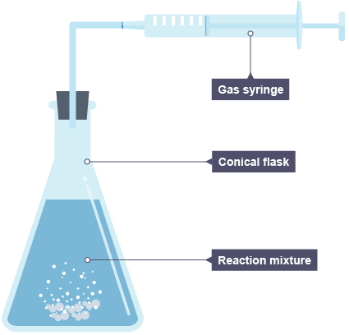
Rates of Reaction
Measuring rates of reaction
The rate of reaction can be found by measuring the amount of product formed in a certain period of time. The mass of a solid product is often measured in grams, while the volume of a gaseous product is often measured in cm³.
The time period chosen may depend upon the rate of the reaction. For example, it may be a few seconds for a fast reaction or a few minutes for a slow reaction.
The units for rate of reaction are commonly written as:
- g/s or g/min
- cm³/s or cm³/min
Measuring the rate where a gas is produced
Time / min | Volume of gas produced / cm³
0 | 0
1 | 34
2 | 42
3 | 48
4 | 50
5 | 50
The apparatus needed depends on the nature of the product being measured:
- the mass of a substance - solid, liquid or gas - is measured with a balance
- the volume of a gas is usually measured with a gas syringe (or sometimes with an upside-down measuring cylinder)—see picture at right
Comparing rates
In a typical rates experiment, the mass or volume of product is measured at regular time intervals. The results are usually recorded in a suitable table. (e.g. the table at right)
Minute (min) | Volume of gas(cm³) | Rate of reaction (cm³/min)
First (0 to 1) | 34 – 0 = 34 | 34 ÷ 1 = 34
Second (1 to 2) | 42 – 34 = 8 | 8 ÷ 1 = 8
Third (2 to 3) | 48 – 42 = 6 | 6 ÷ 1 = 6
Forth (3 to 4) | 50 – 48 = 2 | 2 ÷ 1 = 2
Fifth (4 to 5) | 50 – 50 = 0 | 0 ÷ 1 = 0
The results recorded here show that the reaction had finished by 4 minutes, as no more gas was produced after that.
The mean rate of reaction = 50 ÷ 4 = 12.5 cm³/min
However, the rate decreased during the reaction. The table shows how this happened:
Graphs
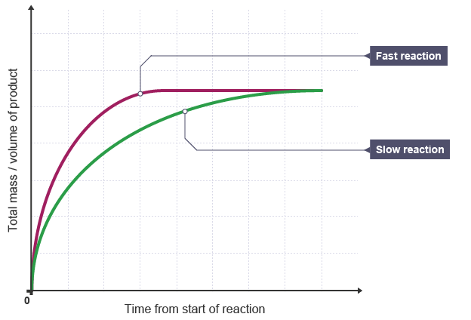
The rate of reaction can be analyzed by plotting a graph of amount of product against time. The graph at the right shows this for two reactions.
Compared to the slow reaction, the graph line for the faster reaction:
- has a steeper gradient at the start
- becomes horizontal sooner (showing that the rate of reaction is greater)
Collision theory [E]
For a chemical reaction to occur, the reactant particles must collide with each other.
However, a collision with too little energy will not produce a reaction. The colliding particles must have enough energy for the collision to be successful or effective in producing a reaction.
The minimum amount of energy for a collision to be successful is called the activation energy.
The rate of a reaction depends on the rate of successful collisions between reactant particles. The more successful collisions there are, the faster the rate of reaction.
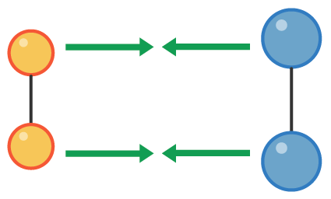  1) Two pairs of particles move towards each other | 2) The pairs collide and reform so that each member of the original pair joins with a member of the other pair, forming two new pairs | 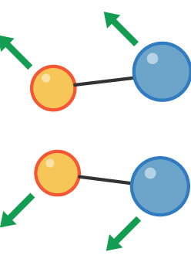  3) The new pairs are now moving away from each other

Factors Affecting Rates of reaction
Effect of temperature
The rate of a chemical reaction can be changed by altering the temperature. If the temperature is increased:
- the reactant particles move more quickly
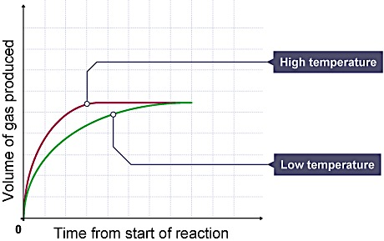
- they have more energy
- the particles collide more often, and more of the collisions are successful
- the rate of reaction increases
Compared to a reaction at a low temperature, the graph line for the same reaction but at a higher temperature:
- has a steeper gradient at the start
- becomes horizontal sooner
This shows that the rate of reaction was greater at the higher temperature.

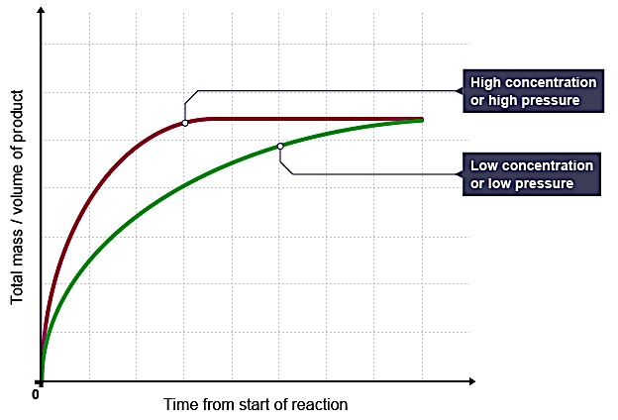
Effect of concentration and pressure
The rate of a chemical reaction can be changed by altering the concentration of a reactant in solution, or the pressure of a gaseous reactant. If the concentration or pressure is increased:
- the reactant particles become more crowded
- there is a greater chance of the particles colliding
- the rate of reaction increases
Compared to a reaction with a reactant at a low concentration (if a solution) or a low pressure (if a gas), the graph line for the same reaction but at a higher concentration or pressure:
- has a steeper gradient at the start
- becomes horizontal sooner
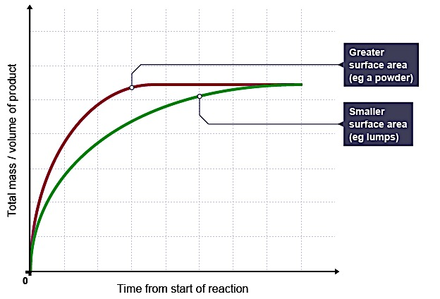
This shows that the rate of reaction was greater at the higher concentration or pressure.

Effect of surface area
The rate of a chemical reaction can be raised by increasing the surface area of a solid reactant. This is done by cutting the substance into small pieces, or by grinding it into a powder. If the surface area of a reactant is increased:
- more particles are exposed to the other reactant
- there are more collisions
- the rate of reaction increases
Compared to a reaction with lumps of reactant, the graph line for the same reaction but with powdered reactant:
- has a steeper gradient at the start
- becomes horizontal sooner
This shows that the rate of reaction is greater when the surface area is increased.

Explosions
An explosion is a very fast reaction that releases a large volume of gaseous products. There is a danger of explosion in factories that handle powdered, flammable substances. These substances include custard powder, flour and powdered sulfur.

Effect of catalysts
This table summarizes some common catalysts used in industry and the reactions they catalyze:
Catalyst | Reaction catalyzed
Iron | Making ammonia from nitrogen and hydrogen
Platinum | Making nitric acid from ammonia
Vanadium(V) oxide | Making sulfuric acid
The rate of a reaction can be increased by adding a suitable catalyst. A catalyst is a substance which changes the rate of reaction but is unchanged at the end of the reaction.
Only a very small amount of catalyst is needed to increase the rate of reaction between large amounts of reactants.
A catalyst is specific to a particular reaction:
- different catalysts catalyze different reactions
- not all reactions have suitable catalysts

Energy changes
Breaking and making bonds
During a chemical reaction bonds in the reactants are broken and new bonds are made in the products
- Energy is absorbed to break bonds. Bond-breaking is an endothermic process.
- Energy is released when new bonds form. Bond-making is an exothermic process.
Whether a reaction is endothermic or exothermic depends on the difference between the energy needed to break bonds and the energy released when new bonds form.
- If more heat energy is released when making the bonds than was taken in, the reaction is exothermic
- If more heat energy was taken in when making the bonds than was released, the reaction is endothermic

Energy diagrams [E]
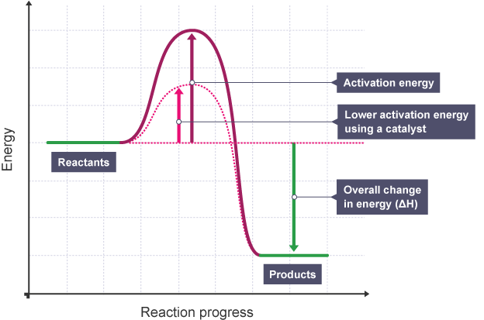
Energy diagrams show the level of energy of the reactants and of the products. The bigger the difference between the energy of the reactants and the energy of the products, the more energy is given out or taken in. It is easy to see from an energy level diagram whether the reaction is exothermic or endothermic:
- in exothermic reactions the reactants are higher than the products. The graph at right shows this
- in endothermic reactions the reactants are lower than the products
Activation energy [E]
- Activation energy is the minimum energy needed for a reaction to occur when two particles collide. It can be represented on an energy level diagram.
- The diagram at the right shows that when a catalyst is used, the activation energy is reduced. This makes more of the collisions successful at a given temperature. So a catalyst provides an alternative reaction pathway with lower activation energy.
References:
http://www.bbc.co.uk/schools/gcsebitesize/science/aqa/limestone/calciumcarbonaterev1.shtml
http://www.bbc.co.uk/schools/gcsebitesize/science/aqa/fundamentals/chemicalreactionsrev1.shtml
http://www.bbc.co.uk/schools/gcsebitesize/science/add_edexcel/quantitative/calculationsrev1.shtml
http://www.bbc.co.uk/schools/gcsebitesize/science/ocr_gateway/chemical_concepts/fundamentalrev7.shtml
http://www.bbc.co.uk/education/guides/zwdp34j/revision
http://www.bbc.co.uk/education/guides/z4cmn39/revision

Review Questions: Multiple-Choice
- Which of these options is a way of speeding up a chemical reaction?

- Adding a catalyst
- Lowering the temperature
- Decreasing the pressure

- When looking at a graph showing the volume of gas given off in a reaction (y axis) against the time (x axis), what does a steeper initial line mean?

- Slower reaction
- Faster reaction
- The reaction is exothermic

- When you increase the concentration of a dissolved reactant (eg an acid), how can you describe the acid particles in solution?

- They move faster
- They have more energy
- They are closer together

- Which of the following has the largest surface area and would react fastest?

- Powder
- Small lumps
- Large chunks

- Which of the following is a true statement about catalysts?

- They are usually able to catalyze many types of reactions
- They give the particles more energy
- They are not used up in a reaction and remain unchanged

- Why do powders react faster than lumps? [E]

- Collisions between reactant particles are more frequent
- Particles of a powder move faster
- Particles of a powder have a lower bond energy

- Magnesium hydroxide contains two oxygen atoms and two hydrogen atoms per magnesium atom. Its formula is:

- Mg₂O₂H
- MgOH₂
- Mg(OH)₂

- The formula of sodium sulfate is Na₂SO₄. How many elements does it contain?

- Two
- Three
- Seven

- Which of the following is a correctly balanced equation? [E]

- Cu + O₂ → CuO
- Cu + O₂ → 2CuO
- 2Cu + O₂ → 2CuO

- The balanced equation for the reaction between sodium and water, producing sodium hydroxide and hydrogen, is: [E]

- Na + H₂O → NaOH + H₂
- Na + 2H₂O → NaOH + H₂
- 2Na + 2H₂O → 2NaOH + H₂

- What term is used to describe the starting chemicals in a reaction?

- Reactants
- Products
- Catalysts

- In reactions, as shown by energy change diagrams, if the products have more energy than the reactants, what does this tell you?

- It is a combustion reaction
- It is an exothermic reaction
- It is an endothermic reaction

- If one energy level diagram shows a much larger fall from the reactants to the products when compared with another energy level diagram, what would this tell you? [E]

- More energy is released
- It is less exothermic
- It is an endothermic reaction

- What is the first step in a chemical reaction?

- Bonds are made

- Bonds are broken
- Atoms rearrange themselves to form the products

- If more heat energy is released in a reaction than is absorbed, what can be said about the reaction overall?

- It is endothermic
- It is exothermic
- It will never happen

- What catalyst is used in the manufacture of sulfuric acid via the Contact Process? [E]

- Nickel
- Vanadium(V) oxide
- Rhodium

- 12 g of magnesium produces 20 g of magnesium oxide when it reacts with oxygen: 2Mg + O₂ → 2MgO. Which statement is correct?

- 32g of oxygen will react with the magnesium
- 16g of oxygen will react with the magnesium
- 8g of oxygen will react with the magnesium

- If 24 g of magnesium reacts with 16 g of oxygen to produce 40 g of magnesium oxide, what mass of magnesium would you need to start with to produce 10 g of magnesium oxide (refer to the equation above)? [E]

- 6 g of magnesium
- 12 g of magnesium
- 4 g of magnesium

- What is the relative formula mass of calcium carbonate, CaCO₃? [E]

- 50
- 100
- 68

- The relative formula mass of CaO is 56 and the relative formula mass of CO₂ is 44. Work out the mass of CaO that can be obtained from 200 g of CaCO₃. CaCO₃ → CaO + CO₂. [E]

- 56 g
- 224 g
- 112 g

- What mass of CO₂ will be produced when 50 g of CaCO₃ decomposes (refer to the equation above)? [E]

- 22 g
- 44 g
- 11 g

Review Questions: Short-Response
- Write the word equation for the formation of the water from hydrogen and oxygen.

  - Write the balanced symbol equation. [E]
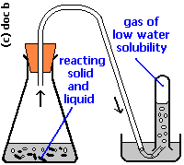

Reaction test tube

Gas collection test tube

- Balance the following chemical equations [E]
- ______Fe + ______H₂O ______Fe₃O₄ + ______ H₂
- ______CS₂ +______ O₂ ______CO₂ + ______SO₂
- ______C₅H₁₂ + ______O₂ ______CO₂ + ______H₂O
- ______Al + ______Cl₂ ______AlCl₃
- A student carried out a reaction between Calcium carbonate and Hydrochloric acid in the apparatus above.
- The products are calcium chloride, carbon dioxide and water. Write the word equation for the reaction.

- Write the balanced chemical equation. [E]

- The mass of the contents of the flask decreases over time. Explain why this is true.

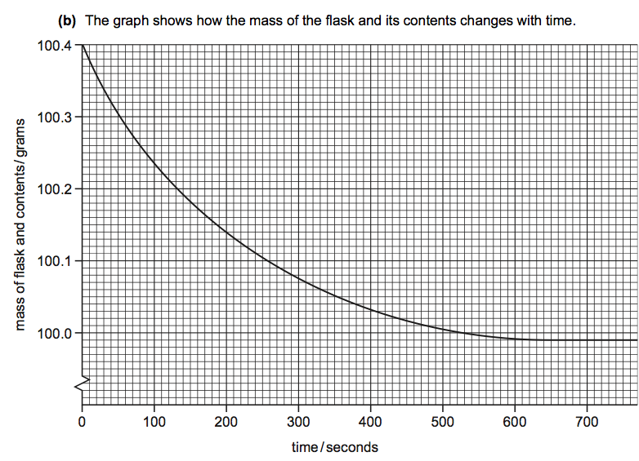
- The graph below shows how the mass of the reaction changes over time.
    - At what time was the reaction complete? Justify your answer.

    - At what time was the reaction rate highest? Justify your answer.

- Hydrogen peroxide decomposes at room temperature to give oxygen and water: Hydrogen peroxide → oxygen + water
- Describe how you could measure the rate of the reaction. Which piece of apparatus could be used to measure the rate of this reaction?

- Give three ways in which the rate of reaction could be increased.

- Manganese (IV) oxide is a catalyst. What effect would adding manganese (IV) oxide have on the rate of this reaction?

- Hydrogen peroxide is H₂O₂. Write the balanced symbol equation for this decomposition reaction of hydrogen peroxide. [E]

- What is the M_{r} of hydrogen peroxide? [E]

- What volume of oxygen would be produced from 68 g of hydrogen peroxide? Show your work. [E]

- When iron oxide is heated with aluminum, the following reaction takes place: Aluminum + iron oxide → iron + aluminum oxide
When aluminum oxide is heated with iron no reaction takes place.
- Iron (III) oxide contains 3 oxygen atoms for every two iron atoms. Write the formula for iron (II) oxide.

- Aluminum and oxide have the following charges: Al³⁺ and O²⁻. Write the formula of aluminum oxide.

- Write a balanced symbol equation to show the reaction between aluminum and iron oxide. [E]

- What is the A_{r} of aluminum? [E]

- What is the M_{r} of iron oxide? [E]

- What mass of iron oxide would react with 54 g of aluminum? Show your work. [E]

