Name: __________________________________________________________________

Ionic bonding
Ions are electrically charged particles formed when atoms lose or gain electrons. Ions have the same electronic structures as noble gases.
Metal atoms form positive ions, while non-metal atoms form negative ions. The strong electrostatic forces of attraction between oppositely charged ions are called ionic bonds.

Ions
How ions form
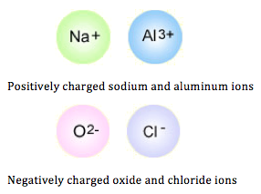
Ions are electrically charged particles formed when atoms lose or gain electrons. This loss or gain leaves a complete highest energy level, so the electronic structure of an ion is the same as that of a noble gas - such as a helium, neon or argon.
Metal atoms and non-metal atoms go in opposite directions when they ionize:
- Metal atoms lose the electron, or electrons, in their highest energy level and become positively charged ions
- Non-metal atoms gain an electron, or electrons, from another atom to become negatively charged ions

How many charges?
There is a quick way to work out what the charge on an ion should be:
- The number of charges on an ion formed by a metal is equal to the group number of the metal
- The number of charges on an ion formed by a non-metal is equal to the group number minus eight
- Hydrogen forms H⁺ ions.

 | Group 1 | Group 2 | Group 3 | Group 4 | Group 5 | Group 6 | Group 7 | Group 0
Example element | Na | Mg | Al | C | N | O | Cl | He
Charge | 1+ | 2+ | 3+ | Note 1 | 3- | 2- | 1- | Note 2
Symbol of ion | Na⁺ | Mg²⁺ | Al³⁺ | Note 1 | N³⁻ | O²⁻ | Cl⁻ | Note 2
Note 1: carbon and silicon in Group 4 usually form covalent bonds by sharing electrons.
Note 2: the elements in Group 0 do not react with other elements to form ions.

Representing positive ions
You need to be able to show the electronic structure of some common metal ions, using diagrams like these:
Lithium, Li
Lithium is in Group 1. It has one electron in its highest energy level. When this electron is lost, a lithium ion Li⁺ is formed.

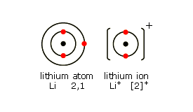

Sodium, Na
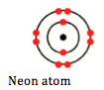
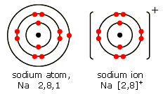
Sodium is also in Group 1. It has one electron in its highest energy level. When this electron is lost, a sodium ion Na⁺ is formed.
Note that a sodium ion has the same electronic structure as a neon atom (Ne).

But be careful - a sodium ion is not a neon atom. This is because the nucleus of a sodium ion is the nucleus of a sodium atom and has 11 protons - but the nucleus of a neon atom has only 10.
Magnesium, Mg
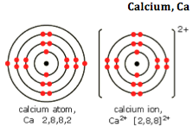
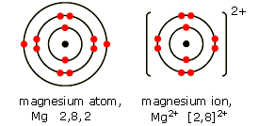
Magnesium is in Group 2. It has two electrons in its highest energy level. When these electrons are lost, a magnesium ion Mg²⁺ is formed.
A magnesium ion has the same electronic structure as a neon atom (Ne).

Calcium is also in Group 2. It has two electrons in its highest energy level. When these electrons are lost, a calcium ion Ca²⁺is formed. A calcium ion has the same electronic structure as an argon atom (Ar).

Representing negative ions
You need to be able to show the electronic structure of some common non-metal ions, using diagrams like these:
Note that a fluoride ion has the same electronic structure as a neon atom (Ne). Once again, a fluoride ion is not a neon atom, because the nucleus of a fluoride ion is the nucleus of a fluorine atom, with 9 protons, and not of a neon atom, with 10.
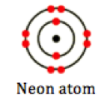

Fluorine, F
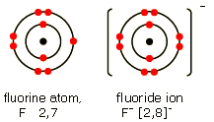
Fluorine is in Group 7. It has seven electrons in its highest energy level. It gains an electron from another atom in reactions, forming a fluoride ion, F⁻.

Note that the atom is called fluorine, but the ion is called fluoride.

Chlorine, Cl
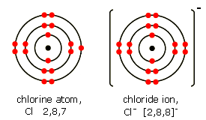
Chlorine is in Group 7. It has seven electrons in its highest energy level. It gains an electron from another atom in reactions, forming a chloride ion, Cl⁻.

Oxygen, O
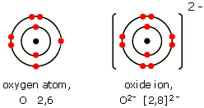
Oxygen is in Group 6. It has six electrons in its highest energy level. It gains two electrons from one or two other atoms in reactions, forming an oxide ion, O²⁻.

Ionic bonding
When metals react with non-metals, electrons are transferred from the metal atoms to the non-metal atoms, forming ions. The resulting compound is called an ionic compound
ionic compound: An ionic compound occurs when a negative ion (an atom that has gained an electron) joins with a positive ion (an atom that has lost an electron): The ions swap electrons to achieve a full outer shell.

Consider reactions between metals and non-metals, for example:
- sodium + chlorine → sodium chloride
- magnesium + oxygen → magnesium oxide
- calcium + chlorine → calcium chloride
In each of these reactions, the metal atoms give electrons to the non-metal atoms. The metal atoms become positive ions and the non-metal atoms become negative ions.
There is a strong electrostatic force of attraction between these oppositely charged ions, called an ionic bond. The animation shows ionic bonds being formed in sodium chloride, magnesium oxide and calcium chloride.
Ionic compounds
Group 1 and Group 7
The elements in Group 1 of the Periodic Table are called the alkali metals. They form ionic compounds when they react with non-metals. Their ions have a single positive charge. For example, sodium forms sodium ions, Na+.

The elements in Group 7 of the Periodic Table are called the halogens. They form ionic compounds when they react with metals. Their ions have a single negative charge. For example, chlorine forms chloride ions, Cl–.

Structure of Ionic Compounds [E]
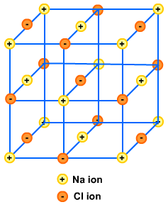
Ionic solids are made up of a lattice composed of oppositely charged ions. The regular arrangement alternates positive and negatively charged ions. One of the most common ionic solids is sodium chloride. It contains oppositely charged ions held together by strong electrostatic forces of attraction – the ionic bonds. The ions form a regular lattice in which the ionic bonds act in all directions.

Properties of ionic compounds [E]
- High melting points and boiling points due to strong ionic bonds. Most are solids at room temp.
- They are brittle - will shatter with a hammer.
- Usually soluble in water. Insoluble in non-polar solvents.
- Do not conduct electricity in solid state. They do conduct when molten or dissolved in water since the ions are free to carry the charges as the ionic bonds do not hold them firmly in the liquid state.

Dot-and-cross diagrams
You need to be able to draw dot-and-cross diagrams to show the ions in some common ionic compounds.
Sodium chloride, NaCl
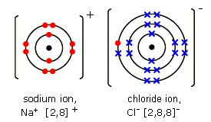
Sodium ions have the formula Na⁺, while chloride ions have the formula Cl⁻.
Magnesium oxide, MgO
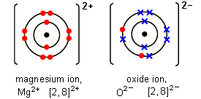
Magnesium ions have the formula Mg²⁺, while oxide ions have the formula O²⁻. You need to show one magnesium ion and one oxide ion.

Calcium chloride, CaCl₂
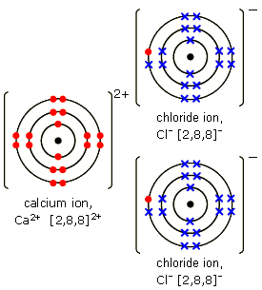
Calcium ions have the formula Ca²⁺. Chloride ions have the formula Cl⁻.
You need to show two chloride ions, because two chloride ions are needed to balance the charge on a calcium ion.
Formulae of ionic compounds [E]
Ionic compounds are represented by formulae. A formula is a combination of symbols that indicates the chemical composition of a substance. Symbols and numbers show the atoms in the compound.
For example: ZnCO₃ is the formula for zinc carbonate.
One zinc atom (Zn) and one carbon atom (C) are chemically bonded with three oxygen atoms (O₃). Notice that we don't need to write a 1 next to the Zn or C.

Brackets in formulae [E]
Sometimes brackets are used.
For example: Fe(OH)₃ is the formula for iron(III) hydroxide.
Iron(III) hydroxide consists of one iron atom joined with three oxygen and three hydrogen atoms. The formula is written like this because the oxygen and hydrogen atom often act together.

Constructing formulae [E]
The formula of a compound can be worked out if the ions in it are known. For example, the compound formed from Na⁺ and SO₄²⁻ will consist of two Na⁺ ions to every one SO₄²⁻ ion so that the compound is neutral overall. The formula is therefore Na₂SO₄.
Here are the formulae of some common ions.

Positive ions (cations)
Name | Formula | Name | Formula | Name | Formula | Name | Formula | Name | Formula
ammonium | NH₄⁺ | magnesium | Mg²⁺ | zinc | Zn²⁺ | iron(II) | Fe²⁺ | potassium | K⁺
hydrogen | H⁺ | calcium | Ca²⁺ | lead | Pb²⁺ | iron(III) | Fe³⁺ | copper(II) | Cu²⁺
lithium | Li⁺ | barium | Ba²⁺ | aluminum | Al³⁺ | silver | Ag⁺ | sodium | Na⁺

Negative ions (anions)
Name | Formula | Name | Formula | Name | Formula | Name | Formula | Name | Formula
fluoride | F⁻ | oxide | O²⁻ | carbonate | CO₃⁻ | sulfide | S²⁻ | hydrogen carbonate | HCO₃⁻
chloride | Cl⁻ | bromide | Br⁻ | nitrate | NO₃⁻ | sulfate | SO₄²⁻ | hydroxide | OH⁻

Covalent bonding
A covalent bond is a strong bond between two non-metal atoms. It consists of a shared pair of electrons. A covalent bond can be represented by a straight line or dot-and-cross diagram.
Hydrogen and chlorine can each form one covalent bond, oxygen two bonds, nitrogen three, while carbon can form four bonds.

A shared pair of electrons
A covalent bond forms when two non-metal atoms share a pair of electrons . The electrons involved are in the highest occupied energy levels - or outer shells - of the atoms. An atom that shares one or more of its electrons will complete its highest occupied energy level. Covalent bonds are strong - a lot of energy is needed to break them. Substances with covalent bonds often form molecules with low melting and boiling points, such as hydrogen and water.
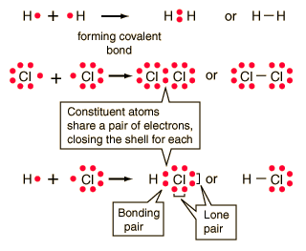
After bonding, the chlorine atom is now in contact with eight electrons in its highest energy level - so it is stable. Atoms are stable if their outer shell contains its maximum number of electrons.. The hydrogen atom is now in contact with two electrons in its highest energy level - so the hydrogen is also stable.

How many bonds?
Atoms may form multiple covalent bonds - that is, share not just one pair of electrons but two or more pairs. Atoms of different elements will form either one, two, three or four covalent bonds with other atoms.
There is a quick way to work out how many covalent bonds an element will form. The number of covalent bonds is equal to eight minus the group number. The table below gives more detail on this rule:

 | Group 4 | Group 5 | Group 6 | Group 7
Example | Carbon | Nitrogen | Oxygen | Chlorine
Number of bonds | 8 - 4 = 4 | 8 - 5 = 3 | 8 - 6 = 2 | 8 - 7 = 1

Hydrogen forms one covalent bond. The noble gases in Group 0 do not form any.

Representing covalent bonds
Covalent bonds can be represented in several different ways.
Straight lines and models
Straight lines are the most common way to represent covalent bonds, with each line representing a shared pair of electrons. 2D or 3D molecular models are especially useful for showing the relationship between atoms in multiple covalent bonds. Below are some examples of straight lines and images of 3D models.

Models for covalent bonds
Element | Formula | Chemical structure | Ball-and-stick model
Hydrogen | H₂
Water | H₂O
Ammonia | NH₃
Methane | CH₄ | 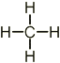 | 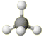
Double and triple bonds [E]
Note that molecules can have a double covalent bond - meaning they have two shared pairs of electrons - or a triple covalent bond - three shared pairs of electrons. A double covalent bond is shown by a double line, and a triple bond by a triple line.
A molecule of oxygen (O₂) consists of two oxygen atoms held together by a double bond, like this:
A molecule of nitrogen (N₂) has two nitrogen atoms held together by a triple bond, like this:

Dot-and-cross diagrams-elements [E]
Dot-and-cross diagrams are used to represent covalent bonds. The shared electron from one atom is shown as a dot, while the shared electron from the other atom is shown as a cross.
When drawing dot-and-cross diagrams for covalent bonds, you only need to show the electrons in the highest occupied energy level, as only these are involved.

Elements
Review the draw dot-and-cross diagrams for hydrogen, chlorine and oxygen.
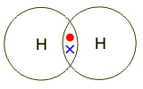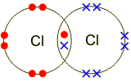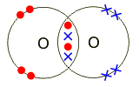

Dot-and-cross diagrams – molecules [E]
You should also review draw dot-and-cross diagrams representing the covalent bonds in the molecules of some common compounds:
Hydrogen chloride, HCl
Hydrogen atoms and chlorine atoms can each form one covalent bond. One pair of electrons is shared in a hydrogen chloride molecule (HCl).

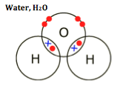
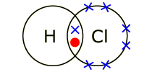Ammonia, NH₃
The structure of a water molecule is shown at right. Hydrogen atoms can each form one covalent bond, while oxygen atoms can each form two covalent bonds. Two pairs of electrons are shared in a water molecule (H₂O).

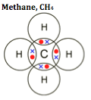
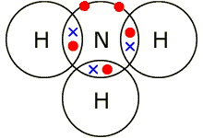
Ammonium is also a covalent compound (shown at left). Hydrogen atoms can each form one covalent bond, while nitrogen atoms can each form three covalent bonds. Three pairs of electrons are shared in an ammonia molecule (NH₃).

Methane is shown at right. Hydrogen atoms can each form one covalent bond, while carbon atoms can each form four covalent bonds. Four pairs of electrons are shared in a methane molecule (CH₄).

Covalent Molecules
Covalent bonds form between non-metal atoms. Each bond consists of a shared pair of electrons, and is very strong. Covalently bonded substances fall into two main types:
- simple molecules and
- giant covalent structures.
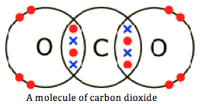
Simple molecules
These contain only a few atoms held together by strong covalent bonds. An example is carbon dioxide (CO₂), the molecules of which contain one atom of carbon bonded with two atoms of oxygen.

Properties of simple molecular substances
- Low melting and boiling points - This is because the weak intermolecular forces break down easily.
- Non-conductive - Substances with a simple molecular structure do not conduct electricity. This is because they do not have any free electrons or an overall electric charge.

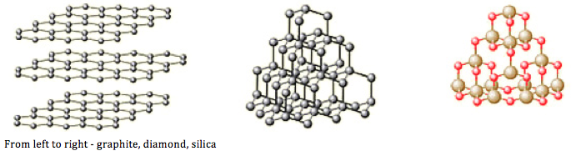
Giant covalent structures [E]
Giant covalent structures contain a lot of non-metal atoms, each joined to adjacent atoms by covalent bonds. The atoms are usually arranged into giant regular lattices - extremely strong structures because of the many bonds involved. The graphic shows the molecular structure of diamond and graphite: two allotropes of carbon, and of silica (silicon dioxide).

Properties of giant covalent structures
- Very high melting points - Substances with giant covalent structures have very high melting points, because a lot of strong covalent bonds must be broken. Graphite, for example, has a melting point of more than 3,600ºC.
- Variable conductivity - Diamond does not conduct electricity. Graphite contains free electrons, so it does conduct electricity. Silicon is semi-conductive - that is, midway between non-conductive and conductive.
Graphite
Graphite is a form of carbon in which the carbon atoms form layers. These layers can slide over each other, so graphite is much softer than diamond. It is used in pencils, and as a lubricant. Each carbon atom in a layer is joined to only three other carbon atoms. Graphite conducts electricity.
Diamond
Diamond is a form of carbon in which each carbon atom is joined to four other carbon atoms, forming a giant covalent structure. As a result, diamond is very hard and has a high melting point. Thus, it is often used as a cutting material. It does not conduct electricity.
Silica
Silica, which is found in sand, has a similar structure to diamond. It is also hard and has a high melting point, but contains silicon and oxygen atoms, instead of carbon atoms. The fact that it is a semi-conductor makes it immensely useful in the electronics industry: most transistors are made of silica.
Sources:
http://www.bbc.co.uk/schools/gcsebitesize/science/add_aqa_pre_2011/atomic/differentsubrev1.shtml
http://www.bbc.co.uk/schools/gcsebitesize/science/add_aqa_pre_2011/atomic/ionicrev1.shtml
http://www.bbc.co.uk/schools/gcsebitesize/science/add_aqa_pre_2011/atomic/covalentrev1.shtml
http://revisionworld.com/gcse-revision/chemistry/atoms-bonding-and-structure/bonding
http://www.gcsenotes.com/2013/09/structure-and-properties-of-ionic.html
http://www.s-cool.co.uk/gcse/chemistry/chemical-bonding/revise-it/types-of-solids

Review Questions
- Which of these formulae belongs to an ion?

  - Fe
  - Na
  - Na⁺

- Which atoms usually gain electrons to form negative ions?

  - Metal atoms
  - Non-metal atoms
  - Group 0 atoms

- Metal atoms form:

  - Positive ions by gaining electrons
  - Negative ions by gaining electrons
  - Positive ions by losing electrons

- In ionic bonding:

  - Oppositely charged ions attract one another
  - Oppositely charged ions repel one another
  - Ions with the same charge attract each other

- Sodium chloride conducts electricity when:

  - Solid or molten
  - Solid or in solution
  - Molten or in solution

- How many electrons are involved in each covalent bond?

  - One
  - Two
  - Three

- Which sort of elements form covalent bonds?

  - Metals
  - Non-metals
  - Gases

- Which of these has molecules with two atoms joined by a covalent bond (“diatomic molecule”)?

  - Helium
  - Copper
  - Chlorine

- What does a covalent bond involve?

  - Sharing electrons between atoms
  - Moving electrons between atoms
  - Forming free electrons

- Where do the electrons in a covalent bond come from?

  - The highest occupied energy level
  - The lowest occupied energy level
  - The inner shell

- An element forms ions with a 2+ charge. Which group is the element mostly likely to be in?

- Group 2
- Group 6
- Group 0

- In what physical state or states do ionic substances conduct electricity?

- solid or dissolved in water
- liquid or dissolved in water
- solid or liquid

- Which of the following statements is true of substances with a simple molecular structure?

- They have low melting points and conduct electricity.
- They have low melting points and do not conduct electricity.
- They have high melting points and do not conduct electricity.

- What is an ion?

- It has the same number of protons but different neutrons
- It has lost or gained protons

- It has lost or gained electrons

- What type of ion will chlorine form?

- -1 ion
- +7 ion
- +1 ion

- Which type of ions are metals more likely to form?

- Positive

- Negative

- A mixture of positive/negative

- What are the correct properties of ionic compounds?

- High melting points
- Medium melting points
- Low melting points

Extended Multiple-Choice
- The structure of magnesium oxide is a: [E]

  - Giant covalent lattice
  - Simple ionic lattice
  - Simple molecular compound
- What is the formula for magnesium chloride (contains Mg²⁺ and Cl⁻ ions)? [E]

  - MgCl
  - Mg₂Cl₂
  - MgCl₂

- What is the formula for calcium hydroxide (contains Ca²⁺ and OH⁻ ions)? [E]

  - CaOH₂
  - Ca(OH)₂
  - Ca₂OH

- Explain the conductivity of sodium chloride. [E]
  - It conducts electricity when molten because it contains free electrons
  - It conducts electricity when molten because sodium has metallic bonding
  - It conducts electricity when molten because its ions are free to move

- Carbon dioxide is CO₂. If oxygen atoms form two covalent bonds, how many bonds does carbon form in carbon dioxide? [E]

  - Two bonds
  - Three bonds
  - Four bonds

- How many covalent bonds are there in an ammonia (NH₃) molecule? [E]

  - Six
  - Four
  - Three

- Nitrogen is in group 5 of the periodic table. How many covalent bonds can it form? [E]

  - Eight
  - Five
  - Three

- Which of these elements normally forms four covalent bonds? [E]

  - Carbon
  - Nitrogen
  - Chlorine

- Which of the following statements is true of diamond? [E]

- Each carbon atom is covalently bonded to three other carbon atoms.
- Each carbon atom is covalently bonded to four other carbon atoms.
- There are no free electrons.

- Which of the following statements is true of graphite? [E]

- Each carbon atom is covalently bonded to three other carbon atoms.
- Each carbon atom is covalently bonded to four other carbon atoms.
- There are no free electrons.

Short-Response Questions
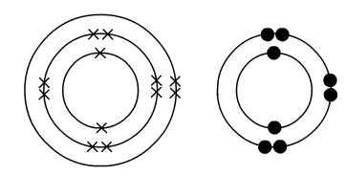
- The diagram below shows the electron arrangements of magnesium and oxygen:
- Use the drawing to show how a bond is made between magnesium and oxygen.
- What name is given to this type of chemical bond?

- Write the symbols for the ions formed by magnesium and oxygen.

- This question is about the ionic bond formed between the metal lithium (proton number 3) and the non-metal fluorine (proton number 9).
  - Complete these 3 tasks in the space below. [2]
    - Draw the structure of a lithium ion, and write the symbol for it, showing its charge.
    - Draw the structure of a fluoride ion, and write a symbol for it, showing its charge.
    - Draw a diagram to show what happens when a lithium atom reacts with a fluorine atom.

  - Write the formula for the compound formed when lithium reacts with fluorine.

  - Name the type of bonding present in the compound named above (part B)

- Choose at least two of the following. For the following pairs of elements, a) draw a diagram showing only the outer shell electrons, b) Draw arrows to show how electrons will be transferred, c) write the formulae of the ions formed by each element, d) write the formula for the compound produced [E], e) write the name of the compound.
  - Lithium, Bromine
  - Sodium, Sulfur
  - Beryllium, Oxygen
  - Magnesium, Iodine

- Write the formulae for the following compounds: [E]
  - Sodium iodide

  - Beryllium chloride

  - Calcium oxide

  - Lithium sulfide

- Covalent bonding occurs between two ____________________. Electrons are ____________ in covalent bonds.

- Choose at least two of the following (Extended students must do at least one extended). Draw dot and cross diagrams to show the covalent bonds formed in:
  - H₂
  - Br₂
  - CH₂F₂
  - HCl
  - N₂ [Extended]
  - C₂Br₄ [Extended]
  - SiO₂ [Extended]

- Describe the differences between the bonding of Cl₂ and NaCl.

- These are some properties of substances A to G.
a Which of the seven substances are metals? Give a reason for your choice.

b Which of the substances are ionic compounds? Give a reason for your choice.

Substance | Melting point / °C | Electrical conductivity |  | Solubility in water
 |  | solid | liquid
A | –112 | poor | poor | insoluble
B | 680 | poor | good | soluble
C | –70 | poor | poor | insoluble
D | 1495 | good | good | insoluble
E | 610 | poor | good | soluble
F | 1610 | poor | poor | insoluble
G | 660 | good | good | insoluble

c Two of the substances are simple molecular compounds. Which two are they?

- d Which substance is a giant covalent structure?

- e Name the type of bonding found in:

    - i B
    - ii C
    - iii E
    - iv F

- Aluminum and nitrogen react to form an ionic compound called aluminum nitride. These show the electron arrangement for the two elements:
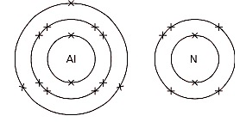
a Add arrows to the diagram to represent what happens when aluminum nitride forms.
b Answer these questions for an aluminum atom. [E]
i Does it gain or lose electrons, to form an ion?

ii How many electrons are transferred?

iii Is the ion formed positive, or negative?

iv What charge does the ion have?

c Now repeat b, but for a nitrogen atom. [E]

i Does it gain or lose electrons, to form an ion?

ii How many electrons are transferred?

iii Is the ion formed positive, or negative?

iv What charge does the ion have?

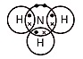
- This diagram at the right represents a molecule of a certain gas. [E]
a Name the gas, and give its formula.

b What do the dot and cross symbols represent?

c Which type of bonding holds the atoms together?

d Name another compound with this type of bonding.

