Name: _____________________________________________________________________________ Date: ___________________

Revision Packet Instructions: 1) Read the included material. Additional resources are available at the indicated websites. 2) Answer the questions at the end of the reading. 3) Readings and Questions with the notation [E] refer to items that will be on the Extended Exam. They are not required for students taking the Core Exam.
This revision packet covers: Elements, Compounds, and Mixtures (C3.2), Atomic Structure and the Periodic Table (C3.3), Periodic Trends (C9.1), Group Properties (C9.2), Transition Elements (C9.3), Noble Gases (C9.4), Properties of Metals (C10.1), Reactivity Series (C10.2), Uses of Metals (C10.4), Types of Oxides (C8.2), and Particulate Nature of Matter (C1)

Atoms

Atoms and elements
All substances are made of tiny particles called atoms. An element is a substance that is made of only one sort of atom. The atoms of any element are different to the atoms of any other element. So iron is made from a different sort of atom to sulfur, and carbon atoms are different to oxygen atoms. All atoms of the same element contain the same number of particles called protons, and this is called the element's atomic number.

There are about 100 different elements. These are shown in the periodic table, which is a chart with all the elements arranged in a particular way. The periodic table is a chart showing all the elements arranged in order of increasing atomic number. The horizontal rows in the periodic table are called periods and the vertical columns are called groups. The elements in a group have similar properties to each other.

Mixtures and compounds
A mixture is made from different substances that are not chemically joined. A compound consists of two or more atoms from different elements chemically joined together. There are two types of chemical bond: covalent bonds and ionic bonds.

Mixtures have different properties from compounds. The table summarizes these differences.
 | Mixture | Compound
Composition | Variable composition – you can vary the amount of each substance in a mixture | Definite composition – you cannot vary the amount of each element in a compound
Joined or not | Different substances are not chemically joined | The different elements are chemically joined together
Properties | Each substance in mixture keeps its own properties | Compound has different properties from its elements
Separation | Each substance easily separated from the mixture | Can only be separated into its elements w/ chemical reactions
Examples | Air, sea water, most rocks | Water, carbon dioxide, magnesium oxide, sodium chloride

Atomic structure
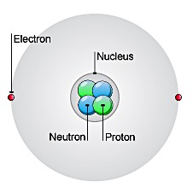
An atom has a small central nucleus made up of smaller sub-atomic particles called protons and neutrons. The nucleus is surrounded by even smaller sub-atomic particles called electrons.

Neutrons are neutral, but protons and electrons are electrically charged: Both have the same size of electrical charge, but the proton is positive and the electron negative. Neutrons are neutral. We say that protons have a relative charge of +1 and electrons have a relative charge of -1.

The number of electrons in an atom is equal to the number of protons in its nucleus. This means atoms have no overall electrical charge.

A summary of the electrical charges in sub-atomic particles
Name of particle | Location | Electrical charge | Approximate relative mass
proton | Nucleus | +1 | 1
neutron | Nucleus | 0 | 1
electron | In shells, or “energy levels” surrounding nucleus | -1 | 0

Chemical symbols
The atoms of each element are represented by a chemical symbol. This usually consists of one or two different letters, but sometimes three letters are used for newly discovered elements. For example, O represents an oxygen atom, and Na represents a sodium atom.
The first letter in a chemical symbol is always an UPPERCASE letter, and the other letters are always lowercase. So, the symbol for a magnesium atom is Mg and not mg, MG or mG.

Atomic number and mass number
The atomic number (also called “proton number”) of an atom is the number of protons it contains. All the atoms of a particular element have the same atomic number (number of protons). The atoms of different elements have different numbers of protons. For example, all oxygen atoms have 8 protons and all sodium atoms have 11 protons.

The mass number (also called “nucleon number”) of an atom is the total number of protons and neutrons it contains. The mass number of an atom is never smaller than the atomic number. It can be the same, but is usually bigger.

Full chemical symbols
You need to be able to calculate the number of each sub-atomic particle in an atom if you are given its atomic number and its mass number. The full chemical symbol for an element shows its mass number at the top, and its atomic number at the bottom.
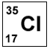
This symbol tells you that the chlorine atom has 17 protons. It will also have 17 electrons, because the number of protons and electrons in an atom is the same.
The symbol also tells you that the total number of protons and neutrons in the chlorine atom is 35. Note that you can work out the number of neutrons from the mass number and atomic number. In this example, it is 35 – 17 = 18 neutrons.

Electronic structure [E]
The electrons in an atom occupy energy levels. These are also called shells. Each electron in an atom is found in a particular energy level. The lowest energy level (innermost shell) fills with electrons first. Each energy level can only hold a certain number of electrons before it becomes full. The first energy level can hold a maximum of two electrons, the second energy level a maximum of eight, and so on.

Electrons in the first three energy levels for the elements with atomic numbers 1 to 20
Energy level or shell | Maximum number of electrons
first | 2
second | 8
third | 8

Writing an electronic structure [E]
The electronic structure of an atom is written using numbers to represent the electrons in each energy level. For example, for sodium this is 2,8,1 – showing that there are:
- 2 electrons in the first energy level
- 8 electrons in the second energy level
- 1 electron in the third energy level.

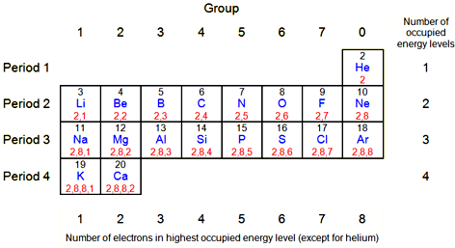
You can work out the electronic structure of an atom from its atomic number or its position in the periodic table. Start at hydrogen, H, and count the elements needed to reach the element you are interested in. For sodium, it takes:
- 2 elements to reach the end of the first period (row)
- 8 elements to reach the end of the second period
- 1 element to reach sodium in the third period.

The diagram of the periodic table shows how this works.

Drawing Electronic structure diagrams
You need to be able to draw the electronic structure of any of the first twenty elements. In these drawings:
- the nucleus is shown as a black spot
- each energy level is shown as a circle around the nucleus
- each electron is shown by a dot or a cross.

The electronic structure of some elements
Element | Symbol | Electronic structure (written) | Electronic structure (drawn)
lithium | Li | 2,1 | 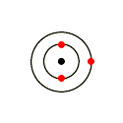
fluorine | F | 2,7 | 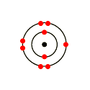
chlorine | Cl | 2,8,7 | 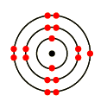
calcium | Ca | 2,8,8,2 | 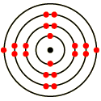

Working out an element's electronic structure
Here is how to work out an electronic structure:
- Find the element in the periodic table. Work out which period (row) it is in, and draw that number of circles around the nucleus.
- Work out which group the element is in and draw that number of electrons in the outer circle – with eight for Group 0 elements – except helium.
- Fill the other circles with as many electrons as needed. Remember – two in the first circle, and eight in the second and third circles.
- Finally, check that the number of electrons is the same as the atomic number.

Isotopes
The atoms of a particular element will all have the same number of protons. Their atomic number will be the same. However, the atoms of an element can have different numbers of neutrons - so their mass numbers will be different.
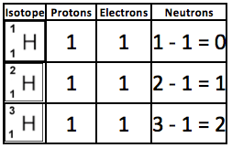
Atoms of the same element with different numbers of neutrons are called isotopes. The different isotopes of an element have identical chemical properties. However, some isotopes are radioactive.

Isotopes examples
Most hydrogen atoms consist of just one proton and one electron, but some also have one or two neutrons. The table summarizes these isotopes.

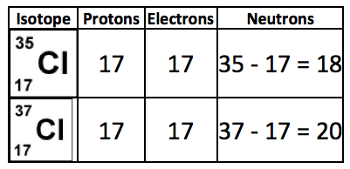
Chlorine has two isotopes. These are shown in the table at the right. The relative atomic mass of an element (A_{r}) is an average value for the isotopes of the element. For example, the A_{r} for chlorine is 35.5 because it contains two different isotopes.
Elements and the Periodic Table
All the different elements are arranged in a chart called the periodic table. Here are the main features of the table:
- the horizontal rows are called periods
- the vertical columns are called groups
- elements in the same group are similar to each other and have similar chemical properties. This is because their atoms have the same number of electrons in the highest occupied energy level.
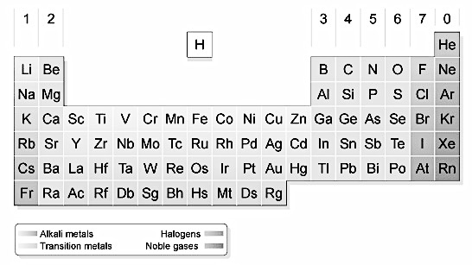
- the metals are on the left and the non-metals are on the right (hydrogen is a non-metal but is often put in the middle)
- the main groups are numbered from 1 to 7 going from left to right, and the last group on the right is Group 0
- the block in between Group 2 and Group 3 is where the transition metals are placed
- there are only two elements in Period 1 (hydrogen and helium)

Group 1 elements are reactive metals called the alkali metals. For example, group 1 contains sodium and other very reactive metals, while group 7 contains chlorine and other very reactive non-metals. Group 0 elements are unreactive non-metals called the noble gases. Group 0 (also known as group 8 or group 18) contains helium and other very unreactive non-metals. Note that you will never find a compound in the periodic table, because these consist of two or more different elements joined together by chemical bonds.

Groups of the Periodic Table

Group 1
The group 1 elements are found on the left hand side of the periodic table. They are called the alkali metals because they form alkaline (basic) compounds. Their atoms all have one electron in their highest occupied energy level (outermost shell). This gives the group 1 elements similar chemical properties to each other.

Reactions of group 1 elements with water
Lithium, sodium and potassium all react vigorously with water to form a metal hydroxide and hydrogen:
metal + water → metal hydroxide + hydrogen
The metal hydroxides are strong alkalis. The group 1 elements need to be stored under oil to prevent them reacting with oxygen and water vapor in the air.

Reactions of group 1 elements with oxygen
Lithium, sodium and potassium are easily cut with a blade. The freshly cut surfaces are silvery and shiny, but quickly turn dull as the metal reacts with oxygen in the air. The group 1 metals react vigorously with oxygen to form metal oxides. Lithium burns with a red flame, sodium with a yellow-orange flame, and potassium burns with a lilac flame.

Group 7
The Group 7 elements are also known as the halogens. They include fluorine, chlorine, bromine and iodine, which all have seven electrons in their outer shell.

Chlorine is used to sterilize the drinking water supply and in the manufacture of many important chemicals such as pesticides and plastics. Iodine can be used to sterilize wounds. An important compound of chlorine is sodium chloride or common salt. It's used to preserve food, as flavoring and to manufacture chlorine.

The properties of the halogens
The halogens have similar properties because they all have seven electrons in the outer shell. They all react very vigorously with alkali metals.

Halogen | Physical State (rtp) | Color | Reaction w/ sodium | Reactivity | Typical uses
Chlorine | Gas | pale green | sodium + chlorine → sodium chloride | Extremely reactive | Sterilizing water
Bromine | Liquid | orange | sodium + bromine → sodium bromide | very reactive | Making pesticides and plastics
Iodine | Solid | grey | sodium + iodine → sodium iodide | reactive | Sterilizing wounds

Trends in Group 7
Reactivity of halogens: The non-metal elements in Group 7 - known as the halogens - get less reactive as you go down the group. This is the opposite trend to that seen in the alkali metals in Group 1 of the periodic table. Fluorine is the most reactive element of all in Group 7.
Melting point and boiling point: The halogens have low melting points and low boiling points. This is typical of non-metals. Fluorine has the lowest. The melting and boiling points then increase as you go down the group.
Color: The halogens become darker as you go down the group. Fluorine is very pale yellow, chlorine is yellow-green, and bromine is red-brown. Iodine crystals are shiny purple.
Predictions: When we can see a trend in the properties of some of the elements in a group, it is possible to predict the properties of other elements in that group. Astatine is below iodine in Group 7. The colour of these elements gets darker as you go down the group. Iodine is purple, and astatine is black.
Reactivity series: If you test different combinations of the halogens and their salts, you can work out a reactivity series for Group 7:
- the most reactive halogen displaces all of the other halogens from solutions of their salts, and is itself displaced by none of the others
- the least reactive halogen displaces none of the others, and is itself displaced by all of the others
It doesn’t matter whether you use sodium salts or potassium salts – it works the same for both types.

Diatomic Molecules
Most of the halogens, as well as some other gases, exist as diatomic molecules. Diatomic molecules are two atoms of the same element joined by a covalent bond (e.g. H₂, N₂, O₂, F₂, Cl₂, Br₂, I₂, At₂). When you write the symbol for the element, you must include the “2” as a subscript to represent this. Writing O2 is incorrect. Writing O₂ is correct.

Group 0
The group 0 elements are found on the right hand side of the periodic table. They are called the noble gases because they are very unreactive.

The highest occupied energy levels (outermost shells) of their atoms are full:
- helium atoms have two electrons in their outer energy level
- atoms of the other noble gases have eight electrons in their outer energy level.

Uses of the noble gases
The uses of the noble gases are usually linked to their inertness, or to their tendency to give off light when an electric current is passed through them.
Noble gas | Uses
Helium | Party balloons, airships, cooling superconducting electromagnets (eg in MRI scanners), gas for scuba diving. It is much less dense than air, so balloons filled with it float upwards.
Neon | Used in advertising signs and lasers. It glows when electricity is passed through it, and different colored 'neon lights' can be made by coating the inside of the glass tubing with other chemicals.
Argon | Used in light bulbs. The very thin metal filament inside the bulb would react with oxygen and burn away if the bulb were filled with air instead of argon. As argon is unreactive, it stops the filament burning away.

Metals and non-metals
The metals are shown on the left of the periodic table, and the non-metals are shown on the right. The dividing line between metals and non-metals is shown in red on the table below. You can see that most of the elements are metals.
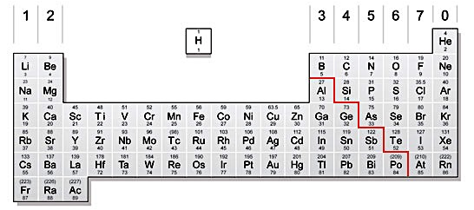
Moving from left to right across a period, the elements become less metallic. This is related to the increase in the number of electrons in the outer shell of their atoms. The atoms become more likely to gain or share electrons, rather than lose them when they form compounds.

Metals
Metals tend to have similar properties. They are always good conductors of electricity, and they usually share these properties:
- high melting point
- good conductors of heat
- malleable (can be beaten into shape)
- shiny when cut
- ductile (can be pulled into wires)
There are some exceptions though. For example, mercury is a liquid at room temperature. The metals in Group 1, such as lithium, sodium and potassium, are all soft.

The properties of metals can be used to explain typical uses of metals. For example, copper is used for wiring because it is ductile and a good conductor of electricity. Its ability to conduct heat is not relevant for this use.

Non-metals
Non-metals have a variety of properties, but very few are good conductors of electricity. Graphite (a form of carbon) is a rare example of a non-metal that conducts electricity very well.
Many non-metals have a low melting and boiling point. When non-metals are in a solid state, they are usually brittle so you can’t beat them into shape.

Metal and non-metal oxides
When a non-metal reacts with oxygen, it forms a non-metal oxide. These compounds are usually acidic.
For example, sulfur reacts with oxygen to form sulfur dioxide S + O₂ → SO₂
And sulfur dioxide dissolves in water to form sulfurous acid: H₂O(l) + SO₂(g) → H₂SO₃(aq)
This is one of the acids found in acid rain.
Metal oxides are usually bases. This means that they can neutralize acids. If a base dissolves in water, it is an alkali. Alkaline solutions have a pH of more than 7.
Copper oxide is a base, and will react with sulfuric acid to make the salt copper sulfate.

Transition Elements
The elements in the middle section of the Periodic Table are the transition elements. They're all metals with typical metallic properties eg conducting heat and electricity and they form positive ions when they react with non-metals. They are generally hard and dense, and less reactive than the alkali metals. They have high melting points, and they often form colored compounds (Copper compounds are blue, Iron(II) compounds are light green, Iron(III) compounds are orange/brown).
Transition metals are often catalysts. Iron is a catalyst in the Haber process. Nickel is a catalyst used in the manufacture of margarine

References:
http://www.bbc.co.uk/schools/gcsebitesize/science/aqa/fundamentals/atomsrev1.shtml
http://www.bbc.co.uk/schools/gcsebitesize/science/aqa/fundamentals/theperiodictablerev1.shtml
http://www.bbc.co.uk/schools/gcsebitesize/science/add_aqa/atomic_structure/atomic_structurerev2.shtml
http://www.bbc.co.uk/education/guides/zb3j6sg/revision/2

Revision Questions:
- An atom consists of:

  - An electron surrounded by a nucleus
  - A nucleus containing electrons
  - A nucleus surrounded by electrons

- What are the groups in the periodic table?

  - A row of similar elements
  - A column of similar elements
  - The boxes in the table

- How many protons, neutrons and electrons are there in a ${}_{13}^{27}{Al}$ atom
  - 13 protons, 27 neutrons, and 13 electrons
  - 13 protons, 14 neutrons, and 13 electrons
  - 13 protons, 14 neutrons, and 14 electrons

- Which of the following does the nucleus contain?
  - Protons and electrons
  - Protons and neutrons
  - Neutrons and electrons

- Which of the following statements is correct?
  - Protons are positively charged and neutrons are negatively charged
  - Protons are negatively charged and electrons are positively charged
  - Protons are positively charged and electrons are negatively charged

- What is the atomic number of an atom?
  - The number of atoms it contains
  - The number of protons it contains
  - The number of neutrons it contains

- Which of the following statements is true of a (neutral) atom?
  - The number of protons is always equal to the number of neutrons
  - The number of protons is always equal to the number of electrons
  - The number of neutrons is always equal to the number of electrons

- Which electronic structure is correct for an element with 17 electrons? [E]

  - 1, 7
  - 10, 7
  - 2, 8, 7
- Which property of an element suggests that it is a metal?

  - It conducts electricity.
  - It forms covalent compounds.
  - It has a low density.
  - It has a low melting point.

- An element has the electronic structure 2,8,4. Which group is it in? [E]

  - Group 3
  - Group 4
  - Group 0

- What do elements in a period have the same number of?
  - Electrons
  - Occupied energy levels or shells
  - Electrons in the highest occupied energy level or outer shell

- What do the elements in a group have the same number of?
  - Electrons
  - Occupied energy levels or shells
  - Electrons in the highest occupied energy level or outer shell

- Which of these electronic structures belongs to a noble gas? [E]

  - 2
  - 2, 2
  - 2,8,2

- Two elements have these electronic structures: 2,1 and 2,8,1. What can you say about the elements? [E]

  - They are both in Group 1.
  - They are both in Group 2.
  - They are both in period 2.

- Which of these elements has three electron shells?

  - Boron
  - Silicon
  - Potassium

- Which atom is the most stable: F, Ne, Na?

  - F
  - Ne
  - Na

- Which sub-atomic particle has a mass of 1 and no charge?

  - Proton
  - Neutron
  - Electron

- Why are the elements in Group 0 unreactive?

  - They have very large atoms
  - They have even numbers of electrons
  - They have full outer shells

- Which of these is a typical property of metals?

  - High melting point
  - Brittle
  - Poor conductor of heat

Practice Problems- Short Response
- The grid below shows the arrangement of the first twenty elements in the Periodic Table.
  - For each of the elements described below, write the letter for each element in the correct box. The first one has been done as an example.
- Element V is made of the lightest atoms.
- Element W is the least reactive in Group 1
- Element X is the most reactive in Group 7.
- Element Y is in Period 3 and atoms of Y have two outer shell electrons.
- Element Z is made of atoms that have 10 protons in their nuclei.

  - Iron is a transition metal which occurs in the Earth’s crust in the form of iron oxide. State three properties of the element iron which is different from an alkali metal such as sodium.

- The figure below shows a diagram of one atom of chlorine.
  - Every electron has a negative charge. Explain why the chlorine atom does not have an overall electrical charge.

  - Chlorine is commonly found in two forms. One with an atomic number of 35 and the other with an atomic number of 37. What are these forms called? What is different about these forms?

- The diagram shows part of the Periodic Table.
  - Answer these questions using only the elements shown in the diagram
    - Write down the symbol for an element which contains diatomic molecules.

    - Write down the symbol for an element which forms a basic oxide.

    - Write down the symbol for an element with smaller proton (atomic) number than lithium, Li.

    - Write down the symbol for an element which contains atoms with a full outer shell of electrons.

  - Describe three things you would see when a small piece of sodium is added to a beaker of water.

- Chlorine, bromine and iodine are halogens. Some properties of these elements are shown below in the table.
Element | Color | State at room temperature | Melting point (ºC) | Boiling point (ºC)
chlorine | yellowish-green | gas | -101 | -35
bromine | reddish-brown | liquid | -7 | 59
iodine | greyish-black | solid | 114 | 184
a) Describe the arrangement and motion of bromine molecules at 25ºC.
    - Arrangement:

    - Motion:

  - Fluorine is also a halogen.
    - Predict the color and state of fluorine at room temperature [E]
      - Color

      - State

    - Predict the boiling point of fluorine [E]

    - Give the formula of a fluorine molecule.

- Draw one atom of Argon, showing how its electrons are arranged [E].

  - Compare the electron structure of Argon with the structure of Chlorine from #21.

- The table at right describes some particles.
a Which three particles are neutral atoms?

b Which particle is a positive ion? What is its charge?

c Which two particles are isotopes?
Particle | Electrons | Protons | Neutrons
A | 12 | 12 | 12
B | 12 | 12 | 14
C | 10 | 12 | 12
D | 10 | 8 | 8
E | 9 | 9 | 10

- Boron has two types of atom, shown below.
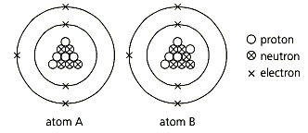
a What is different about these two atoms?

b What name is given to atoms like these?

c Write the Chemical Symbol for each of these atoms of Boron.

d What is the nucleon number of atom A?

e Is atom B heavier, or lighter, than atom A?

f Write the electronic configuration for A and B. [E]

- This diagram represents the electronic arrangement in an atom of an element.
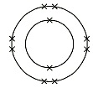
a i Write the electron configuration for the atom. [E]

      - ii What is special about this arrangement? [E]

  - b Which period of the Periodic Table does the element belong to?

  - c Name the element shown in the diagram.

  - d Name another element with the same number of outer-shell electrons in its atoms.

  - e Draw the electronic diagram for the halogen that is in the same period as the element shown above.

