Name: __________________________________________________ Date: _____________

Revision Packet Instructions: 1) Read the included material. Additional resources are available at the indicated websites. 2) Answer the questions at the end of the reading. 3) Readings and Questions with the notation [E] refer to items that will be on the Extended Exam. They are not required for students taking the Core Exam.
This revision packet covers: Enzymes (B3), Nutrients (B4.1)

Nutrition:
Defined as taking in nutrients, which are, organic substances and mineral ions, containing raw materials or energy for growth and tissue repair, absorbing and assimilating them. [E]

CHEMICAL ELEMENTS THAT MAKE UP LIFE
Carbohydrates | Carbon, hydrogen (2), oxygen = CH₂O
Fats | Carbon, hydrogen, oxygen
Proteins | Carbon, hydrogen, oxygen, nitrogen, sulphur
Nucleic Acids | carbon, hydrogen, oxygen, nitrogen, phosphorous

Carbohydrates
Carbohydrates are made in the chemical structure of carbon, hydrogen and oxygen.
- Monosaccharaides: they are the simplest carbohydrate units; they are soluble in water and have a sweet taste. E.g. glucose. Their formula, C₆H₁₂O₆
- Disaccharides: e.g. sucrose. These are 2 monosaccharide’s joined together; they are sweeter than monosaccharide’s and dissolve in water. Their formula C₁₂H₂₂O₁₂
- Polysaccharides: e.g. starch. Made out of many mono and disaccharides, they are insoluble in water and don’t have a sweet taste. Their formula (C12, H22, O12).

CARBOHYDRATES MONOSACCARIDE DISACCARIDE POLYSACCARIDE
glucose maltose starch

Carbohydrates are very important because they produce energy. In plants cells they are stored as starch and in animal cells they are stored as glycogen. Carbohydrates are always stored as polysaccharides because this does not affect the osmotic pressure. Excess carbohydrates can be stored as fats under the skin.
*Recognize that each “ring” is a single sugar  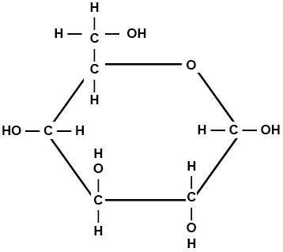  (Above) Monosaccharide  Example: Glucose (C₆H₁₂O₆) – one ring | 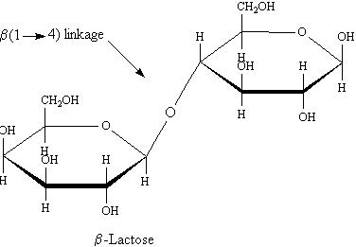  (Above) Disaccharide Example: two rings
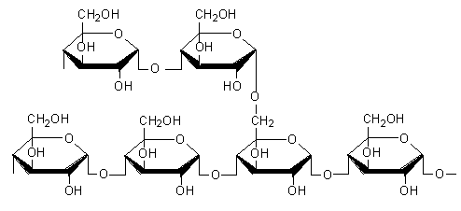  (Above) Polysaccharide Example: more than two rings | 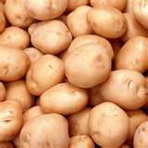  *Starches like pasta and potatoes are polysaccharides*

Fats
Fats are a source of energy. They produce double the amount of energy produced by carbohydrates they are formed from fatty acids and glycerol and from the atoms carbon, hydrogen and oxygen (the amount of oxygen in fats is about half the one in carbohydrates). Fats form a part of the cell membrane and they form a waterproof layer under the skin.
Individual phospholipid below:  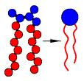 | Here is a model of the cell membrane: 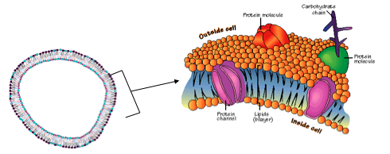
Proteins
Proteins are made from amino acids and the elements carbon, hydrogen, nitrogen and sometimes sulphur. They are present in foods such as milk and meat. They are used in growth and repair and in enzymes and make up antibodies. Some are used to form bones and muscles. Others are embedded throughout the phospholipid bilayer (cell membrane) in order to help transport substances into or out of cells.

AMINO ACIDS DIPEPTIDE POLYPEPTIDE
1 amino acid 2 amino acids e.g. protein
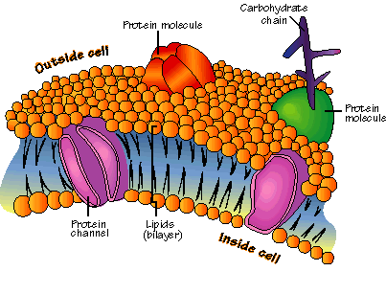
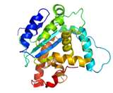

PROTEINS: 3 fatty acid molecules and 1 glycerol molecule form a lipid. Peptide bonds join amino acids together. Lipids come in three forms: liquid (oils), semi-solid (wax) and solid (fats)
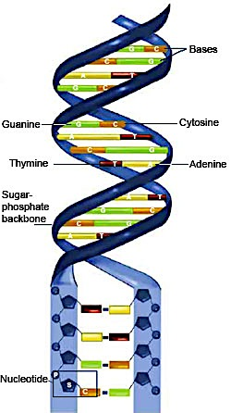
Nucleic Acids
Nucleic acids are long chains made from base pairs attached to a sugar-phosphate backbone. They are polymers that are assembled from individual monomers known as nucleotides. Nucleotides consist of three parts: a 5-carbon sugar, a phosphate group, and a nitrogen base. Nucleic acids store and transmit hereditary, or genetic, information. There are two kinds of nucleic acids: ribonucleic acid (RNA) and deoxyribonucleic acid (DNA). RNA has the sugar ribose and DNA has the sugar deoxyribose. The entire purpose of DNA is the code to make proteins.

Nutrients and their Roles:

 |  | Principal source: | Importance:
Carbohydrates | bread, rice, potatoes, pasta, cereal |  | Carbohydrates are the body’s main source of fuel. They give us our energy. They’re needed for our body to function properly
Fats | meat, dairy products, nuts |  | Energy, absorbing certain vitamins, maintaining cell membranes
Proteins | meat, fish, cheese, vegetables |  | Tissue growth and repair, maintaining immune system, making essential hormones and enzymes
Vitamins C | fresh fruits and vegetables |  | It can protect cells from damage, it can prevent cataracts. A lack of vitamin C can cause scurvy.
Vitamin D | Certain types of fish sunlight |  | Promotes calcium absorption in the gut and bone growth. A lack of vitamin D can cause bones to become thin and brittle, and can cause rickets.
Calcium | cows’ milk, vegetables |  | For bone growth, for muscles to contract and relax properly. Lack of calcium can cause rickets.
Iron | breakfast cereals, liver, meat, nuts, green vegetables |  | Helps make red blood cells (key component of hemoglobin). Lack can cause anemia, fatigue and hair loss.
Fibre | whole meal bread and pasta, fruits and vegetables, nuts, seeds |  | Aids digestion but doesn’t get digested
Water |  |  | It is necessary for the digestion and absorption of food; helps maintain proper muscle tone; supplies oxygen and nutrients to the cells; rids the body of wastes

Vitamins:
Are organic substances only needed in small amounts in the body to perform specific functions.

Vitamin | Sources | Importance | Deficiency Symptoms
C | - Citrus fruits (orange, lemons)  - Fresh vegetables | - Helps wounds to heal  - Keeps blood vessel healthy  - Keeps gum and teeth healthy | - Can cause scurvy  Symptoms:  - Pain in joints and muscles  - Bleeding from the gums and other parts of the body  - Delayed healing of wounds
D | - Butter, eggs and cod- liver oil.  - Can be formed in the skin by being exposed to sun rays | - Helps absorption of calcium and phosphorous  - Helps the deposition of calcium and phosphorous in bones and teeth | Rickets in children  - Causes bones to be soft and deformed  - Soft bones or osteomalacia in adults

Minerals:
Are inorganic substances.

Mineral | Sources | Importance | Deficiency Symptoms
Calcium | - Milk, dairy products  - Bread | - For bones and teeth  - Blood clotting | - Brittle bones and teeth  - Poor blood
Iron | - Liver, Red Meat, Egg yolk, dark green vegetables | - For making hemoglobin- the red pigment in blood which carries oxygen | - Anemia- in which there are not enough red blood cells so the tissues do not get enough oxygen delivered to them.
Tests
Molecule | Test Procedures | Result for positive test (and explanation)
starch | Using a pipette, place a drop of sample solution in a depression in a spotting tile. Add a drop of iodine solution. | A blue-black colour is formed.  A coloured polyiodide complex is formed with starch.
reducing sugars (such as glucose) | Place about 10 cm³ of sample solution in a test tube. Add a few drops of Benedict’s solution. Stand the tube in the water bath and heat for five minutes. | A brick-red/orange-red precipitate is formed.  The reducing sugar reduces the copper(ii) ions in the Benedict’s to copper(i) oxide.  (If a lower concentration of reducing sugar is used, the colour may be green, yellow or orange.)
protein | Place about 5 cm³ of sample solution in a test tube. Add an equal volume of biuret reagent. | A lilac (purple) solution is formed.  Nitrogen atoms in the peptide bonds of the protein form a lilac complex with copper(ii) ions in the biuret reagent.
lipid | Place one drop of sample solution in a clean, dry test tube. Add about 5 cm³ of ethanol and shake thoroughly to dissolve. Pour the mixture into a test tube three-quarters filled with cold water. | A cloudy white emulsion is formed on the surface of the water.  The alcohol mixes with the water, leaving the lipid to form an emulsion of microscopic droplets suspended at the surface.

Enzymes:
The reactions of cells including photosynthesis and respiration require the participation of substances called enzymes that are produced by living things. Enzymes are biological catalysts that speed up reactions. They increase the rate at which cellular reactions occur. Enzymes show specificity, that is, they only react with a particular substance. The substance whose rate the enzyme catalyzes (speeds up) is called a substrate.

Enzyme + substrate enzyme substrate complexproduct

Enzymes are specific; any individual enzyme can usually only catalyze one particular reaction. The induced fit hypothesis has been put forward to explain how enzymes work (Fig 1).
- Substrate approaches the active site of the enzyme
- The shape of the active site then changes to fit precisely around the substrate – in other words, the substrate induces the active site to change shape.
- The reaction is catalyzed and products form.
- The products are a different shape from the substrate and therefore diffuse away from the active site. As they do, the active sites revert to its original shape.

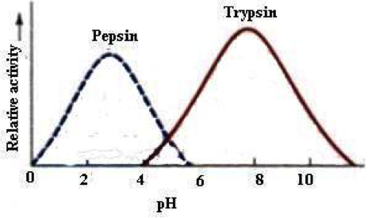
The activity of enzymes is influenced, among other things, by the temperature, the pH of the medium and the concentration of the substrate.

- Effect of Temperature on Enzyme Activity
Enzymes have an optimum temperature- this is the temperature at which they work most rapidly. Below the optimum temperature, increasing the temperature will increase the rate of reaction. This is because the temperature increases kinetic energy of the system, effectively increasing the number of collisions between the substrate and the enzymes’ active site.

Temperatures above the optimum will lead to denaturation. This occurs because the hydrogen bonds and disulfide bridges, which maintain the shape of the active site, are broken; this enzyme substrate complexes can no longer be formed.

2. Effect of pH on Enzyme Reaction
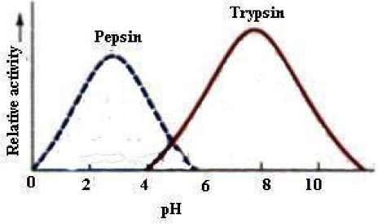
Some enzymes act best at different pH. As with temperature, each enzyme has an optimum pH. If the pH increases or decreases much beyond this optimum, the ionization of groups at the active site and on the substrate may change, effectively slowing or preventing the formation of the enzyme substrate complex. At extreme pH, the bonds which maintaining the tertiary structure- hence the active site- are disrupted and the enzyme is irreversibly de natured.

Pepsin which digests protein in the stomach, acts best at an acidic pH medium of between 1 and 2. Trypsin, an enzyme produced by the pancreas, shows optimum activity in an alkaline medium, usually at a pH that is between 7 and 9.

3. Effect of Enzyme Concentration
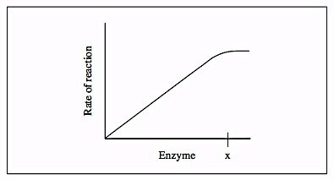
At low enzyme concentration there are more substrate molecules than there are available active sites. Increasing the number of active sites bun increasing the concentration of the enzyme, therefore, effectively increases the rate of the reaction. Eventually increasing the enzyme concentration has no effect on the rate of reaction. Given that all the other factors are constant, the rate of reaction of an enzyme is directly proportional to the concentration of the enzyme. If the substrate concentration falls, the reaction will plateau out to a constant rate. This is due to the number of substrate molecules becoming the limiting factor.

4. Effect of Substrate Concentration
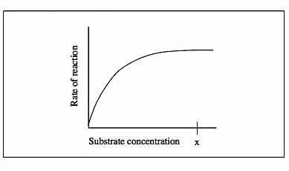
At low substrate concentration the reaction proceeds slowly. This is because there are not enough substrate molecules to occupy all the active sites on the enzyme. Given a constant enzyme concentration, increasing the concentration of the substrate increases the rate of reaction. The increase in the rate of reaction ceases when all the active sites of the enzyme are occupied. This is because all of the enzyme’s active sites are now occupied by substrate molecules – increasing the substrate concentration further will have no effect, because no more enzyme substrate complexes can form.

Enzyme Inhibition
(a) Competitive inhibitors
Some substances that are closely related to the normal substrates of certain enzymes have similar shapes. For example, succinic acid the substrate for succinic dehydrogenase is closely related to malonic acid. When both are present, they compete for the same active sites on the enzyme succinic dehydrogenase. By occupying the active sites of the enzyme, malonic acid prevents succinic acid from reacting with the enzyme and the enzyme is inhibited. This is called competitive inhibition.
(b) Non-competitive inhibition
A molecule can attach itself to an enzyme and cause the shape and the active sites of the enzyme to alter. Because the shape of the active sites is altered, the substrate is unable to react with the enzyme. Cyanide is a poison that acts by altering the sites of certain respiratory enzyme.

- Match the test to the biomolecule

Ethanol Emulsion Test Protein

Benedict Test Starch

Biuret Test Lipids

Iodine Test Reducing Sugars

- Which of the following statements is correct about lipids?
- They store genetic information in cells
- They are used for long-term energy storage
- They contain the elements carbon, hydrogen, oxygen, nitrogen, and phosphorus
- They form long chains made of repeating subunits (monomers)

- Which element is found in all proteins, but not in carbohydrates?
  - Nitrogen
  - Carbon
  - Hydrogen
  - Oxygen
- Which of the following statements is not correct about nucleic acids?
  - They are used for long-term energy storage
  - They store genetic information in cells
  - They contain the elements carbon, hydrogen, oxygen, nitrogen, and phosphorus
  - They form long chains made of base pairs attached to a sugar-phosphate backbone.
- Which nutrients can provide the body with energy?
- Carbohydrates, minerals, and vitamins
- Minerals, vitamins, and proteins
- Vitamins, fats, and proteins
- Proteins, fats, and carbohydrates

- State the role that iron plays in the body and describe the deficiency that results due to a lack of iron.

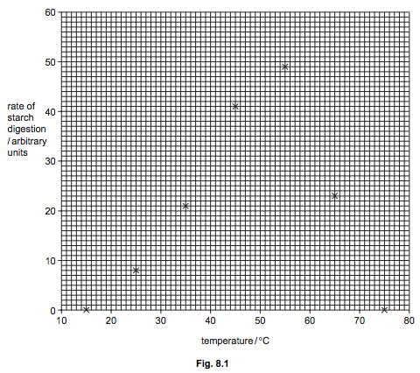
- Samples of an amylase enzyme were incubated with starch at different temperatures.
The rate of starch digestion in each sample was recorded and points plotted on the graph shown in Fig. 8.1.
(a) Complete this line graph to show the effect of temperature on rate of digestion of starch by the amylase enzyme by adding the most appropriate line to Fig. 8.1. Put your line on Fig. 8.1. [1]
(b) Using your graph estimate the optimum temperature for this enzyme. [1] ºC
(c) Suggest the rate of starch digestion at 37ºC. [The enzymes originally incubated at 15 ºC and 75 ºC did not digest any starch. These samples were later incubated at the optimum temperature. Predict what results could be expected in each sample and suggest reasons for your predictions.

- Give five functions of fats and oils in the body.

- Starches and sugars are carbohydrates and provide the body with energy
  - Name the elements from which carbohydrates are formed

  - Name two other nutrients that can provide energy. Define the following terms and give two examples of each
    - Monosaccharides

    - Disaccharides

- Fill in the table for the following digestive enzymes. Some boxes have been completed for you.
Enzyme | Substrate(s) | Product(s) | Where in human digestive system it’s produced
Amylase
Protease |  |  | Stomach and small intestine
Lipase |  | Fatty acids + glycerol

- A protease enzyme is found in the stomachs of humans. It catalyzes the breakdown of long chains of amino acids (proteins) into individual amino acid molecules.
  - In this example, identify:
    - The substrate: _____________________________________________________________________________
    - The products: _____________________________________________________________________________
    - The enzyme: _____________________________________________________________________________
  - Suggest the optimum temperature for the activity of the protease enzyme.______________ºC

  - Explain why the rate of an enzyme-controlled reaction is relatively slow at low temperatures.

  - Explain why the rate of the reaction slows down above the enzyme’s optimum temperature.

