Name: Date: Class: Gold 1
DUE DATE: Wednesday, January 7, 2015
Directions: Answer these questions using your knowledge of Cell Division. You may use other sources to help you, but you must note the sources used on the bottom of the last page. Everything must be in your own words, and answers should be thorough but should not exceed the space provided.

- The graph shows the amount of DNA in a cell during a cell cycle.
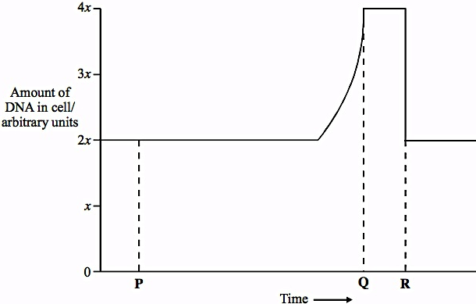
- Name the stage occurring between time P and time Q. Give the reason for your answer. [2]

- Explain the decrease in the amount of DNA present at time R. [1]

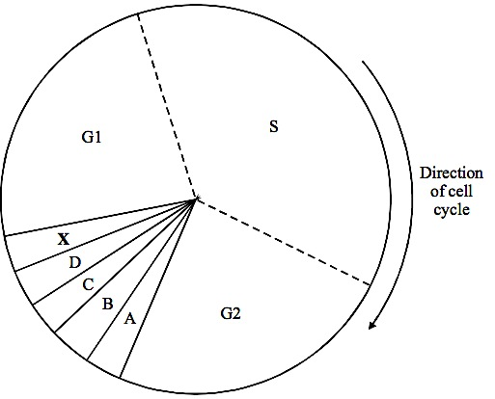
- The diagram shows the main stages of the cell cycle. The letters A to D represent the four stages of mitosis.
(a) Identify the stage when each of the following events is taking place. [2]
      - (i) DNA replication

  - (ii) Individual chromatids from a chromatid pair move to opposite poles of the cell.

(b) What is happening during Stage X? [1]

(c) Vinblastine is an anti-cancer drug that prevents the formation of a spindle.
  - (i) What is the function of the spindle? [1]

  - (ii) How would a drug like vinblastine help prevent the growth of a tumor? [2]

- The diagram shows some plant cells in different stages of the cell cycle.
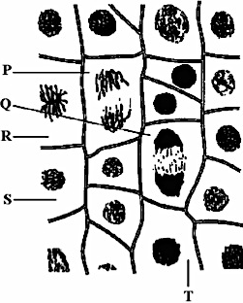
- (i) Name the stage of the cell cycle that Cell T is in. [1]

(ii) Describe two events which occur during this stage shown in Cell T. [2]

(b) Cells P, Q, R and S have reached different stages of mitosis. Arrange them in the correct sequence beginning with the cell representing the earliest stage. [1]

_______ _______ _______ ________

- The diagram shows the chromosomes from a cell with a diploid chromosome number of six.
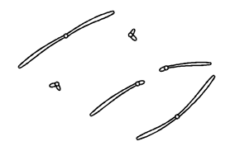
Draw a diagram to show the chromosomes from one of the resulting cells if
(i) the cell divides by mitosis; [2]

(ii) the cell divides by meiosis. [2]

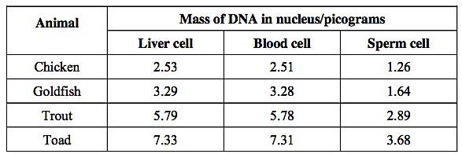
- Biologists found the mean mass of DNA in three different types of cells from different animals. Their results are shown in the table.
- What would you expect to be the mean mass of DNA in a skin cell from a toad? Explain your answer. [2]

- A zygote is formed when a sperm cell fertilizes an egg cell. How much DNA would you expect to find in a trout zygote that had just been formed? Explain your answer. [2]

- Scientists produced a model to show how chemotherapy works in the treatment of cancer. The model is shown in the diagram.
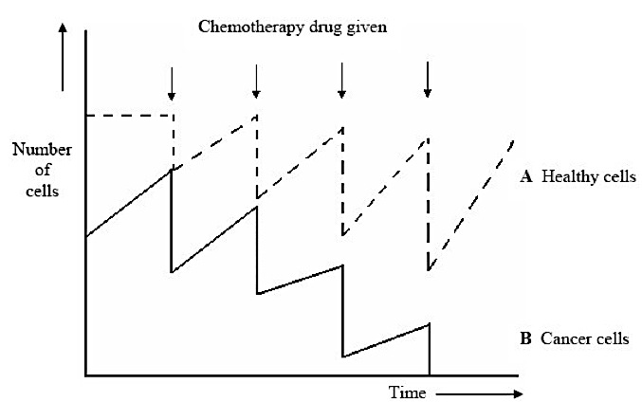
- Explain the difference in curves A and B before chemotherapy starts. [2]

- Chemotherapy drugs must be given a number of times if the treatment is to be successful. Use the diagram to explain why. [2]

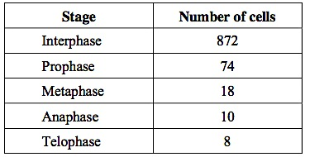
- A student examined the cells in a garlic root tip under the microscope, and obtained the following data.
a) Calculate the percentage of these cells in which the chromosomes are visible and would consist of a pair of chromatids joined together. Show your work. [2]

b) A different set of results was obtained when the count was repeated on another occasion with a different garlic root tip. Give two reasons for the difference in results. [2]

- The diagram shows a cell cycle.
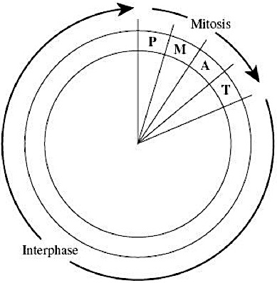
(a) The table shows the number of chromosomes and the mass of DNA in different nuclei. All the nuclei come from the same animal. Complete this table.[4]
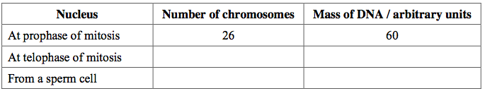
(b) If the DNA of the cell is damaged, a protein called p53 stops the cell cycle. Mutation in the gene for p53 could cause cancer to develop. Explain how. [3]

(c) Drugs are used to treat cancer. At what phase in the cell cycle would each of the following drugs act? [2]
  - (i) A drug that prevents DNA replication

  - (ii) A drug that prevents spindle fibers shortening

Sources: List any sources (besides class notes) that you used to help you answer these questions, including other people you worked with.

