Name: Date: Class:

Background
A reducing sugar is a carbohydrate that is oxidized by a weak oxidizing agent (such as Copper Sulfate) in basic aqueous solution. Most sugars will reduce copper sulfate solution, which is blue, to copper oxide, which is brownish red. The test for reducing sugars is called Benedict's test.
The test for starch is called the iodine test. Starch turns iodine solution a dark blue-black color.

Procedures
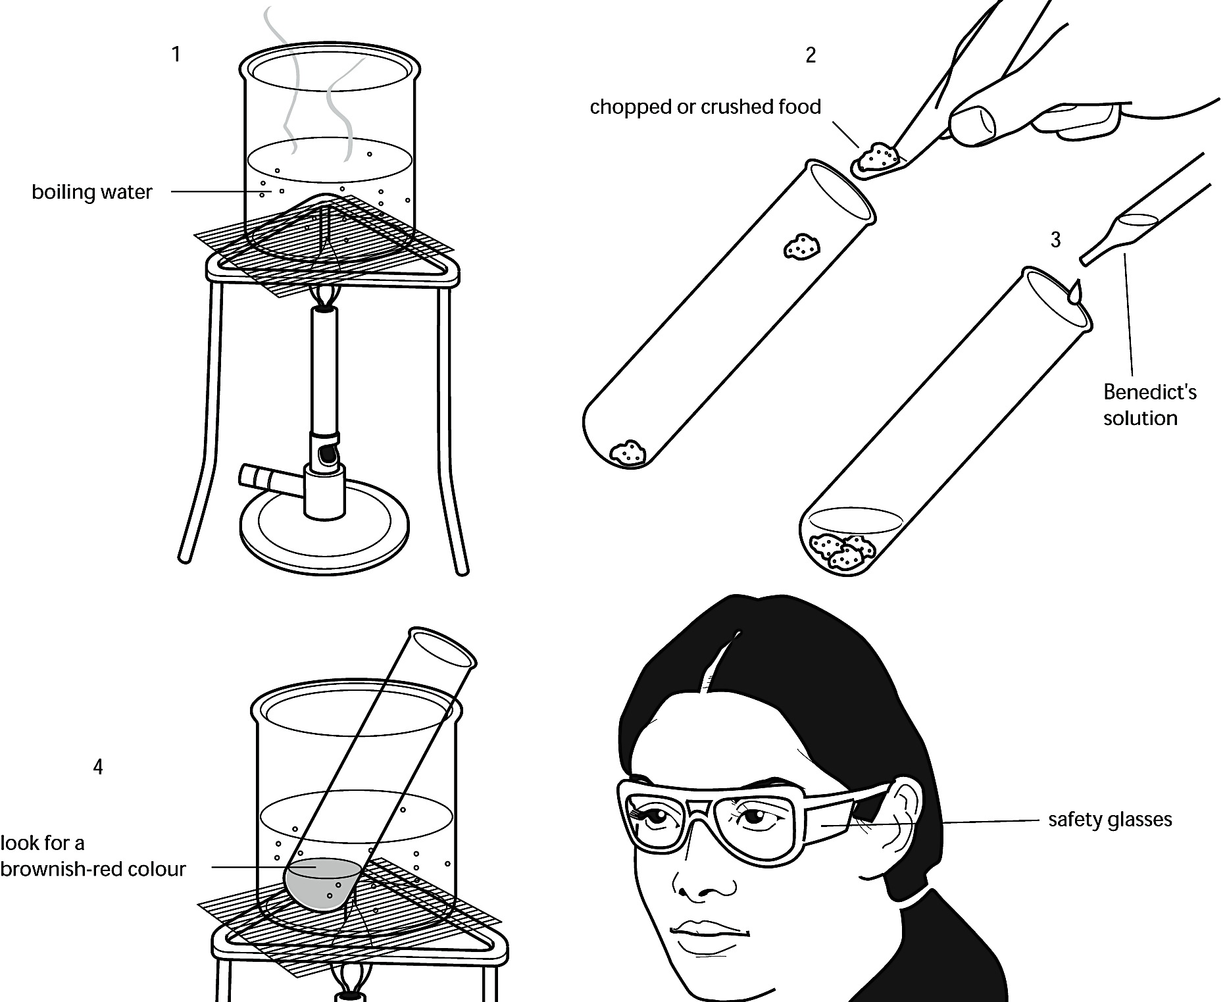
Read through the following instructions, and then design an Observations Table in which you can write your results and conclusions for both parts 1 and 2.

Safety: Wear goggles and apron at all times. You will be using very hot liquids. Be careful to wear gloves when touching hot glassware. Additionally, Benedict’s solution is a strong base. Avoid contact with skin. Iodine is an irritant and a dye. Again, avoid contact with skin.
Part 1: Testing for Reducing Sugars
1 Prepare a water bath at about 75°C
2 Add about 5 cm³ of liquid or chopped/crushed (use the mortar and pestle if needed) sample to a boiling tube.
3 Add 5 cm³ of Benedict's solution to the boiling tube.
4 Stand the boiling tube containing the sample and Benedict's solution in the water bath. Leave it for 5-9 minutes. Watch for any color changes, and record your observations in your table.
5 If the Benedict’s solution stays blue, there is no reducing sugar in the food. If it changes to a rather dirty yellow-green color, there is a small amount of reducing sugar in the food. If you see an orange or reddish-brown precipitate, there is a lot of reducing sugar in the food. Record your observations in your table.
6 Repeat with the remaining food samples (if time)
7 Repeat the test with 5 cm³ of pure sucrose. Record your observations in your table.
8 Repeat the test with 5 cm³ of pure glucose. Record your observations in your table.

Part 2: Testing for Starch
Read through the following instructions, and then design an Observations Table in which you can write your results and conclusions.
1 In a spotting tile, put small amounts (a few drops) of each of the samples in different wells
2 Using a dropper pipette, add a few drops of iodine in potassium iodide solution to each food.
3 Wait a few moments, and then write down the color you observe in your Observations Table.
4 If the iodine in potassium iodide solution stays orange-brown, there is no starch in the food. If it turns dark blue-black, there is starch in the sample. Record your conclusions in your table.
Observations Table (create below) [12 pts]: This should include both parts 1 and 2

Analysis [8 pts]:
- Which sample(s) contained the most reducing sugars? Is glucose a reducing sugar? Is sucrose?

- Which sample(s) contained the most starch?

- What are some different carbohydrates that were not tested for in this lab?

- What are some possible sources of experimental error? How could you increase the validity/reliability of the experiment?

