Name: _________________________________________________________________________ Date: ______________

Due Thursday, January 22 (M3) or Friday, January 23 (G2/G4)
*This will be 10 points towards in your Quarter 3 “A- Knowledge with Understanding” standards grade

Instructions:
- Look at the diagram below. Explain the steps involved in protein synthesis. Use the phrase DNA mRNA Protein to help you.
- Be sure to include the following terms, and underline them in your explanation:
DNA, enzymes, hydrogen bonds, gene, replication, mRNA, nucleus, transcription, translation, ribosome, codon, tRNA, anticodon, amino acid, peptide bonds, and protein
- You may write your answer on the back of this worksheet. Attach any additional sheets needed.
- Write all internet (or other) sources used in the space provided below.
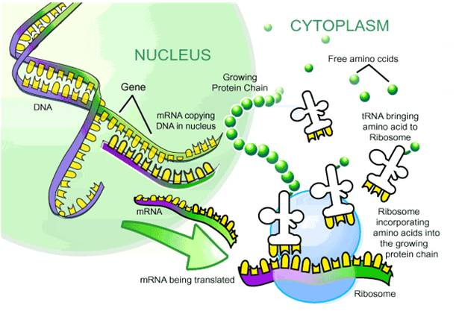
Image Source: http://westwood.roundrockisd.org/cms/One.aspx?portalId=13553&pageId=2843249
Sources:

