Name: ___________________________________________________________
Sheep Heart Dissection Lab
Purpose: In this practical, you will:
- identify the structures visible on the surface of the heart
- trace the pathway taken by blood as it flows through the heart
- dissect the heart to show how its structure enables it to carry out its function as a pump.
Apparatus and materials
• sheep heart |  | • blunt seeker  • scalpel |  | • scissors  • surgical gloves
• dissection board |  | • disinfectant |  | • forceps

Preparation: Do the following in your LAB notebook.
- Draw up a table to compare the structure and appearance of the four chambers of the heart.
- Create a table to record all your measurements of wall thickness in a suitable way.
Procedure Part I:
Place the heart on a dissection board with the coronary vessels on the upper side. You should be looking at the heart as seen from the front of the animal (a ventral view). The ventral side is the most convex (rounded). The thick walled arteries come from this side too. Also, figure out which is the bottom of the heart, called the apex because it is narrow, and which is the top part of the heart, called the base because it is wide.

Check that the left ventricle is on the right-hand side – it will feel solid when pressed. The right ventricle feels softer.

Procedure Part II:
- Identify the parts of the heart shown in the diagram below: The side shown in this diagram is the ventral side (rounded side). Don't cut it yet.
- Carefully put a rubber tube into part of the vena cave, close off any other holes in the vena cava and gently turn on the tap. Locate which blood vessel water comes out of-this should be the pulmonary artery.
- Repeat the last step with the pulmonary vein. The water should flow out of the Aorta.

Aorta | 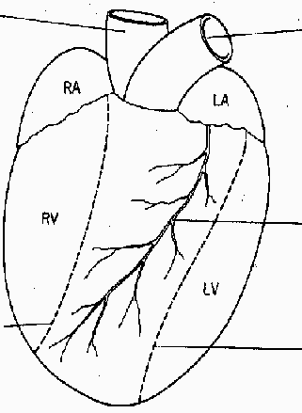 | Pulmonary artery
The two vena cava go into the right atrium on the other side (dorsal side) |  | The pulmonary vein goes into the left atrium on the dorsal side.
 |  | Coronary artery and vein
When you need to see inside the right ventricle, cut here.
 |  | When you want to open the left ventricle cut here.

- In your notebook, make a drawing of the heart to show the main external features. Draw a ventral view, with the apex at the bottom of the drawing. Label and add a scale to your drawing.

Procedure Part IIIA:
- Cut open the left ventricle following the lines on the diagram. Turn the heart upside down and run water into the ventricle.
- Examine the bicuspid valve between the left atrium and the left ventricle. Measure the thickness of the walls of the two chambers. Record in your table.
- In your notebook, make a sketch of one valve with the chordae tendineae.

Procedure Part IIIB:
- Cut the aorta leaving about 3cm above the heart. Expose the semilunar valves. Find the origin of the coronary arteries in the aorta. Run water into the Aorta from the top of the heart.
- Trace the pathway of blood as it leaves the left ventricle through the aorta.
- In your notebook, make a drawing of your dissection of the left side of the heart. Label the drawing. Use annotations to describe the appearance of the structures you have drawn and their functions. Add a scale to your drawing.

Procedure Part IIIC:
- Cut into the vena cava and then through the right atrium. From there cut into the wall of the right ventricle down to its base. Clear out any clotted blood. Open up the chambers and wash out with water if necessary.
- Cut into the right and left atria and look at the muscle in the wall of the atria.
- Measure the thickness of the walls of the chamber. Record in your table.

Procedure Part IIID:
- Cut open the right ventricle by following the lines on the diagram.
- Examine the valve between the right atrium and the right ventricle. Measure the thickness of the walls of the two chambers.
- Trace the pathway taken by blood as it leaves the right ventricle through the pulmonary artery.
- Cut down the pulmonary artery to expose the semilunar valves.
- In your notebook, make a drawing of your dissection of the right side of the heart. Label the drawing. Use annotations to describe the appearance of the structures you have drawn and their functions. Add a scale to your drawing.

- When you have finished, dispose of the dissected material as instructed, wash the dissection board and place the instruments into disinfectant. Wash your hands thoroughly.

