Name: ______________________________________________________________________Date: Class:

Directions: Use the powerpoint on my Weebly to fill in these notes and answer these review questions Go to my Weebly (ecampbellasuprep.weeb;y.com) AS Biology Unit 9: Reproduction Fertilization & Pregnancy. These are due at the start of next class.
SCORE: /10

Part 1: Fertilization
Watch the videos posted on my Weebly about fertilization. View the readings linked on my Weebly for further info.
Number | What happens?
 | The ZYGOTE reproduces to make a ball of cells called an EMBRYO.
 | The EMBRYO develops into a foetus (an unborn baby).
 | The egg is release from the ovary into the fallopian tube
 | The sperm and egg join together. This is called fertilisation and it makes a ZYGOTE.
 | The EMBRYO travels into the uterus and implants in the lining.

Fertilization Flowchart
Fill in the boxes with the words below. Also write the correct numbers of chromosomes in the nucleus of each cell (as shown below).
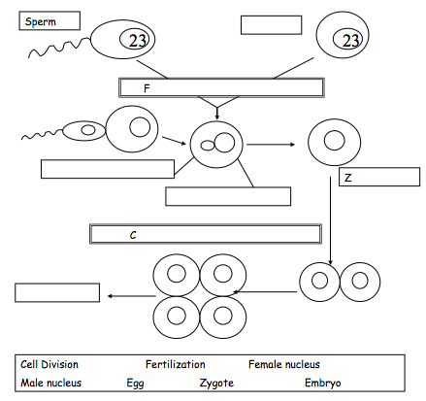

Part 2: Placenta and Pregnancy
Read the article, “Pregnancy- The Basics” then complete these questions based on the reading.
- Diagrams. Fill in the blanks to complete the diagrams below

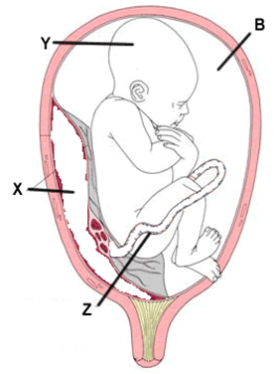
- Placenta Color-Coding
In the placental mammals the embryo is surrounded by an amnion filled with amniotic fluid – (B) color blue.

Doctors will sometimes examine the fluid to determine the health of the fetus (Y, color pink).

The umbilical cord provides a connection through which food reaches the fetus, and wastes are removed. Color the umbilical cord (Z) green.

Together with part of the chorion, these membranes make up the placenta, which physically attaches the embryo to the uterine wall of its mother. It is across the placenta that air, food, and wastes must be transferred. Color the placenta (X) red.

- Complete this table by putting ticks in the correct columns:

Substance | From mother to embryo | From embryo to mother
Oxygen
Carbon dioxide
Food
Waste
Alcohol
Drugs
Viruses (e.g. HIV)

- Pregnancy - Dangers to fetus
Match the substance to the effect it may have on a developing baby.
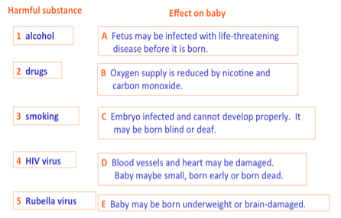

- Pregnancy Questions, Part 1
CHOOSE SIX OF THE FOLLOWING questions to answer based on the reading, “Pregnancy- The Basics”
Question |  | Your Answers
1. | Which key terms are defined below?  - a fertilized egg  - a ball of cells formed when a fertilized egg starts to divide  - a developing embryo, once it has reached the stage where we can identify its head and limbs, and what species it is
2. | Roughly, how many cells make up an adult human body?
3. | Name the protective sheet surrounding the foetus?
4. | What is the job of the amniotic fluid?
5. | Explain what is meant by the term implantation
6. | What is the job of the placenta?
7. | The umbilical cord contains two types of blood vessels – arteries and veins. Explain why this is
8. | What are villi?
9. | Why is the surface of the placenta covered in villi?
10. | Why does the lining of the uterus have a good blood supply?
11. | Cigarette smoke contains carbon monoxide and nicotine. Carbon monoxide reduces the amount of oxygen which the blood can carry. Nicotine is addictive.  Explain why pregnant women are advised not to smoke.
12. | Malaria is a disease caused by a parasite. The parasite is several times bigger than a bacterium. The malaria parasite infects red blood cells and destroys them. The function of red blood cells is to carry oxygen around the body.  If a pregnant woman has malaria, explain how this could harm her foetus
- Pregnancy Questions, continued
The diagram shows a fetus.
- Label the umbilical cord on the diagram.
- Explain what the umbilical cord does.

- Explain the function of the amniotic fluid.
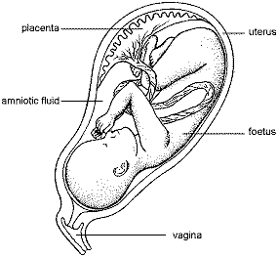
Using the graph opposite
- How long is pregnancy?

- Between which weeks is there the most rapid growth in mass?

- What is the approximate mass gain in kilograms between this time period?

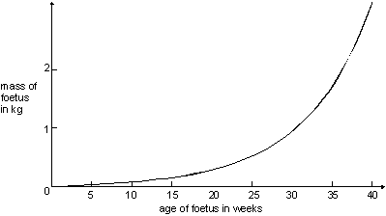
Using the diagram
- Explain the function of the ovary.

- If a women’s fallopian tube were blocked, what effect would that have?

- When a female takes a contraceptive pill the lining of the uterus does not thicken.

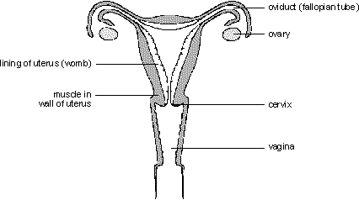

- Journey of a Sperm Cell
Use the key words to write a story, or DRAW A CARTOON, of the journey you would take if you were a sperm cell starting in the testicles and travelling to find the egg cell. You must use all of the keywords.
For help, refer to the resources on Fertilization.
Keywords
Sperm, Urethra, Penis, Vagina, Testicles, Cervix, Uterus, Fallopian tube, Egg cell, Fertilize, Sperm duct

