Calibrating an Eyepiece Graticule
Apparatus and materials
CLASS SET

• microscope
• eyepiece graticule
• stage micrometer
• prepared slide of TS of a young stem,
• prepared slide of LS of a stem

Introduction
In this practical, you will:
set up a light microscope and use it to make observations and measurements
make a drawing of the plant cells
- calibrate an eyepiece graticule and use it to measure the size of the cells.
- study the microscopic structure of xylem and phloem tissues within the vascular bundle.

Procedure
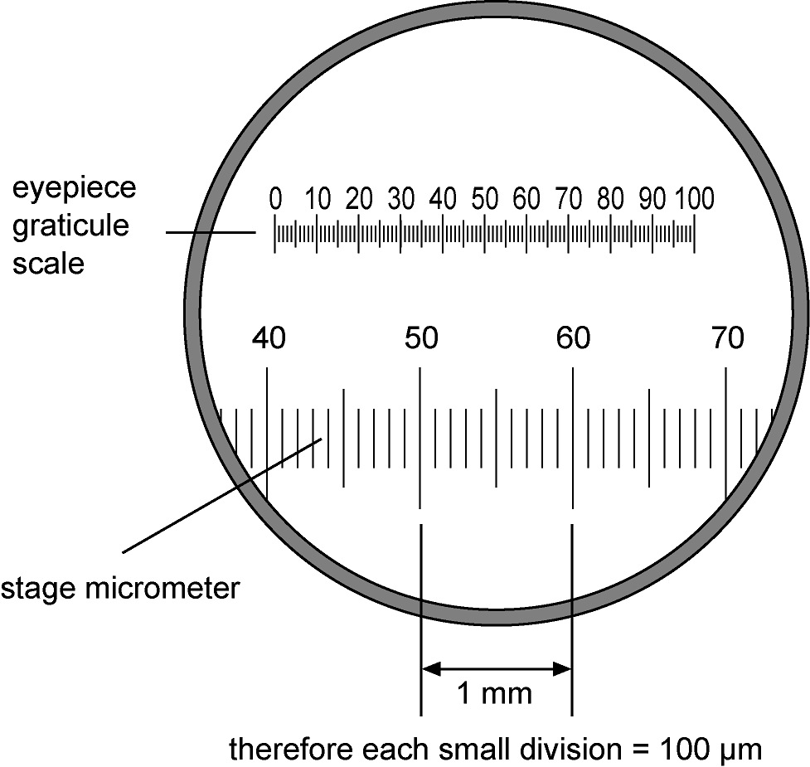
A Calibrating an eyepiece graticule
1 Obtain a microscope containing an eyepiece graticule
2 Place a stage micrometer slide on the stage of the microscope. The smallest division on the stage micrometer equals 100 µm.
3 Using the low-power objective, focus the microscope on the stage micrometer. Rotate the eyepiece and move the slide to superimpose the scales of the eyepiece graticule and the stage micrometer (shown in the diagram here).
4 Count the number of divisions on the eyepiece graticule equivalent to 100 µm on the stage micrometer and then calculate the length that one eyepiece division is equivalent to. For example, if three divisions are equal to 100 µm, then each division is equal to 33.3 µm at low power. Record your answer.
5 Repeat step 4 for the medium- and high-power objectives. You have now calibrated the eyepiece graticule and you can use it to measure cells in the preparation below, or in the preparations in the next practicals.
B Practice measuring
1 Obtain two prepared slides of your choice
2 Place the slide on the stage of the microscope and use the low-power objective to locate the cells. Now use the high-power objective to select three adjacent cells that are clearly visible in your field of view.
3 Make a large biological drawing in your notebook. Use a sharp pencil (HB) and a ruler to draw the label lines and labels.
5 Use the eyepiece graticule to measure the length of one of the cells that you have drawn. Now measure the same cells in your drawing. Calculate the magnification of your drawing and indicate this below your drawing (see part C-step 6)
6 Repeat steps 1-5 for the other prepared slide.
C Viewing plant slides
1 Obtain a prepared slide of plant tissue
2 Place the slide on the stage of the microscope and use the low-power objective to locate the cells. Now use the high-power objective to select three adjacent cells that are clearly visible in your field of view.
3 Make a large, labelled drawing of these three plant cells. Use a sharp pencil (HB) and a ruler to draw the label lines and labels.
5 Use the eyepiece graticule to measure the length of one of the epidermal cells that you have drawn. Now measure the same cell in your drawing.
6 Calculate the magnification of your drawing, using the formula:
Remember that both lengths must be measured in the same units, e.g. micrometres (µm). Write the magnification underneath your drawing.
7 Use the low-power objective of your microscope to examine the prepared slide of a transverse section (TS) of a stem. Find the xylem. Use the high-power objective to examine carefully the xylem tissue. Compare what you can see with Figure 7.7 on page 127 of the Coursebook.
Using high power, draw three adjacent xylem vessels. Use a calibrated eyepiece graticule to measure the width of one of the xylem vessels and indicate this on your drawing.
8 Examine a prepared longitudinal section (LS) of stem under high power for xylem vessels. Add any further observations to the illustrated description you made in step 4.
9 Look again at the prepared slide of a transverse section of a stem. This time find phloem tissue. Use high-power objective to examine the phloem tissue carefully. Look for any sieve plates with sieve pores – sometimes these are visible in cross-sections.
10 Make a drawing to show the details of three adjacent phloem sieve tube elements and their companion cells. Use a calibrated eyepiece graticule to measure the width of one of the sieve tube elements and indicate this on your drawing. Use labels to show the two types of cell you have drawn.
11 Examine a longitudinal section of stem using the high-power objective and look for phloem tissue. Compare what you can see with Figure 7.15 on page 133 of the Coursebook.
12 Write an illustrated description of your observations of phloem tissue.
13 Construct a table to show the differences between xylem and phloem tissue that are visible using a light microscope.
D. Analysis and Application Questions : Show Your Calculations!
- Approximately 500 of a certain type of bacteria can fit across your low-power field of vision. What is the approximate size of 1 bacterium?
- Approximately 7 of a certain type of protist can fit across your high-power field of vision. What is the approximate size of 1 protist?
- If a microscope has a low-power magnification of 100X, a high-power magnification of 600X, and a low-power field diameter of 1800 micrometers, what is the high-power field diameter in micrometers?
- If 20 objects fit across a low-power field of view whose field diameter is 3000 micrometers, what is the approximate size of each object?

To summarize, for this lab, you need in your notebook:
- Your calibration values and evidence of the calculations
- Two biological drawings of prepared slides of your choice, with magnifications calculated and labelled
- -Three biological drawings of the plant elements specified above, with magnifications calculated
-Illustrated descriptions and table of differences (see steps 12 and 13 of part C)
- Analysis and Application Questions with calculations shown

