Name: ____________________________________________________ Date: ___________________ Class: Maroon 2

Directions: To view the powerpoint for today’s notes, go to ecampbellasuprep.weebly.com/plants.html

- REPRODUCTIVE STRUCTURES
- Which structures are the reproductive structures of plants?

- Label the numbered structures in the flower below.
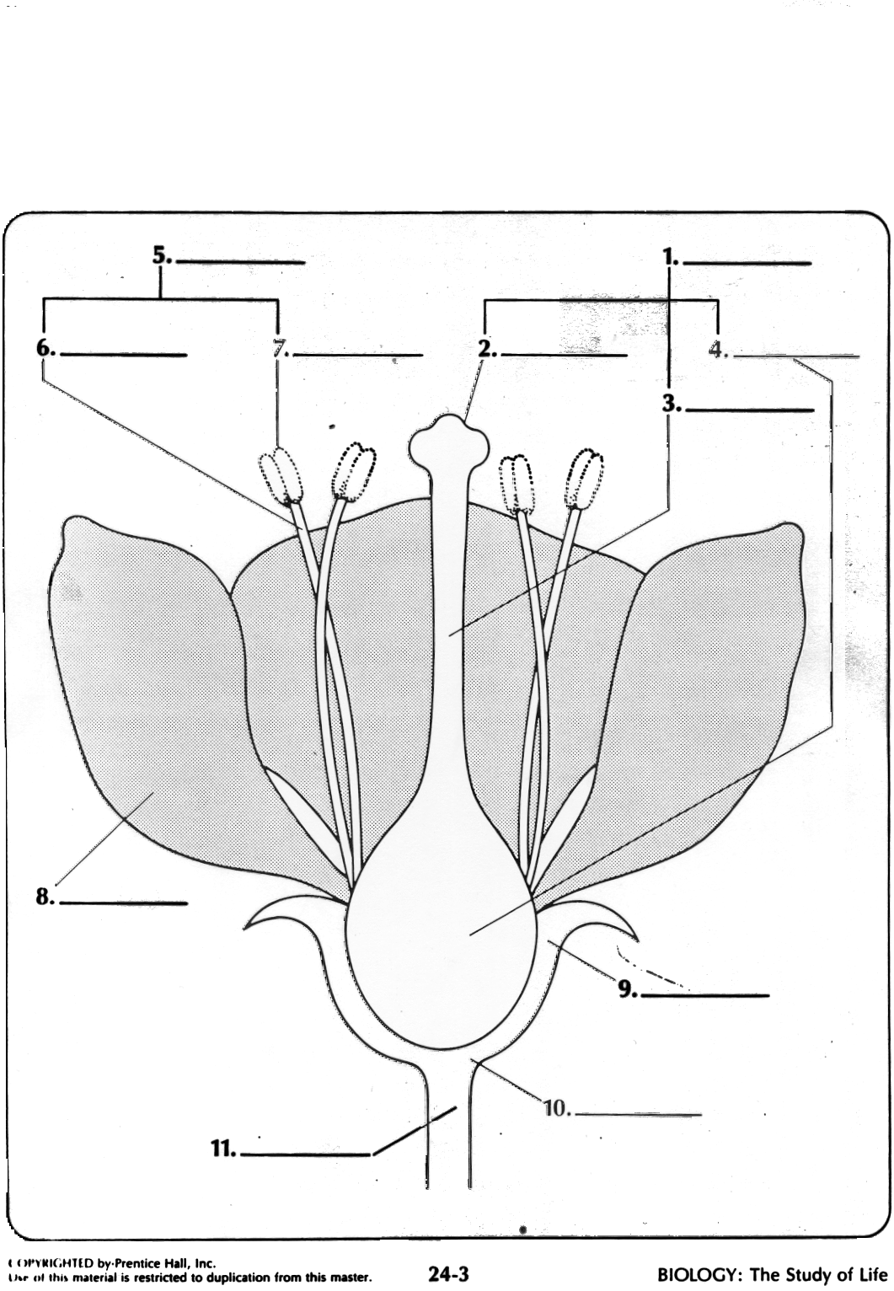

- The stamen consists of two parts: ___________________________ & ____________________
  - The anther is where __________________
  - The filament is a _________________
- The pistil (or carpel) consists of the ________________________________
  - Meiosis occurs in _____________________ to produce _______________________________
  - The sticky stigma _______________________________
  - The pollen _______________________________
- FERTILIZATION:
- After pollen lands on the _________________________, a ______________________________ grows down through the ______________________________ to ______________________________
- The pollen tube passes through the ______________________________ into the ____________________________
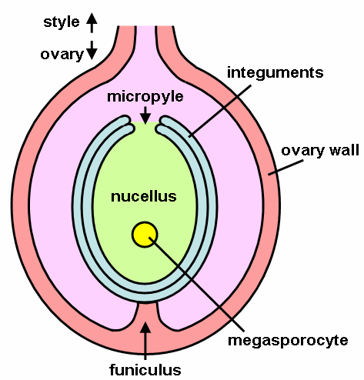
- Male gametes travel ____________________________tube and ____________________________
- The ___________________________fuses with the ____________________________–-- ____________________________ has taken place

- SEED AND FRUIT DEVELOPMENT
- After fertilization, the ____________________________ and ____________________________ fall off flower
- ____________________________ “ripens” into a ____________________________
- The ____________________________ develops into ____________________________
OTHER REPRODUCTIVE STRUCTURES: What do they do?
- Petals:

- Sepals:

REFLECT
In which part of a flower are male gametes made?
In which part of a flower are female gametes made?

- POLLINATION
- ____________________________, ____________________________ or ____________________________ transfer pollen from the ____________________________ of one flower to the ____________________________ of another

- Flowers vary depending on ____________________________
- Pollination Vectors:
  - Wind Pollination
  - Bees/Butterfly Pollination
  - Bird Pollination
  - Moth Pollination
  - Fly Pollination
REFLECT:
After pollination, how does the male gamete reach the ovule?

- SEED DISPERSAL: Describe each of the following seed dispersal mechanisms
- Seed Dispersal Mechanisms
  - Wind Dispersal

  - Animal Dispersal

  - Gravity Dispersal

  - Water Dispersal

HW: Cambridge Practice Questions: DUE DATE: Wednesday, April 8th, 5 points
- A plant was allowed to disperse seeds naturally. The seedlings were examined two weeks after they had started to grow. They were found to be of very different heights.
  - Suggest three environmental factors which could have affected the height of the seedlings.

  - The seedlings all developed from seeds of a single plant. The plants which later developed from these seedlings showed a number of inherited differences. Suggest three possible reasons for these inherited differences.

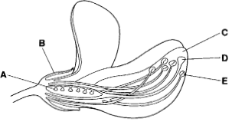
- The figure at the right shows a section through a bean flower.
  - Name the parts labeled A and B.

  - The flower is insect pollinated. Suggest how parts C, D, and E help in pollination of this flower.

  - After pollination the ovules develop into seeds. Describe the events which occur after pollination and which result in the formation of seeds.

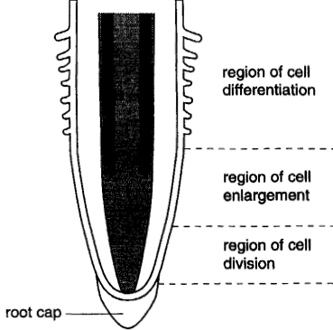

- The figure at the right is a longitudinal section through a root tip showing the regions of growth and development.
  - Distinguish between growth and development.

  - Outlines what happens in the “region of cell division”.

