Directions: You must complete this in order to receive credit for each part of the lab. If you do not finish this in class, you must complete it as homework and turn it in at the start of the next class in order to participate in that day’s lab. To turn-in each page, detach it from the packet; do not detach pages if you haven’t finished both sides. Attach additional pages as needed.

Many of the answers are in your procedures packet. For those that are not, the answers can be found via the resources posted on my Weebly, or via Google.

Day 1: PART A- EXTERNAL ANATOMY (5 points)

1. How long (metric) is your fetal pig? ________________

2. What is the age of your fetal pig? ________________
3. What sense organs are located on the head & in the mouth? _______________________________________________
4. How many toes are present on each foot? ________________
5. Are the hooves split or fused? ________________
6. What is the sex of your fetal pig? ________________________________
- What directional word means:
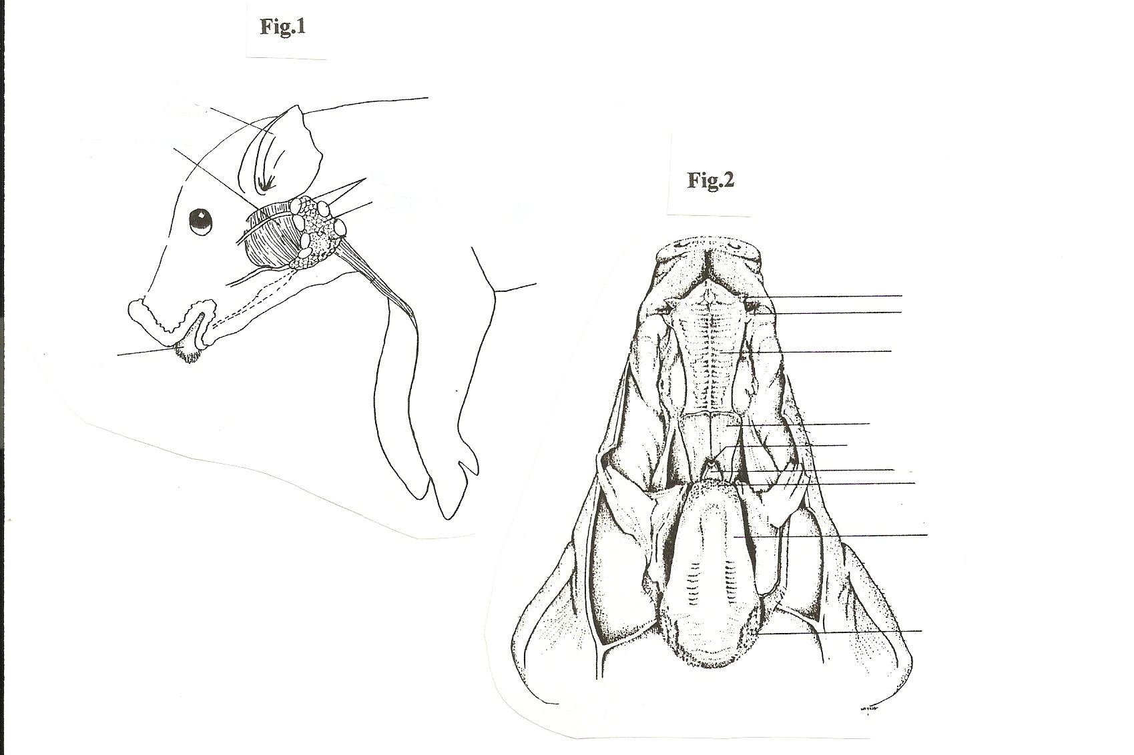
- Forward? _________________________________
- Toward the snout? _________________________________
- Toward the tail? _________________________________
- Toward the backbone? ___________________________________
- Toward the belly? ___________________________________
- Toward the side? ___________________________________
- Toward the midline? ___________________________________
- Near the reference point? ___________________________________
- Far from the reference area? ___________________________________
- Label Figure 1 and Figure 2 (at right):

DAY 1: PART C- Digestive System (5 points)
Directions: You must answer questions 11-13. For questions 1-10, choose 3 questions to answer. These may be completed as homework.
- What is the purpose of saliva?

- Fetal pigs receive nourishment from their mother through the___________________________
- The stomach of a fetal pig won’t be empty because they also drink_________________________________

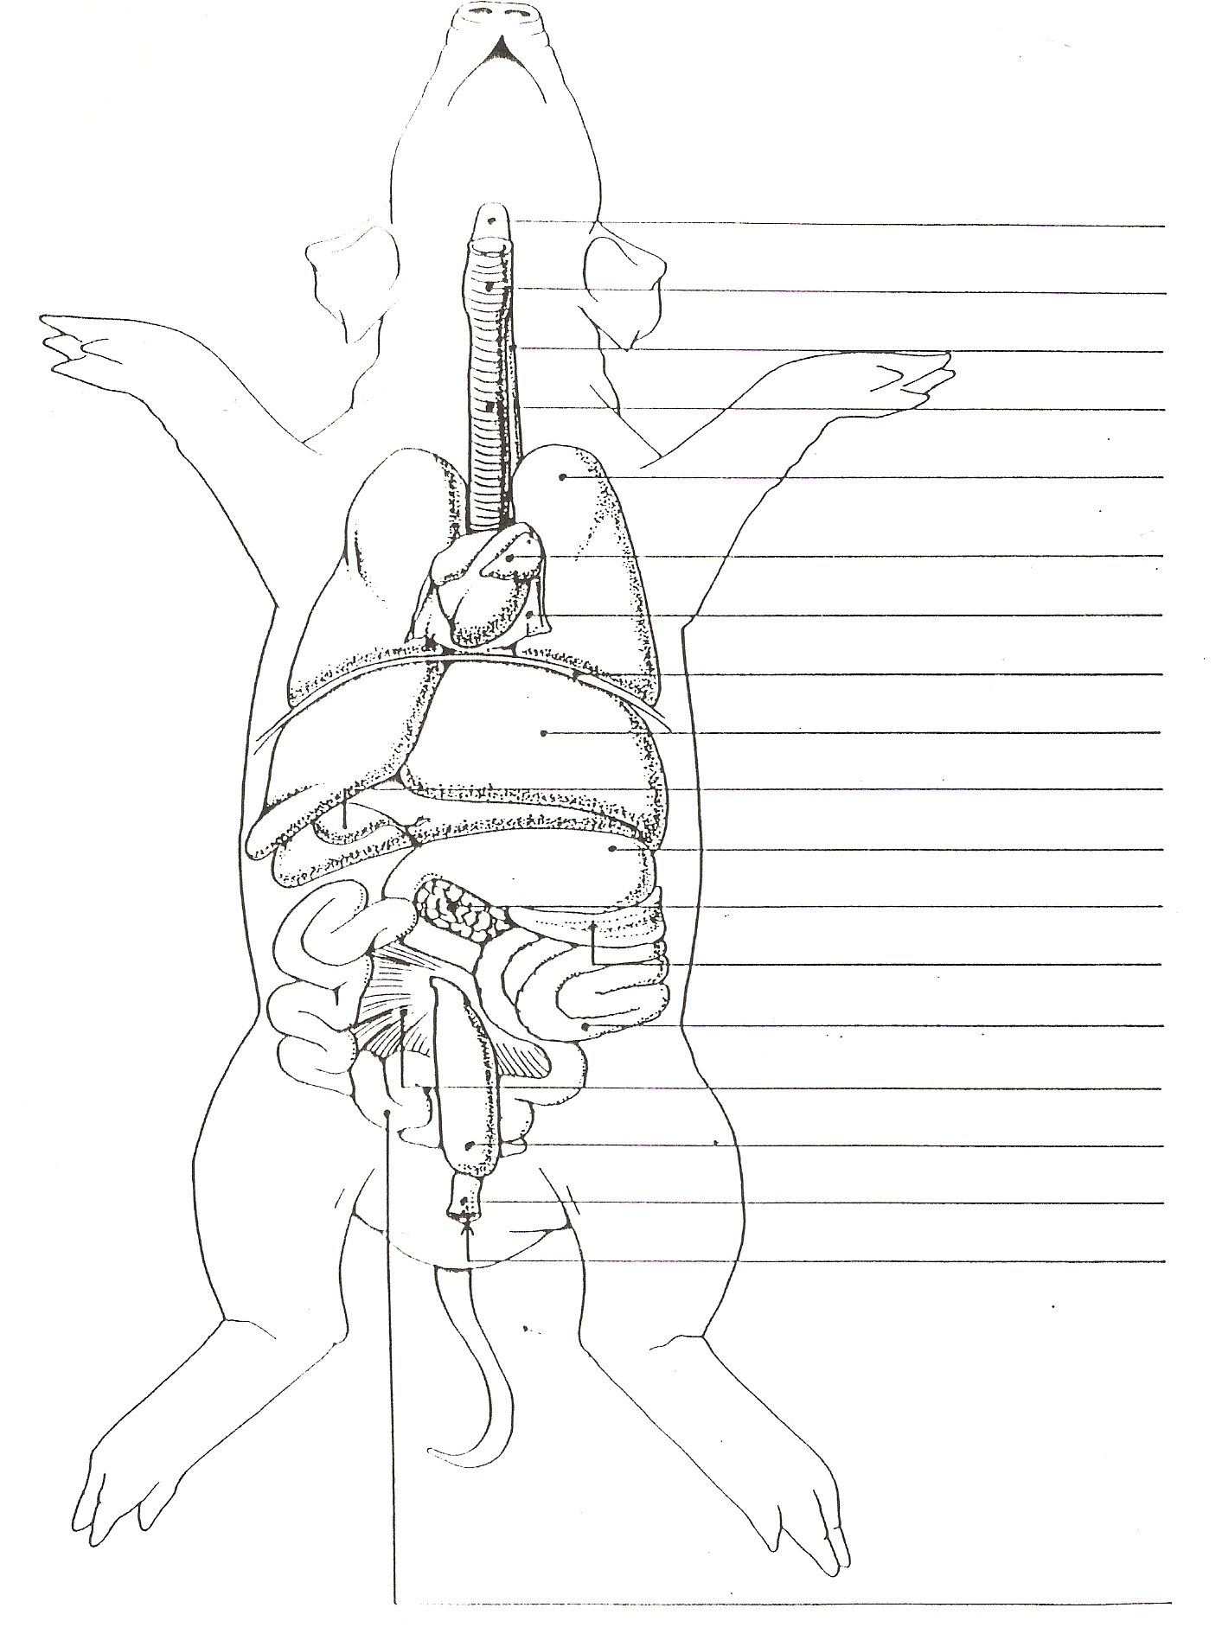
- How many lobes are there to the pig’s liver? What’s the function of the liver?

- Give the function for:
- gall bladder?

- pancreas?

- Name the ridges inside the stomach & briefly state their function.

- Are pigs herbivores, carnivores, or omnivores? Explain.

- Give the function of sphincters & where can they be found

- Food leaves the stomach as a soupy, partly digested material called____________________.

- Another name for the large intestine is __________________________________________.
Its function is?

- *Length of small intestine (cm): ___________ Width of small intestine (cm): ___________
- *Length of large intestine (cm): ___________ Width of large intestine (cm): ___________
- Label the diagram on the above right (you must label a minimum of 5 structures).
Day 2-PART D: Respiratory System (5 points) Fetal Pig Dissection Hand-in
1. The lungs are found in what body cavity? ___________________________________

2. Name the tissue that covers and protects the lungs.__________________________________

3. Where is the epiglottis & what is its function? ___________________________________

4. Where is the pharynx located? ___________________________________

5. Give the function of the larynx. ___________________________________

6. What keeps the trachea from collapsing? ___________________________________

7. Where is the diaphragm & give its function.

8.Does the diaphragm function in the fetus? Explain.

9. Name the
- large tubes that enter the lungs. ___________________________________
- smaller tubes that branch from these? ___________________________________
- air sacs for gas exchange? ___________________________________
10. Why do the lungs appear collapsed in the fetus? ___________________________________
Label the following diagram:

PART E: Circulatory System (5 points) FETAL PIG DISSECTION HAND-IN

1. What is the pericardium?

2. What differences between the atria and the ventricles can you feel with your fingers?

3. Into what heart chamber does the superior and posterior vena cava open?

4. From what chamber does the aorta arise?

5. To what structures do the pulmonary arteries lead?

6. Why does the ductus arteriosus close off at the time of birth?

7. What is the function of coronary circulation?

8. What results when coronary circulation is prevented in humans?

9. Describe, in detail, the interior of the lungs.

10. In what 2 systems does the epiglottis function?

Label the parts of these two diagrams.

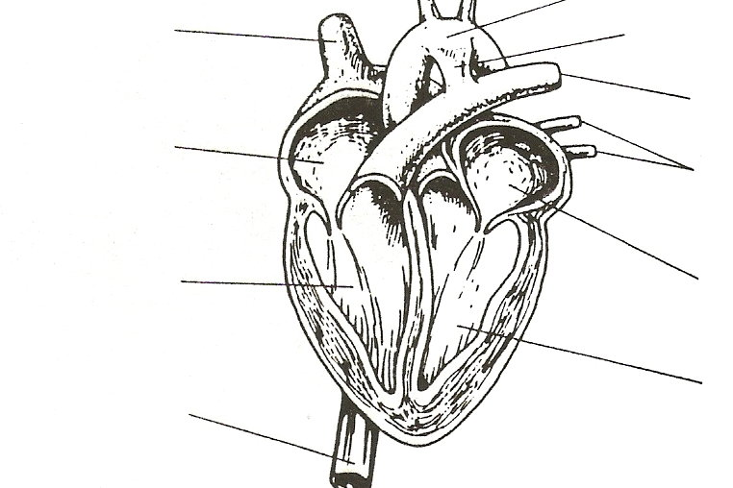

PART F: Urogenital System (5 points) FETAL PIG DISSECTION HAND-IN
***Be sure to observe a pig of both sexes.

1. In order, name the structures through which urine passes from the kidneys.

2. In order, name the structures through which sperm passes from the testes.

3. In order, name the structures through which an egg would pass from the ovary.

Label the parts of these two diagrams.

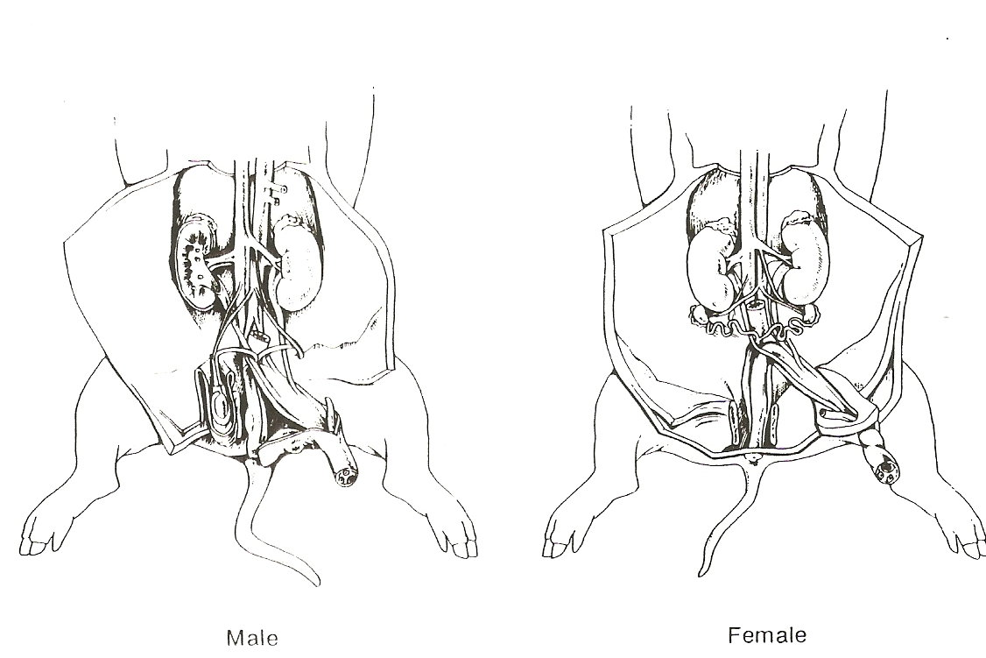

DAY 3-PART G: Nervous System (5 points) FETAL PIG DISSECTION HAND-IN

1. Name the protective membranes covering the brain. _____________________________

2. The olfactory lobe at the front of the brain controls what? ________________________

3. What part of the skeletal system protects the brain? _____________________________

4. Name the largest area of the brain? ___________________________________________
How many hemispheres does this lobe have? ___________________________________

5. Give the function of the following:
Cerebrum? ____________________________________________________

Cerebellum? ____________________________________________________

Medulla oblongata? ____________________________________________________

Spinal cord? ____________________________________________________

Label the parts of the brain and spinal cord:

