Name: Date: Class: Gold 1
SCORE: /20
Syllabus Objectives for Infectious Diseases:
- Define the term disease and explain the difference between an infectious disease and non-infectious diseases (limited to sickle cell anemia and lung cancer)
- Explain how cholera, malaria, TB & HIV/AIDS are transmitted
- State names and types of causative organism of each of the following diseases: cholera, malaria, TB, HIV/AIDS, smallpox and measles
- Discuss the factors that need to be considered in the prevention and control of cholera, measles, malaria, TB and HIV/AIDS
- Discuss the factors that influence the global patterns of distribution of malaria, TB and HIV/AIDS and assess the importance of these diseases worldwide;
- outline the role of antibiotics in the treatment of bacterial infectious diseases (knowledge of specific antibiotics and their mode of action is not required);

- Defining Disease and Causative Organisms
- Define the term disease:

- Disease can infectious or non-infectious. Explain the difference between these two types of disease.

- Use the table to make a list of 4 infectious diseases and 4 non-infectious diseases.
Infectious Diseases | Non-infectious Diseases

- Sickle cell anemia and lung cancer are two diseases which are non-infectious. What are the symptoms of these two diseases and how are they caused?
  - Sickle cell anemia:

  - Lung cancer:

- An infectious disease is caused by a pathogen. List the 4 different types of pathogen and give at least one example of a disease caused by each one.
Type of pathogen | Description | Example of disease caused by pathogen

- Transmission
- What is meant by the term transmission? Why is it better to use this term when describing how diseases are spread rather than saying “passed from person to person”?

- These are the infectious diseases that the syllabus says you need to know. Fill in the column for Causative organism with the terms (Virus “V”, Bacterium “B” Protozoan “P”).
Name of disease | Causative organism type | Name of pathogen
Smallpox |  | Variola major and Variolia minor
Acquired immune deficiency syndrome (AIDS) |  | Human immunodeficiency virus (HIV)
Tuberculosis |  | Mycobacterium tuberculosis
Malaria |  | Plasmodium falciparum and other Plasmodium sp.
Cholera |  | Vibrio cholerae
Measles |  | Morbillivirus
- How are the following diseases transmitted?
- HIV/AIDS

- Tuberculosis

- Measles

- Cholera

- Malaria

- Global Distributions
- Read this article to find where malaria, tuberculosis and HIV/AIDs are prevalent and highlight these on your World Map on the next page (please use a different color for each). Complete the key.
http://generalhealthonline.com/2011/11/06/global-distribution-diseases-tb-hivaids-cholera-malaria/
- Describe the global distribution of each disease and explain why each of these diseases is distributed this way?
- Malaria

- HIV/AIDS

- Tuberculosis

- Use the WHO Database to find statistics on current numbers of cases of malaria, tuberculosis and HIV/AIDS. How many people died from each of these diseases in 2011?
http://apps.who.int/ghodata/
Disease | Deaths 2011
HIV/AIDS
Malaria
Tuberculosis

- Finally, for each of the three diseases - malaria, tuberculosis and HIV/AIDS – find out what treatments are available and how it can be prevented.
Disease | Treatment | Prevention

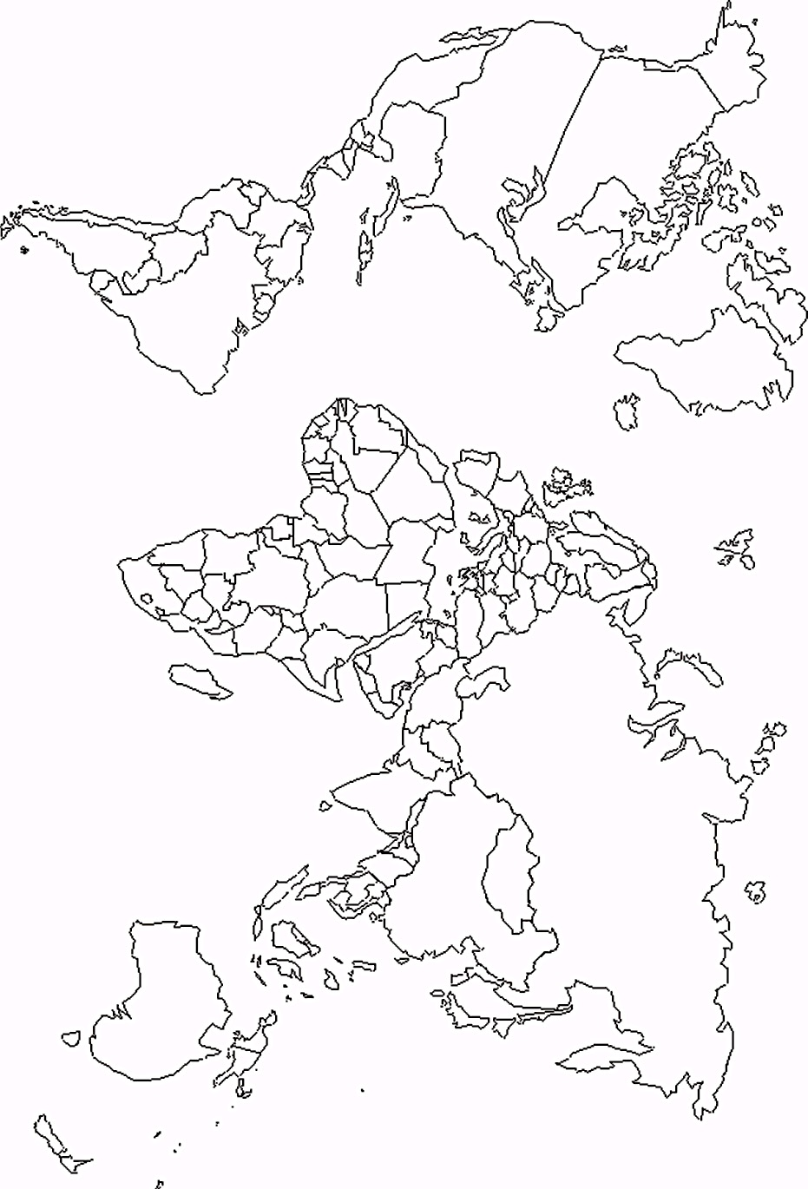

The following come from the Coursebook Ch. 12.
TUBERCULOSIS | Pathogen: Mycobacterium tuberculosis and M. bovis
Methods of transmission | Airborne droplets; via undercooked meats and unpasteurized milk
Global distribution | worldwide
Incubation* period | Few weeks or months
Site of action of pathogen | Primary infection in lungs; secondary infection in lymph nodes, bones and gut
Clinical features | Racking cough, coughing blood, chest pain, shortness of breath, fever, sweating, weight loss
Method of diagnosis | Microscopic examination of sputum for bacteria, chest-X ray
Annual incidence worldwide (2009): 9.4 million Annual mortality worldwide (2009): 1.7 million

MALARIA | Pathogen: Plasmodium falciparum, P. vivax, P. ovale, P. malariae
Methods of transmission | Insect vector: female Anopheles mosquito
Global distribution | Throughout the tropics and subtropics
Incubation* period | From a week and to a year
Site of action of pathogen | Liver, red blood cells, brain
Clinical features | Fever, anemia, nausea, headaches, muscle pain, shivering, sweating, enlarge spleen
Method of diagnosis | Microscopic examination of blood; dipstick test for malaria antigens
Annual (2010) worldwide- 1) incidence: 216 million (81% in Africa), 2) Mortality: 655,000 (90% are in Africa)

CHOLERA | Pathogen: Vibrio cholerae
Methods of transmission | Food-borne, water-borne
Global distribution | Asia, Africa, Latin America
Incubation* period | 1 – 5 days
Site of action of pathogen | Wall of small intestine
Clinical features | Severe diarrhea, loss of water and salts, dehydration, weakness
Method of diagnosis | Microscopic analysis of feces
Annual incidence worldwide: 3-5 million Annual mortality worldwide: 100,000-120,000

AIDS | Pathogen: Human Immunodeficiency Virus (HIV)
Methods of transmission | In semen& vaginal fluids during intercourse, infected blood or blood products, contaminated hypodermic syringes, mother to fetus across placenta, mother to infant in breast milk
Global distribution | Worldwide, especially in Sub-Saharan Africa and South-East Asia
Incubation* period | Initial incubation a few weeks; but 10 years or more before symptoms of AIDS may develop
Site of action of pathogen | T helper lymphocytes, macrophages, brain cells
Clinical features | HIV infection – flu-like symptoms and then symptomless  AIDS – opportunistic infections including pneumonia, TB, and cancer; weight loss, diarrhea, fever, sweating, dementia
Method of diagnosis | Blood test from antibodies to HIV
Estimated (2010) worldwide number of: 1) people infected with HIV: 34 million, 2) new cases of HIV infection: 2.7 million, 3) deaths from AIDS-related diseases: 30 million(UNAIDS estimate)

*Incubation: the phase in the development of an infectious disease between initial infection and the appearance of the first symptoms.
Incidence: the # of people who are diagnosed over a certain period of time, usually a year
Prevalence: the # of people who have that disease at any one time, Mortality: the death rate from a disease

