Arteries and Veins through the Microscope
Apparatus and materials:
CLASS SET
Microscope, calibrated eyepiece graticule, prepared slides of transverse sections of artery and veinous tissue
Introduction
In this practical, you will compare the structures of arteries and veins as seen through the light microscope.
You are provided with prepared slides of transverse sections of an elastic artery, a muscular artery and a vein from a small mammal. The diagram shows the tissues in a transverse section of a generalised mammalian blood vessel.
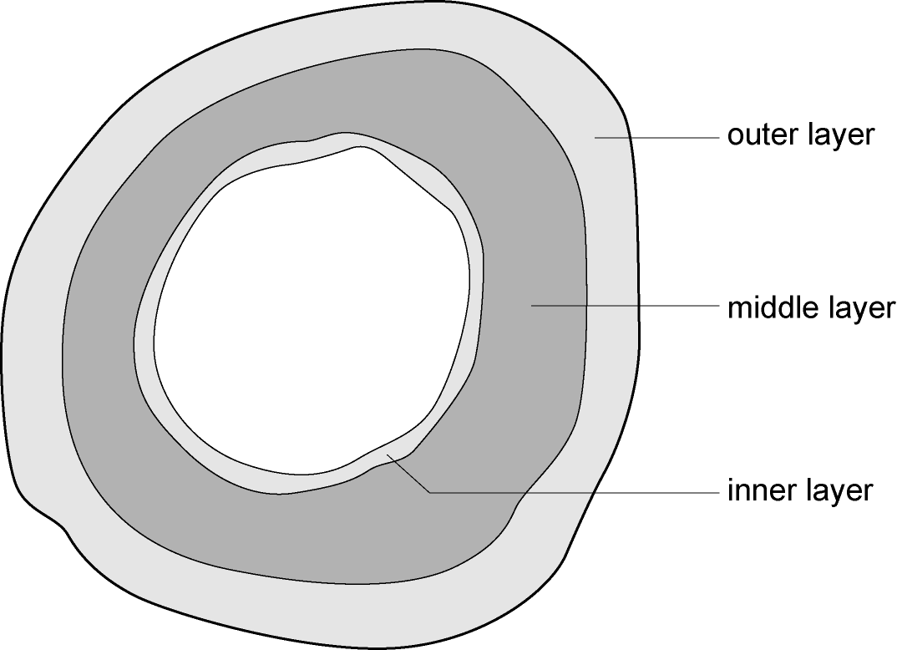You should also refer to Figure 8.4 on page 146 of the Coursebook, which shows sections through an artery and a vein.
Procedure
1 Examine the artery with the low- and medium-power objective of your microscope. Note how the structure differs from both the diagram above and the elastic artery.
2 Make a plan drawing to show the shape of the artery and the distribution of the tissues within it. Annotate your drawing, considering the size of the lumen, and the thickness and composition of each tissue layer.
3 Use the calibrated eyepiece graticule to measure the thickness of the wall of the artery. Add this information to your drawing and construct a linear scale for the drawing.
4 Examine the vein with the low- and medium-power objective of your microscope. Note how the structure differs from the generalized diagram and the artery that you have already looked at.
5 Make a plan drawing to show the shape of the vein and the distribution of the tissues within it. Annotate your drawing to show how the vein differs from the diagram above and from the artery that you have drawn.
6 Use the calibrated eyepiece graticule to measure the thickness of the wall of the vein. Add this information to your drawing and construct a linear scale for the drawing.
7 a Construct a table to show the differences in appearance between an artery and a vein, and include descriptions of each layer of the walls.
b Explain how the features of the arteries that are visible under the microscope are adaptations for their functions within mammals. (In other words, how does the structure of an artery relate to its function?)
c Explain how the features of the vein that are visible under the microscope are adaptations for its function within mammals.

What will be graded for this lab:
- 2 annotated plan drawings, with scale bars
- All of step 7 (the table and explanations)

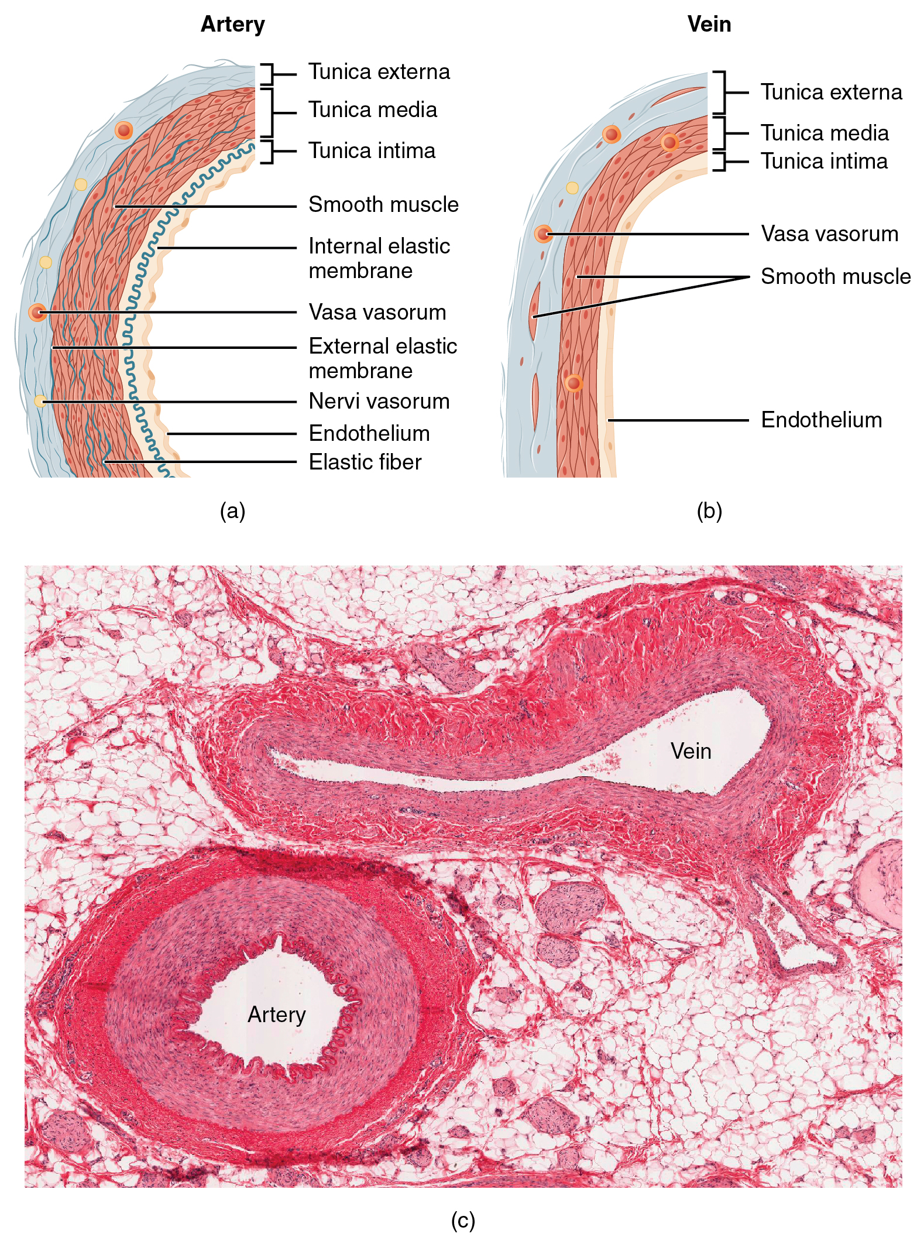
Figure 2: (a) Arteries and (b) veins share the same general features, but the walls of arteries are much thicker because of the higher pressure of the blood that flows through them. (c) A micrograph shows the relative differences in thickness. LM × 160. (Micrograph provided by the Regents of the University of Michigan Medical School © 2012)
Source: http://cnx.org/content/m46597/latest/

